REFLECTION OF YAHWEH TO LORENA 06/24/2024
I was in my room very sad listening to praises when Yahweh of Hosts spoke to me like this:
Israel unfaithful wife, hope reigns forever even after discouragement, I your God of Israel come to take your heart, to walk with Mine, through deserts and paths, a walk that goes from My Hand, passing through swamps and hills, through forests and jungles, defying the stormy sea, because I will show you the intimate of My Heart and you will know My DESIGNS AND SECRETS, because I will give you WISDOM to know how to discern between good and evil.
I am your home, your support, come Israel to Me and I will give you your reward, in this starry night I want to hear your voice, that resounds in the dark Universe that I have created for you, I have created everything for you and I unite it to you, so that united My Creation may be one before My Presence, that united the heart of the creatures, you invoke My Voice, from the interior of your heart desolated by the lack of love, without breath and hope for living accommodated to the crumbs of human and treacherous love.
Awake Israel, may My Love for you resound in your heart, may your interior be filled with Me and thus, with that strength you will unite entirely to Me and fused in a single heart of father and son, let us contemplate a new dawn, after the winter and the darkness, spring arrives and the greening of the flowers, come Israel unfaithful wife and make a Pact of Love with Me, from all Eternity, and I your God will deliver you from your enemies and oppressors, come, raise your head and trust in Me your God, I Yahweh of Hosts, I call you Israel, to walk with Me, come and hear the Shofar, galloping in majesty comes My Beloved Son, and I want to see you Israel dressed in fine linen for your Beloved.
Israel awakens and runs hastily to meet him, she hears the Shofar, the end is near, the end of the evil and terror that afflicts the world, and the beginning of a new generation freed from the evil and the influence of the enemy.
Come Israel and sing melodies of hope, because after this great trial the Sun will rise, hear how the voice of My Angels and Seraphim sing in unison, songs of War, because the War between good and evil is at its peak.
I WANT TO SEE YOUR HEAD HELD HIGH, FIGHTING WITH THE WOMAN CLOTHED IN THE SUN, FOR THE TRIUMPH OF TRUTH AND GOODNESS.
HEAR TODAY ISRAEL THIS DAY THE TRUMPETS IN ZION, ON MY HOLY MOUNTAIN, WHICH IS DECLARED BY EVERY PEOPLE, RACE AND NATION TO BE THE MOUNTAIN CHOSEN BY ME, TO SEE THE NEW JERUSALEM COME DOWN.
My people or Shema Israel, your liberation is near, do not fall, do not defeat yourself, do not succumb to sin, rise up.
I raise you with My Great Power, from the rottenness and the stench of sin, and I ask you with all my heart to fight for salvation, the Promised Land, the New Jerusalem, will be your reward, listen o Israel to the cry of your God and Savior, together with the Shofar of My Angels and Archangels, sing together with the song and drums, the melody of Love and Liberation, I will deliver you Israel from your enemies, they will fall into their own nets of evil.
Listen O Israel to the swaying of the waves of the sea, which sing to My God the end of oppression and evil, to give way to an Era of Peace and Love, persevere Israel, do not falter, strive and be brave.
THE BLOOD OF THE MARTYRS WILL FLOW THROUGH MY VEINS, AND WILL GIVE TO THIS MY NEW CHURCH, THE STRENGTH OF ITS RENEWAL, BY THE BLOOD AND THE BLOODY MARTYRDOM OF MY ISRAEL, AN ISRAEL THAT LIVES THE CALVARY OF MY SON, NEXT TO ME YOUR GOD, YOU WILL BE THE SEED OF NEW CHRISTIANS.
LISTEN TO ME YOUR GOD AND UNDER THE SHADOW OF MY LOVING FATHER'S ARMS, YOU WILL BE PROTECTED FROM THE SECOND DEATH, IT WILL NOT BE ABLE TO TOUCH YOUR MIND AND YOUR HEART, BECAUSE I WILL DELIVER YOU FROM IT THROUGH THE WOMAN CLOTHED WITH THE SUN, WHO WILL TAKE YOU TO THE PROMISED LAND, I GIVE YOU EAGLE'S WINGS, I WILL PUT A COAL ON THE LIPS OF YOUR MOUTH, AND I WILL ANOINT YOU WITH MY POWER, SO THAT YOU MAY CLEANSE YOUR BOWELS AND PROCLAIM MY WORD, RISE UP ISRAEL, YOUR GOD IS CALLING YOU, TO GO ON WAR FOOTING, TO FIGHT FOR THE RENEWAL OF MY CHURCH.
O Shema Israel, your God calls you today, to shine in the darkness, forget your past, your lovers and your sin, rise and shine, for you will rise as a light, which enlightens the World and Creation.
O Israel, unfaithful wife, today I make a Pact of Love with you forever, sealed with the Blood of the Lamb on your forehead, come to Me your God or Israel, and celebrate your prompt liberation, listen to your heart in unison united with Mine, and reconfirm yourself, so that with renewed strength, you may go out on war footing, to fight for the ideal of My Son Jesus Christ, the truth will set you free and you will fly free as an eagle, to conquer Nations, for Me your God.
Arise, come to Me, I await your answer.
O Israel my people, I call you to fight for the Gospel and the Truth, for I your God, the God of your fathers, the God of Hosts, am with you today.
I Yahweh.
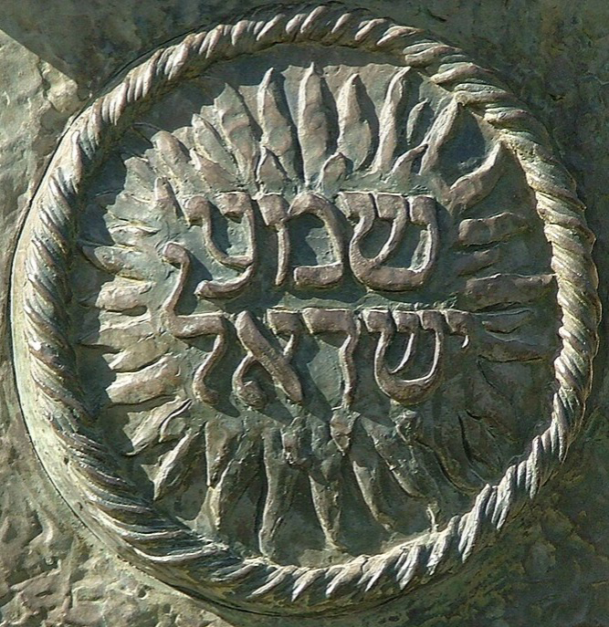
Shema Israel

