MESSAGE FROM JESUS CHRIST TO LORENA
NOVEMBER 12, 2023
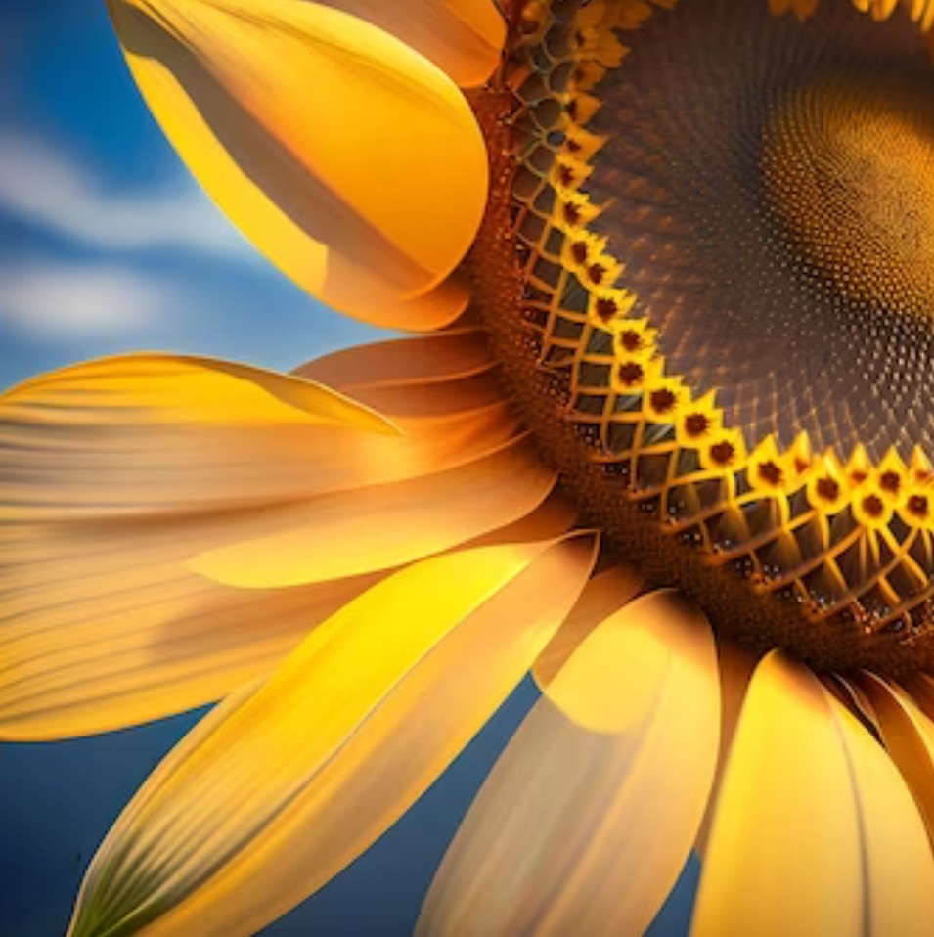
The Flower of My Divine Will
My dear daughter of My Divine Love,
Today on this day near the culmination of My Father's Hour of Redemption, because very soon I will return as a Lion of the Tribe of Judah, I want to give you a Flower, THE FLOWER OF MY DIVINE WILL.
IT IS LIKE A SUNFLOWER THAT WITH ITS PETALS OPENS TO THE SUN, FOR EACH PETAL CONTAINS A PREMISE, A GUIDELINE, AN INSTRUCTION FOR YOU TO LIVE BY MY DIVINE WILL.
You must always learn to forget yourself and all that disturbs your mind and heart, abandoning your whole being in the infinity of Mine, so that with that Purity of Heart you may begin to live in My Divine Will.
THEREFORE THE FIRST PETAL of this beautiful Sunflower is FORGETTING YOURSELF, concentrating all your Powers of your Soul, Mind and Spirit in My Being.
THE SECOND PETAL is to learn to melt your own being into Mine, through EFFECTIVE COMMUNICATION WITH THE HOLY SPIRIT, which is He who will guide you to achieve a Fusion of the Spirit to such magnitude that your Soul is founded to Mine, thus achieving the FIRST FIAT that will be the commitment of the Soul with the Creator to carry out a life that goes in the direction of the Sanctification of this through ALL the circumstances that God allows to live the Soul in his Pilgrimage for this life.
THE THIRD PETAL is the Fusion of the Soul with its Creator through a LIFE OF PRAYER AND CONTEMPLATION that leads the Soul to Fuse with its Creator and to understand exactly the DIVINE WILL when reaching this point, the Soul is Sanctified and reaches the…
FOURTH PETAL of our Sunflower where one already lives in the Divine Fiat and the SECOND FIAT is given which commits the Soul to its Creator to live in the Divine Will, but the Fifth and Sixth Petal are missing. IN THE FOURTH PETAL, The Soul lives in the FIAT and the RING OF COMMITMENT has been given to the Soul to be betrothed to the Most Holy Trinity in the Sixth Petal.
THE FIFTH PETAL of our Sunflower is to live entering into the Divine Will at every moment of your life without separating yourself from it because you have reached Sanctity, THE SOUL, BY LEARNING TO LIVE EVERY INSTANT OF ITS LIFE IN THE DIVINE WILL, ACQUIRES THE DIVINITY REQUESTED BY HEAVEN, to become the little daughter of the Divine Will and it is when in the…
SIXTH PETAL The Soul is espoused to the Most Holy Trinity, fusing into a WHOLE and FULFILLS WITH THE FIAT VOLUNTAS TUA OF THE SOUL AND IT IS ONE, FOUNDED IN THE DIVINE WILL AND IT BECOMES PART OF THE DIVINE KINGDOM OF THE DIVINE WILL AND IT IS NO LONGER THE ONE WHO LIVES, she has died, she has buried her Essence in the sepulcher of the human will, acquiring when she dies her Essence, the Essence of the one who created her and therefore, when she merges, she dies to her, It is when it Fuses all its being, in the transforming and Glorious being of the Victory of Life over Death, this no longer has power over that Soul because it has been Transformed, Liberated and Glorified to fly to Heaven and form together with the Holy Trinity, what the Soul should have always been, it is Clothed with the Power and Magnificence of God being then the very Fusion of the Soul to the Holy Trinity.
Resulting in the Transformation and Fusion of the Soul with its Creator and therefore as part of a WHOLE, of the ALL that lives in the FIAT VOLUNTAS TUA, the WHOLE of all creation is fused with the Creator to form the greatest Work of Creation the FIAT VOLUNTAS TUA IN ALL CREATION and then the Triumph of Good over evil and of the Eucharistic Hearts of Jesus and Mary, fusing all hearts into one to the Most Holy Trinity to Shine in Glory and Splendor for all the Centuries in the Love of the Creator, who with astonishment contemplates His Work of Redemption that finally reaches its culmination, therefore, My Soul, work in your Soul, so that you may reach this Fusion of your Soul to the Most Holy Trinity and may participate in the Work of Redemption in the ERA OF THE THIRD FIAT, strive to achieve it, put your grain of sand that I will put the rest.
The New Heavens and New Earths, the New Jerusalem, the Work of Redemption of My Father that culminates after centuries of pilgrimage through the desert.
My Soul, fight and be brave so that you can achieve your transformation and transfiguration, your Spiritual Metamorphosis from caterpillar to butterfly.
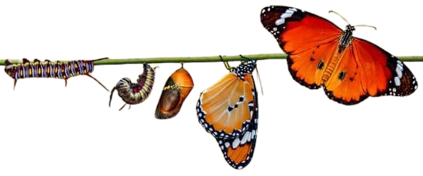
We await you at the Wedding of the Lamb.
MARANATHA - THE LORD IS COMING.

(FIAT VOLUNTAS TUA = THY WILL BE DONE)

