MESSAGE FROM GOD THE FATHER TO LORENA
SEPTEMBER 3, 2023
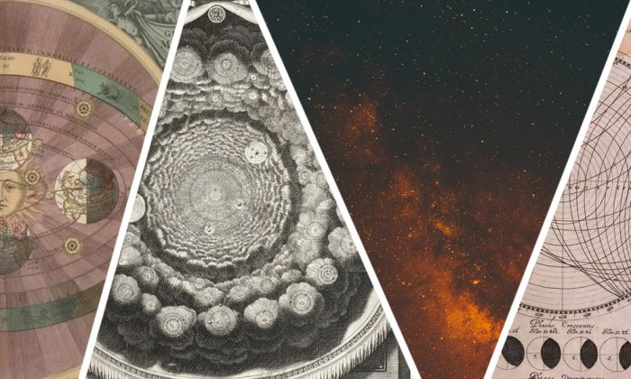
EXTRATERRESTRIAL INVASION

I, as God the Father of ALL creation, come to warn you through this Supernatural Dogmatic Theology in the Light of Faith of the supernatural events that will happen to the Light of Faith in these End Times.
They will be things NEVER seen before by the human eye, which will come to make mankind susceptible to various tests of all kinds that will lead them to doubt Me and My Son Jesus Christ, since they will try to tear down the Dogmas of Faith of My Holy Catholic Church trying to confuse countless people with false ideologies based on the NEW AGE, FREEMASONRY AND SATANISM; which unite in a SATANIC TRINITY to make known to the World the coming of a supreme being who will be seen by many people as the Messiah and Savior.
The conspirators against My Holy Doctrine, are mostly beings from other planets, extraterrestrials from other Galaxies that come from the beginning of the Angelic Fall when Luzbel revealed himself and were banished to live in Galaxies far away from the Solar System.
They are the ones who are calling the shots in all this Universal deception, where they will try to uprise the Human Race with their wicked purposes through the New World Order, composed of Satanism, the New Age and Freemasonry.
This New World Order will try to enslave Humans by indoctrinating the People, especially the youth and children who have been indoctrinated through the media for more than a couple of decades.
Therefore, I ask My Faithful Remnant to listen to EVERYTHING I am going to tell you in this Theology, where we will see supernatural themes, for many people that cause controversy and disbelief.
The UFO sightings have been increasing their paranormal activity lately, and this with the purpose of appearing before Humanity as a superior race of special Entities that come from outside to "help" the Human Race but their purpose is different, it is to CHANGE THE PERSPECTIVE AND THE VALUES, IDEOLOGIES AND CULTURE OF THE PEOPLE.
Trying to make people believe that My Son is NOT the Messiah who came more than two thousand years ago to die for Humanity, but that the Messiah who comes to rescue Humanity is Maitreya, the Antichrist himself, son of a Satanic Priestess and Lucifer himself.
IT IS THEREFORE OF THE UTMOST IMPORTANCE TO BE ATTENTIVE TO THIS ALIEN INVASION THAT WILL COME FROM SPACE CROSSING GALAXIES TO COME TO INDOCTRINATE AND MANIPULATE HUMANS.
For this reason, as a WARNING, I will give this, My People of Israel, a series of supernatural Themes, in which, in the Light of the Faith of Jesus Christ, you will understand what is about to happen in this World, because the Antichrist is about to appear on the scene and the Extraterrestrials, who are nothing more than DEMONS, will pave the way for him, so that the people deceived by these perverse entities will listen and believe that they come in peace, but it will NOT be so, they will come to DESTROY THE HUMAN GENDER SO THAT THEY CAN SUPPOSEDLY CARRY OUT THEIR REIGN IN THIS WORLD OF SEVERAL MILLENNIA WHERE THE HUMAN RACE WILL BE TOTALLY ENSLAVED TO THE NEW WORLD ORDER MAKING THEM TRANSHUMANS WITHOUT THE CAPACITY TO MAKE THEIR OWN DECISIONS.
Since they will affect the Free Will that I, as the Father of every Human Being, give you as a Great Gift to have the power to decide between good and evil, however the New World Order led by the Antichrist, will NOT respect the gift par excellence that I gave to Humanity, he will take away your Free Will making you Trans humans and slaves to his service being the owner of your BODIES, MINDS AND SOULS.
That is why in this topic about Extraterrestrials and UFO sightings I want to warn you about the new deception of the Antichrist and the New World Order in accordance with the Extraterrestrials, Illuminati, Freemasons, Atheists, Communists who come to pave the way for the Antichrist.
Therefore, today I ask you as My Faithful Remnant, listen to this Theme and strengthen yourselves with PRAYER, FASTING and PENANCE and know that the Dark Forces are trying to bring down the children of Light.
Therefore, I ask you through your Prayers, to Live in the Divine Will, so that the Era of The Third Fiat comes soon to Earth, and puts an end to the evil and perversion of the human beings, and to the malevolent Entities that seek to pervert Humanity.
There are several Three-Dimensional portals that have been opened with Satanic Spells and Rites to allow the Demons from Avernus to enter the World, as well as the Extraterrestrials from other Galaxies.
Satanism has been gaining strength and after several decades, after 1948 they have tried to infiltrate all areas of Society including Religion through various ideologies such as New Age, Freemasonry, Ecclesiastical Freemasonry, Communism, Atheism and Satanic and Occult Rites preparing Mankind for the arrival of the Antichrist and his New World Order.
Therefore, in the face of these UFO sightings and the arrival of supposed Extraterrestrials, DO NOT listen and lock yourselves up and concentrate on LIVING IN THE DIVINE WILL and do a lot of PRAYER, FASTING AND PENANCE.
When these supposed Extraterrestrials arrive on Earth and make their appearance in the Media, DO NOT pay attention to them and ignore them, SECLUDING YOURSELF IN PRAYER CENACLES that will keep you protected from all this conspiracy against Humanity.
1) Pray the Devotion to the Most Precious Blood of Jesus Christ
2) Seal Your Homes and Do Not Leave Them
3) There Will Be Mass Abductions
4) You Must Protect Yourselves With Prayer
5) Therefore You Should Try to Be in a State of Grace and Prayer
6) Invoke St. Michael the Archangel and He Will Protect You
7) Pray the Chaplet of the 9 Angelic Choirs and Remain in Guard and Prayer
8) For Protection Read Psalm 91, Ephesians 6 and Shema Israel
9) Unite in Prayer Cenacles and Trust in Me

I as your Father will protect you from ALL evil.

I YAHWEH OF THE ARMIES

