Message of Saint Michael the Archangel to Lorena
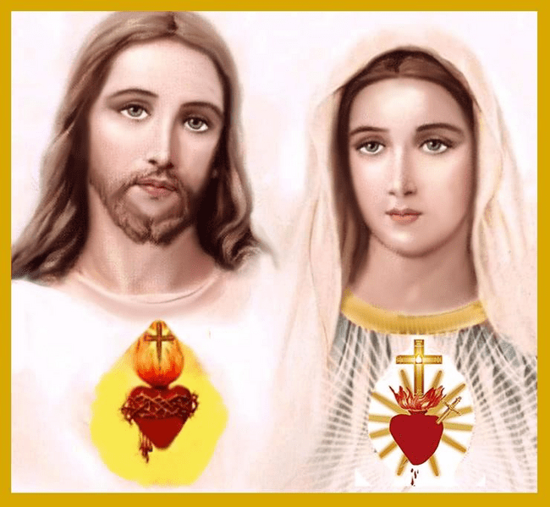
March 14, 2025
Prayer To Become Living Tabernacles
The United and Pierced Hearts of Jesus and Mary Await God's Warning to Humanity to Unite With the Heart of All Humanity and Give Each Being the Light to Become Living Tabernacles and Become One Heart, Beating in Unison With That of Jesus and Mary.
After the Warning, the Destiny of All Humanity Will Be Defined and Many Good and Noble Hearts That Hope in God Their Creator Will Be Converted Into Living Tabernacles of My Lord Jesus Christ.
Therefore, I, St. Michael the Archangel, Come to Prepare You for the Warning and to Become Living Tabernacles That Illuminate the Darkness of the World, for It Will Be Jesus Christ Himself Who Dwells Within These Hearts.
Therefore, Holy People of My God, I Invite You to Prepare Your Spirits and Souls to Be Able to Become Living Tabernacles and to Achieve This You Need to Work in Your Hearts, Which is the Most Important for Your Transformations, a Clean, Pure and Healthy Heart That is Ready to Be Transformed on the Day of the Warning.
Therefore, You Must Heal Through Prayer, Every Wound You May Have From the Time of your Gestation Until Adulthood.
Therefore, I will invite St. Raphael the Archangel, the Archangel of Health to give you a Special Healing Prayer For Your Hearts, This Prayer Will Be Useful for Your Healings and You Can Pray It From Today Until the Day of the Illumination of Consciousness.
PRAYER: I, as Part of the Army of Saint Michael the Archangel, Through the Healing Power of Saint Raphael the Archangel, Bow Before the Most Holy and Say Thus:
I (Name) With the Power of the Blood of Our Lord Jesus Christ, Shed for Me on the Cross, Declare Healing in My Heart.
I Ask the Holy Spirit to Transform It Into a Clean, Pure and Benign Heart, Free of Hatred, Resentment or Wounds Caused by My Relatives, Friends, Parents or Siblings.
Free From All Bondage, I Declare That I Am Healed Through the Intercession of Saint Raphael the Archangel of All Hatred, Resentment, Envy, Lack of Charity or Love Towards Myself or Others.
That With a Pure and Clean Heart, I May Adore the Blessed Sacrament of the Altar, This Day and Today Before His Presence I Surrender to Him All That I Am and All That I Have, My Being and My Essence.
That Free From All Bondage, With a Clean and Pure Heart, My Lord Jesus Christ, May Dwell in my heart and I can Become a Living Tabernacle,
So That My Lord Jesus Christ Lives In Me and I Can Carry Out My Mission in This End Times and as Part of His Army of Saint Michael the Archangel,
I Give My Fiat to the Holy Trinity, to My Beloved Mother in Heaven, and to Saint Michael the Archangel and Thus Commit Myself to Fulfill My Mission,
I Surrender to My Lord Jesus Christ My Whole Being, All That I Have and All That I Am and Thus Free of Everything and Empty of Everything,
I Fill Myself With the Holy Spirit, My Heart Restored by the Love of My Lord Jesus Christ. Amen.
This Prayer will be said in front of the Blessed Sacrament, after having made a Confession of Life and thus with your SOUL, HEART and SPIRIT RENEWED, you will prepare yourselves for the Illumination of Consciences by means of an arduous Journey of Prayer and surrender to God the Father.

I, Saint Michael The Archangel
Who Is Like God, No One Is Like God !!!!

