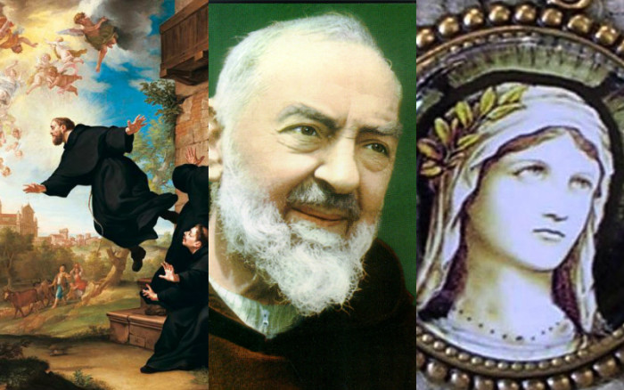
CAN A MAN BECOME A SUPERNATURAL BEING (FIRST FRUIT)
CHAPTER ONE
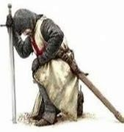
The supernatural truths of God the Father can only be glimpsed in the light of faith, it is as if a blind man wanted to see, a deaf man hear, a lame man walk well, it is really impossible, but if we want to see this reality in the light of faith, we will have to invite first Jesus Christ to do a miracle in our lives, through Faith in His Word, in His Gospel, in His Teachings, to be free from all ties, ailments or physical defects that invalidate us to see beyond for not having the ability to do so.
However, if we ask Jesus Christ to heal the eyes of the blind, open the ears of the deaf, and relieve the foot of the lame, which can only be achieved with a pure spirit, soul and heart, with this we will be able to heal those ailments that make us incapable. to see, hear or walk like others, then our eyes in the light of faith will be able to see surprising and wonderful things that we are not able to see when we do not die to our carnal senses, because when we die to our carnal senses the blind man sees, the deaf hear, the lame walk well, and that is when in the light of faith we know that the liberation of our soul will have an effect on our physical ailment and we are totally healthy in Mind, Body and Soul and especially in Spirit.

Therefore we can know and accept higher and incomprehensible Mysteries of Creation, but for this Purity of Heart it is necessary, and openness to God the Father, God the Son and God the Holy Spirit, this openness that is obviously not a dogma of faith , nor a theological foundation for not having validity or human support because it is of a supernatural nature, will open our senses to the spiritual world, which we cannot physically feel, but nevertheless it is very real and true, because it is a spiritual world in which there are rules and guidelines to follow that are very different than in humans, because they are based on these rules and guidelines of a Divine Logic and incomprehensible to the human mind, which is why the human being, not having a very elevated and humble heart cannot know things that escape the subjectivity and objectivity of human reasoning, because they are irrational and incongruous for the human being.
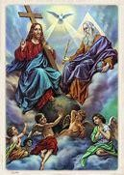

However, this mysterious spiritual world is possible to be understood by humans who have a very High Spirituality and because it is an open conduit to the light of the Holy Spirit they understand everything perfectly, things that many people in the world, due to spiritual and mental pride cannot even think about it, and to justify that incomprehensible Spiritual reality, they resort to easy solutions, that calm their spiritual pride and selfishness centered on them, the solution that will feed the soul of themselves to continue impoverishing themselves as semi Gods incapable of flying towards the freedom of the soul because they are subject to sin, being tied to feelings of greatness that in the light of faith are of poverty.

These poor human beings will never understand unfathomable mysteries or unreal rules, that are the foundation of supernatural life, in God's logic where 2 plus 2 equals 4 may not be true, because of His Omnipotence and Supernatural Flow of the Holy Trinity leads Him to exclaim that, if in His Omnipotence, He wants to conceive that 2 plus 2 is equal to 7 He can do it with all the Power that comes from God.

This is easy and difficult to understand because they are unfathomable mysteries of God of a Supernatural nature, which are based on an irrational and incomprehensible logic to the human mind because the limited human being in the face of these incomprehensible situations, does not know how to defend himself, basing his human and erroneous theories on a spiritual blindness that leads him to affirm that everything comes from human logic.
However, it is by Faith in Jesus Christ that the blind see, the deaf hear, the lame walk, God heals those foolish and small souls, exalts them, makes them sublime and supernatural.
Can an ordinary man of flesh and blood become an Angelic or supernatural being?

Within human logic no, but within the supernaturality and Omnipotence of God everything is possible, a normal human being can become a Divine Angelic being, therefore supernatural, and this can happen and we can say in the light of faith that 2 plus 2 equals 7.

So if I raise my wings to the sky, I know that I will fly, not because of human logic, but because of the spiritual dimension that will give me the faith to believe that I will actually fly.
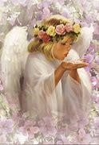
This Supernatural logic of myself nourishes my spirit, therefore, it is no longer difficult for me to delve into the Mysteries of Faith and the supernatural, reaching the conclusion that this theory was not false, but on the contrary, I do not understand it with my human and limited capacity and mind, but if I make my senses open in the light of faith to the light of the Holy Spirit for this it is easy to understand that 2 plus 2 is 7, because the logic of God is supernatural and not human.

Because simply and easily the supernatural and almighty God breaks into human logic, making the blind see, the deaf hear and the lame walk well, this breaks human schemes.
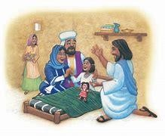
But why not think that not everything is written, looking at the Divine Logic His Omnipotence and Supernaturality we can say in the light of faith that He did not want to leave everything written, for being incomprehensible to humanity, he proves His Love, faith and availability, to do His Will even at the cost of everything and everyone and because his faith is not based on anything palpable, He is able to walk on water without sinking, go through the red sea without drowning or accept, like the Virgin Mary, the Divine Will through the Archangel Saint Gabriel.

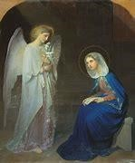

He is capable of resuscitating the sick, taking poison and not dying, walking on snakes and dragons because his faith is not based on anything palpable, on nothing written, and this is the faith that God asks of us, the faith based on our love for God, not on something palpable or written by men.

But faith grounded in God makes us grow and reach unsuspected heights, which is when the theological virtues are born in the human being, therefore, unsuspected and beautiful scales, paths that man discovers and makes his own, that nests them in his heart and therefore, they make this being such a sublime and beautiful being in the eyes of the creator, because there is no stain or evil, his soul is transparent, he can go freely to the arms of the father, free from all ties and tell God Father here I am to do your will.
Because I no longer live, but Jesus Christ lives in me, from there the roots of holiness begin to sprout that only need special care so that the seeds may grow, since the roots are there, therefore it is easy for these human beings, who already have passed these tests, that they can say thanks before the throne of God.
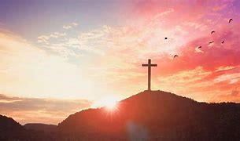
Suffering exalts you, makes you mature, grow, endure and strengthens the human being, making him capable of shipwrecking in the sea of ​​the world and of sin, without succumbing because finally his future is God, but to be able to properly base faith in God it is necessary to have passed on the base suffering of all human faith that becomes when it is purified in Divine Faith that gives us the guideline to understand the incomprehensible.

The suffering of the blind for not seeing, the deaf for not hearing and the lame for not walking well, purifies them when God considers it prudent and then Jesus Christ appears in their lives and performs the miracle of being able to hear, see and walk and that is when suffering purifies them who are capable of understanding what is incomprehensible to the human mind in the light of faith. Therefore, in the Supernatural Dogmatic Theology in the light of faith we deduce that here the blind man saw, the deaf heard and the lame walked and because of their suffering exalted by the grace of Jesus Christ and divine logic they understand by their purity of Spirit that 2 plus 2 is 7 in such an obvious way that it is not necessary to question it, so its logic is based on faith in God, not on human guidelines.
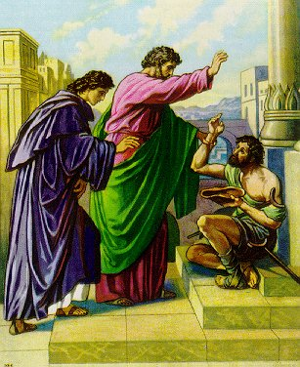
That is why the humans chosen for an important mission God allows them a greater suffering that enables them so that under this suffering that can be physical or spiritual they purify themselves, and when they are healed by Jesus Christ they understand the unfathomable mysteries of the Father. Because if they are not purified by pain they will not be able to carry out their mission, this suffering strengthens them and makes them more capable of understanding the incomprehensible, their human mind is not that of an ordinary human because by their refinement they possess infused knowledge divine and this makes him understand without problems that 2 plus 2 equals 7, and that God may have broken the schemes by being Omnipotent.
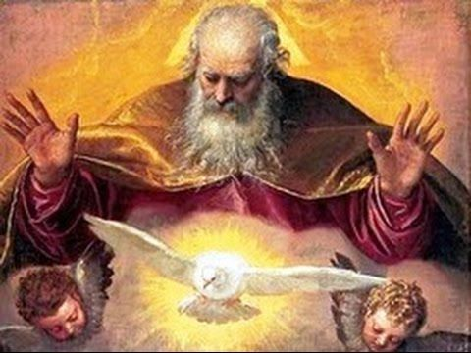

THE FIRST FRUITS OF JESUS CHRIST
CHAPTER TWO

As First Fruits of Jesus Christ, it is necessary that you know the unfathomable mysteries of the love of the Father and the Son for humanity, as well as the Maternal Protection of the Heavenly Mother.

The First Fruits in this End of Time, were chosen from the womb of their mothers. They were conceived for this specific mission and were protected by the Blood of Christ, hidden from the enemy in their wounds, because they have been very besieged by him throughout their lives.

They are very special souls, because this Mission has been reserved for a few souls, from the beginning of humanity to the End of Time. Chosen from the beginning of humanity for such a Praiseworthy Mission.

The group of the 144,000 elect is from the 12 Tribes of Israel: Reuben, Simeon, Levi, Judah, Zebulun, Issachar, Gad, Dan, Asher, Naphtali, Joseph, and Benjamin.

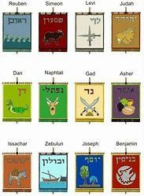
God directs his people Israel from the pilgrimage through the desert to their liberation as a new humanity.

Descendants of the 12 Tribes of Israel, from all corners of the globe, are chosen from birth, protected from their first months of life, by special Angels, because they are not like other mortals.

On their foreheads they bear the Seal of the Living God, which means the Alliance of Christ Jesus with his
People Israel, for the final fight between good and evil, at the end of time.

That is why in Revelation 7,3-4 it speaks of the 144,000 and says:
Do not harm the land or the sea or the trees, until we mark with the Seal on the forehead the servants of our God.
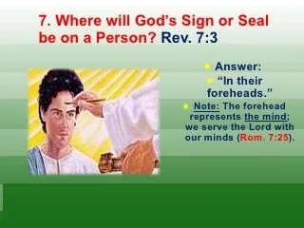
And I heard the number of those who had been marked with the seal. They were 144,000 from all the Tribes of Israel.

The 144,000 sealed are called with a powerful voice to their mission from their childhood. They feel they do not belong to this world and are cruelly besieged by the enemy. Throughout their lives they have been refined in the fire of purification, forged from the Divine Light of the Holy Spirit, and conceived in the womb of the sweet Mother of Heaven.

They have been prepared, without them knowing it, preparing their hearts since their childhood. They do not belong to the world and are characterized by not being contaminated.

Myriads of Angels protect them and have freed them from a multitude of dangers, especially spiritual ones, and the fire of Christ blows in their hearts and burns strongly, radiating a special light.
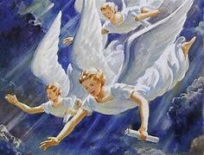

They are not like the others, they are warrior souls capable of giving their lives for their God and Lord. They fear nothing, only to lose their soul.

They have a superior knowledge of the Divine Mysteries, assimilate and understand them better than anyone. They will dwell in the New Jerusalem as part of the twelve Tribes of Israel.

Their names will be written on the gates forged by Angels, and the Archangels will guard the city, besieging it from every angle.

She is busy dressing herself in fine linen for her husband, because the fight has begun and also her preparation for the Marriage of the Lamb.
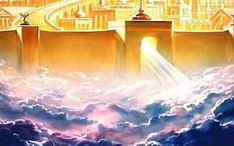
Listen well, inhabitants of the earth! when the trumpets sound announcing the Great Battle in all the ends of the Earth, the First Fruits will hear them within their hearts.

You will know that the Final Transformations are near.
The whole earth has been contaminated, we only have to clean it with the Light of Christ, which is found in every soul that lights up the Whole Earth.

The lights of the Martyrs flash a reddish light, for their blood shed by Christ, the lights of the First Fruits flash a blue light, which means that they will give victory to good, together with the Virgin Mary, Jesus Christ and Saint Michael the Archangel.

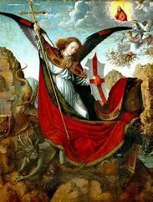
And the world, amid the glow of red and blue lights, will look from space like a ball of fire, which will slowly catch fire, exploding, and giving rise to the New Heavens and Earths, because the old things will pass away and the new will prevail.

The First Fruits engendered in the womb of the Virgin Mary of Guadalupe will be instructed by Heaven.
Since childhood, these people are different from others and therefore hated and forgotten by the world; they never felt belonging or accepted by the world; there was always an inexplicable rejection towards them.

All Saints would have wanted to be First Fruits, because they are the ones chosen by God to make way for the Lion of the Tribe of Judah to come and establish his kingdom.
You will be endowed with Divine infused knowledge by the Holy Trinity, you will have knowledge never before thought of and you will be able to fly at the speed of thought. They will possess extraordinary gifts.
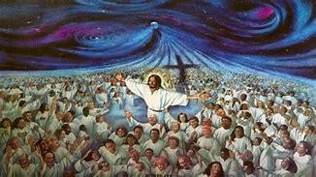

All of them are from the twelve Tribes of Israel, descendants of the lineage of David. People with indomitable spirits, rigorous in their Spiritual Life, followers of God and His Precepts.

They are like lights that illuminate any darkness, because God has taken their hearts, and has put them in new wineskins, separated from the world.

There is no filth in their hearts, they radiate the Glory of God through the extremities of their hands and feet, and also through their foreheads.
Their rays that emanate giving the world light, give and infuse the Spirit of Christ to his brothers.
They do not feel hatred or resentment, since in their transformations they will reach the Sixth Chamber in their hearts and they will live the Reign of Christ Jesus in their spirits, souls and hearts from Earth.

Secrets and mysteries will be revealed to them, they will be able to penetrate the minds and hearts of people.
Men and women forged in suffering who have only one ideal in their lives, to serve Christ Jesus.
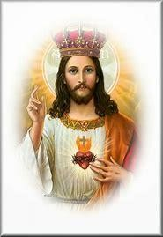
As they were conceived and God infused the breath of life into their souls, He put a different flame from those of other souls. It is a flame that radiates the light of the Holy Spirit, which has been growing and developing through its existences until it reaches the final transformation, first passing through the womb of the Mother of Heaven and receiving the final instructions in Heaven through of the Holy Trinity.

Captained by the Virgin Mary, and led by Saint Michael the Archangel, they possess extraordinary strength and an indomitable spirit.
They have eagle wings, and their hearts melt into the Hearth of Jesus Christ. They will breathe life into souls that are dead by sin.

Warriors of Christ, King of kings, Lord of lords. Special men and women, because they were born to govern the Heavens and New Earths.

They will be freed from the chains of sin, since when transformed they will fly free into the hands of the Father, who will receive them in His Hands and there He will give them the last instructions, to go out to Evangelize Humanity, dressed in fine linen, with their tunics whitened and resplendent with the Light of the Holy Spirit.
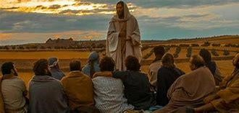

First Fruits from Heaven, ready for the Final Battle! They will be escorted by Myriads of Angels, so that when Preaching the Gospel to all people, races and nations, they will go unnoticed by the antichrist.
First Fruits, almost ready for the Great Combat, with the Seal of the Living God on their foreheads, distinguishing them from other beings by these characteristics described.

They will fight against the antichrist, lead their brothers and lead the great crowd into the New Millennium.
They will fearlessly preach the Gospel and face the hosts of evil with the Power of the Holy Spirit, overcoming all obstacles they will be able to complete their mission.

First Fruits trained to give their lives and deliver their soul and spirit to the Father.
Instructed by Heaven. For being chosen since the fall of Adam and Eve, to bring the Victory of Jesus to the world; together with the Virgin Mary, Saint Michael the Archangel, Saint Gabriel and Saint Raphael, you will pave the way for the Lion of the Tribe of Judah, because as a Powerful King of kings, He will give the Triumph of Good over evil.
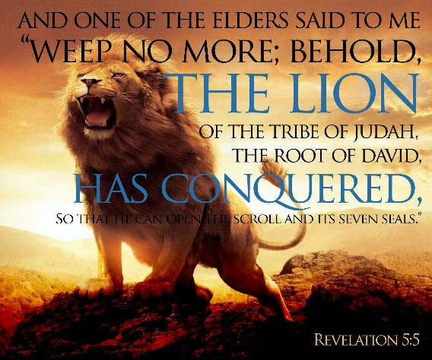

What a great honor than to pave the way for the King of kings, Lord of lords. What souls more fortunate and loved by the Father are the First Fruits, who entrusted them with such a Praiseworthy Mission.

From space you can see the dark earth and few Red and Blue lights that begin to emerge radiating their light, a light that spreads little by little, until the earth is covered with fire and is renewed.

The Mission of the Martyrs and the First Fruits is very important in the Renewal of the Earth, because the Martyrs with their blood renew the Church and the world and the First Fruits with their light pave the way for the Lion of the Tribe of Judah, to that they, with the light that they radiate from their hearts, give way to the emergence of the New Heavens and Earths.

And together, Martyrs and First Fruits, will see the Triumph of the Lion of the Tribe of Judah. ​​The whole world will be lit and then Renewed, although the evil today is very great, the lights begin to turn on little by little, one after another, and they begin to illuminate the Earth, and soon it will burn, and the Triumph of the United and Pierced Hearts of Jesus and Mary will come.
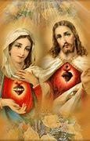

Army of Christ, First Fruits of Heaven, sing and praise God and together, in unison let us shout:
Who is like unto God! Nobody is like unto God!

SPIRITUAL METAMORPHOSIS IN THE LIGHT OF THE HOLY SPIRIT
IN THE LIFE OF GOD'S CHILDREN
07/27/2017
CHAPTER THREE
The human being made in the image and likeness of God by Divine Decree and love for man, intends through this appendix to establish an effective communication in each human being so that in the Light of the Holy Spirit he can begin his Metamorphosis.

This Metamorphosis is necessary to be able to acquire the Supernatural Gifts that will be given to the First Fruits, but for this, "Chapter one" must have been fully understood (Can an ordinary man become a supernatural being, First Fruit) and have experienced this topic, because the one who is not refined in pain and suffering is not a First Fruit, so this is a necessary Guideline so that all those, who aspire to be First Fruits and have NOT suffered the purifying pain of the deaf, lame and blind know that They have NOT been called to this laudable Mission because simply and easily they do NOT have their soul prepared to be able to carry out this Universal Mission.
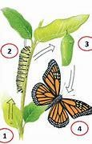

Therefore; the First Premise is to have been purified in suffering, the Second Premise is to understand that two plus two equals seven, the Third and most important is to ask Jesus Christ to HEAL each one of you so that you can hear, see and walk since by being healed, you will be able to fly into the Arms of the Father and tell Him here I am to do your will because it is no longer I who lives but Jesus Christ who lives in me.

This Healing Step that we have already been experiencing is the Stage of Metamorphosis to which all First Fruits are called to live, therefore you feel in your hearts, that you are First Fruits due to the following Steps:

1.- Purified in pain.
2.-Understand that two plus two is seven because the Will of God is Omnipotent and Supernatural, therefore a characteristic of the First Fruits that we have already mentioned many times is:
2.1 Heart of a child
2.2 Humility and simplicity
2.3 Openness to the outpouring of the Holy Spirit
2.4 Recognize that the Will of God is so Beautiful and Sublime because it means Feeling the Love of God the Father and Giving Thanks to him for everything that has been lived.
2.5 Love to the Cross
2.6 Trust totally in the designs of God the Father.
2.7 A First Fruit must have the availability and fervent Love for Jesus Christ so that he would not mind giving his life for Him.

This stage of Metamorphosis is painful because it is like when butterflies are being transformed, from a carnal man to a supernatural human being, because he is no longer an ordinary human being, his mind is open to knowing incomprehensible Designs and Mysteries of God, and acquiring an endless number of Extraordinary Gifts that an unlimited human mind could not handle because they would die trying, they would become inflamed with ego and they would not fully develop the gifts, what is more, it would be counterproductive because their gifts would not be fruitful in him, that is why he must first comply with the aforementioned points: refinement, knowledge of the omnipotence and supernaturality of God the Father, therefore, of the premise that two plus two equals seven and all the aforementioned premises.
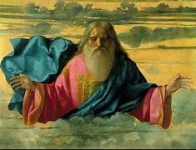

This stage of Metamorphosis is very hard because it is to die to the flesh, to the world and to sin, therefore, if you do not die to these Three Premises you will not be able to see, walk and hear, when you open your eyes, uncover your ears and can walk well, then the Metamorphosis will be almost over and the premise that two plus two equals seven will be fulfilled in you, and you will be ready to receive Supernatural Gifts such as Levitation, Flight at the Speed of Thought, Mind Reading, Infused Knowledge Divine, Mental Powers and Knowledge of the Mysterious Divine Designs and the Total and Perfect Union of his spirit with that of Jesus Christ through the Infusion of the Holy Spirit.

Resulting in a supernatural human being who is no longer an ordinary human being because he has broken the schemes and God instills in him His Breath of Life because through the Infusion of the Holy Spirit and the help of the Intercession of the Holy Trinity , he will be able to carry out his laudable End-Time Mission as a supernatural human being who has transformed from a caterpillar into a butterfly.

For this reason, it is necessary that all soldiers who meet these characteristics and have given their Fiat as Active Soldiers thoroughly study what Supernatural Dogmatic Theology is in the light of Faith, which are the foundations that the Father asks of his First Fruits to that in the light of the Holy Spirit they understand their missions and can get to know the unfathomable and incomprehensible mysteries to the human mind, which therefore are understandable to men with a supernatural mind and soul who are the First Fruits.

I bid farewell with the battle cry of my beloved faithful guide and Patron Saint Michael the Archangel Who is like God, no one is like God.

DISCOVERY OF GIFTS AND CHARISMS
It is important to start working with the Gifts and Charismas, all of you from your birth have gifts that we will call Conventional because they are the ones that according to your Genetic and Spiritual Heritage you possess from birth, these gifts are important that you know well and develop them, it can be dancing, singing, writing, what you are good at and so is your vocation if you are married, you live in celibacy or have a consecrated life.
It is important to discover the Conventional Gifts because many times from there, arise some other gifts that we will call Extraordinary and these are received when you have an intimate contact with My Father God, it could have been in an Evangelization Retreat, in an hour of Adoration, We will call these gifts of the Holy Spirit and Charisms, which are quite a lot, and later we will explain them more fully.

The purpose of this appendix is ​​for you to recognize them and, in order to develop them, we will give you this short review of what Gifts and Charisms are:

THE GIFTS OF THE HOLY SPIRIT ARE:
Wisdom: It is the gift of understanding what favors and what harms God's project. He strengthens our charity and prepares us for a Full Vision of God. Jesus himself told us: “But when they hand you over, do not worry about how or what you are going to say. What you have to speak will be communicated to you at that time. For it will not be you who will speak, but the Spirit of your Father who will speak in you” (Mt 10, 19-20).
True Wisdom brings the taste of God and His Word.

Understanding: It is the Divine Gift that enlightens us to accept the Truths revealed by God. Through this gift, the Holy Spirit allows us to scrutinize the depths of God, communicating to our hearts a particular Participation in Divine Knowledge, in the secrets of the world and in the intimacy of God Himself. The Lord said: “I will give you a heart to know me, for I am Yahweh” (Jer 24:7).

Advice: It is the gift of knowing how to discern paths and options, of knowing how to Guide and Listen. It is the light that the Spirit gives us to distinguish right and wrong, true and false. The Holy Spirit rested on Jesus, and gave him that gift in its fullness, as Isaiah had prophesied: “He will not judge by appearances, nor will he sentence by hearsay. He will judge the weak with Justice, and will sentence the poor of the earth with Justice” (Is 11, 3-4).

Science: It is the gift of Science from God and not the science of the world. Through this Gift, the Holy Spirit Reveals to us interiorly the thought of God about us, since "no one knows the Secret of God, except the Spirit of God" (1Co 2, 11).

Piety: It is the gift that the Holy Spirit gives us to always be open to the Will of God, always seeking to act as Jesus would act. If God lives his covenant with man in such an all-encompassing way, man, in turn, also feels invited to be merciful to everyone. In the First Letter of Saint Paul to the Corinthians he wrote: “As for Spiritual Gifts, I do not want you to be in ignorance, brothers. You know that when you were Gentiles, you allowed yourselves to be drawn blindly towards mute idols. That is why I let you know that no one, speaking with the Spirit of God, can say: "Anathema is Jesus!"; and no one can say: "Jesus is Lord!" but with the Holy Spirit” (1Co 12, 1-3).

Strength: This is the gift that makes us brave to face the difficulties of the day-to-day life of the Christian. Faith becomes strong and heroic. Let us remember the Courage of the Martyrs. It gives us perseverance and firmness in decisions. Those who have this gift are not intimidated in the face of threats and persecution, because they trust the Father unconditionally. The Apocalypse says: “Do not fear what you are going to suffer: the Devil is going to put some of you in prison so that you may be tempted, and you will suffer a tribulation of ten days. Remain faithful until death and I will give you the Crown of Life” (Rev 2,10).

Fear of God: This gift keeps us in due respect towards God and in submission to His Will, keeping us away from everything that may displease Him. For this reason, Jesus was always careful to do the Will of the Father in everything, as Isaiah had prophesied: “The Spirit of Yahveh will rest on Him: the spirit of wisdom and understanding, the spirit of counsel and strength, the spirit of knowledge and the fear of Yahveh.” (Isaiah 11,2).
To ask for the Gifts of the Holy Spirit in our First Fruits, first of all we will do the following, it is important to recognize that in order to receive the Gifts of the Holy Spirit we must put ourselves in the Presence of God and open our hearts to the infusion of the Holy Spirit in our soul and spirit and in our conscious, subconscious and unconscious therefore we must be free of all contamination whether visual, auditory or sensitive.

For this reason the Generational Curses must be broken and the traumas from the womb overcome, for this you were given the Prayer of Saint Raphael which we will attach to this appendix and will be prayed every day, apart from covering your Conscious, Subconscious and Unconscious with MY BLOOD, this is VERY IMPORTANT otherwise you will not be able to develop the gifts and charisms so you will follow the following instructions:

- Confession to free the Spirit and soul from sin
- Prayer of Saint Rafael to disrupt Generational Curses and overcome traumas from the womb.
- Cover the Conscious, Subconscious and Unconscious with My Blood as well as Liberate the body and soul with prayer number one in order to Discover and Develop the Gifts of the Holy Spirit and the Charisms.
- Development and Discovery of the specific and special gifts, therefore supernatural, of the First Fruits with Prayer number two.
PRAYER ONE
As the First Fruit of my Lord Jesus Christ and willing to Develop my Gifts and Charisms, I ask Jesus Christ to cover with His Blood my Conscious, Subconscious and Unconscious of all bad thoughts, suggestions, bad desires or attacks on my Physical, Spiritual and Mental Integrity that want to make a dent in my being so that the enemy does not interfere in my development of Gifts and Charisms for the Glory of God and Fulfillment of my Mission in these End Times, I cover myself with the Blood of Christ, I fill myself with the Holy Spirit and I protect myself in the Womb of my beloved Mother asking for the intercession of the Holy Trinity Amen.

We arrive to the conclusion that in order to develop the Gifts of the Holy Spirit we have to be Free in Mind, Body and Soul and from there Charisms and Gifts arise, that is why many people do not develop them and think they do not have them and that my Father God does not listen to them or does not choose them for Specific Missions, but the Gifts and Charisms are there, they just need to be developed, but in order to discover and develop them we need to know them, so we will give you a brief review of what Charisms are:

WHAT ARE CHARISMS?
But, in addition, some specific people receive Charisms. The Church, in the Catechism n. 799 tells us: “Extraordinary or simple and humble, charisms are Graces of the Holy Spirit, which directly or indirectly have an ecclesial utility; the Charisms are ordered to the edification of the Church, to the good of men and to the needs of the world”.
Therefore, Charisms are extraordinary Graces of the Holy Spirit that allow us to act in certain aspects or circumstances.
Charisms are not requirements for personal salvation, the one who has greater charisms is not holier, and they are not received through Baptism or any other Sacrament.

WHAT ARE CHARISMS FOR?
God grants them in an incomparable way within the Church, for the Merits of Christ, for the common good, and for the Renewal and Construction and usefulness of the Church. In each Charism the Spirit reveals his presence with a gift that is also a service.
The Holy Spirit grants them to whoever he wants, with which he is qualified and disposed to assume some specific works and functions.
In the N. 800 of the Catechism: “…they are a wonderful wealth of grace for the apostolic vitality and for the holiness of the entire Body of Christ. Charisms constitute such richness as long as they are gifts that truly come from the Holy Spirit and that are exercised fully in accordance with the authentic impulses of this same Spirit…”

HOW DO THEY ACT?
They are Graces that can be from transitory to more or less constant. The Holy Spirit gives them and takes them away according to His good pleasure. That is why each expression of charismatic appearance must be discerned if they come from God, or not.
The Charisms arise with new and different forms according to the needs of the Church.

WHAT ARE THE CHARISMS?
It is a useless effort to try to make a rigid scheme within which all the infinite dynamics of the Spirit would fit.
Neither in the Catechism of the Catholic Church nor in Lumen Gentium of the Second Vatican Council are there exhaustive lists of charisms.
Saint Paul listed a series of charisms in 1Co 12, 4-12:
“Certainly, there are varieties of gifts, but they all come from the same Spirit. There are diversity of ministries, but only one Lord. There is a diversity of activities, but it is the same God who does everything in everyone. In each one, the Spirit is manifested for the common good.
The Spirit gives one the wisdom to speak; to another, knowledge to teach, according to the same Spirit; to another, faith, also the same Spirit.

To This one is given the gift of healing, always in that one Spirit; to that one, the gift of performing miracles; to one, the gift of prophecy; to another, the gift of judging the value of the gifts of the Spirit; to this, the gift of tongues; to him, the gift of interpreting them.
But in all this, it is the same and unique Spirit who acts, distributing his gifts to each one in particular as He wants.

Just as the body has many members, and yet is one, and these members, though many, form but one body, so it is with Christ."
Taking into account that we cannot prepare a complete list of charisms, if orientation schemes have been made:
Those that refer to the instruction of the faithful: the charism of apostle, prophet, doctor, evangelist and exhorter, the word of wisdom, the word of knowledge, the discerning of spirits, the gift of tongues, the gift to interpret languages.
Those that have to do with the relief of the faithful: the charism of almsgiving, of hospitality, the gift of assistance, that of faith, the graces of healing, the power of miracles.

Those related to the Government of the community: the charism of pastor, that of the one who presides, the gifts of ministry, the gifts of government.
There are many more charisms, such as, for example, the charism of religious life, the charism of the infallibility of the Supreme Pontiff.
In any case, the Church prudently establishes that “For this reason, the discernment of charisms always seems necessary. No charism exempts from reference and submission to the pastors of the Church” (n.800 of the CIC).
To develop the specific and special gifts of the First Fruits, after having discovered and developed the Seven Gifts of the Holy Spirit and the Charisms, we will discover and develop the Supernatural Gifts of the First Fruits with this prayer, (it is important to follow all the previous steps for the months that remain before their Final Transformations, so we will carry out a questionnaire where they will summarize everything that has happened to them in these last months of preparation before their Final Transformations).

SECOND PRAYER
I, as the First Fruit of my Lord Jesus Christ, after having discovered my gifts and charisms, I ask for the intercession of the Most Holy Trinity and my Beloved Mother of Heaven to indicate me and help me to develop my Supernatural Gifts little by little and those that heaven allows me. develop and put them into practice before my Final Transformation and through the Blood of Christ, the Infusion of the Holy Spirit and the Powerful hand of my Father God, I ask you to help me develop these gifts for the good of myself and my brothers, after I have developed the Conventional and extraordinary gifts and charisms I ask to discover and develop the Supernatural, with the intervention of the most Holy Trinity and my Beloved Mother from Heaven. Amen.

After having discovered these three types of Conventional gifts and charisms, Extraordinary, Supernatural.
You will be ready for your final Transformations. BE WATCHFUL I AM COMING SOON MARANATHA!

Many of you have experienced changes in your Souls, Minds and Spirits.

It is as if little by little they began to awaken to the spiritual life, which I have called my First Fruits.

You are more sensitive and persuasive to spiritual things and many have received charisms, which is why this appendix is ​​about the Discovery of Gifts and Charisms starting with the Conventional and the Extraordinary.

The conventional ones, you have been developing them throughout your lives, such as writing, music, singing; and The Extraordinary ones, are those that the Holy Spirit has given you and will continue to give you according to your mission.

We will do the following questionnaire, which you will answer and mentally read before the Blessed Sacrament, so that God the Father will help you in this stage of your important transformations:

1. What Conventional Gifts have I had since I was a child, which have I been developing throughout my life?
2. What conventional gifts are the basis or foundation of my extraordinary gifts and how I have develop them, will they help me to grow more spiritually?
For example, the conventional gift of being a good writer can be linked to that of prophecy that is later developed based on the conventional gift of being good at writing.
1. What conventional gifts have I been developing more lately?
2. What conventional gifts do I have that will help me in my Mission?
3. What extraordinary gifts has the Holy Spirit instilled in me in my walk with Jesus Christ?
4. What extraordinary gifts do I have that I have not been able to develop?
5. What extraordinary gifts do I want to possess and believe will be effective for my mission? Mention them and ask the Holy Spirit with a Prayer that I will give you to say from now on every day so that you can increase your gifts, both Conventional and Extraordinary.
6. How will I cultivate my extraordinary gifts for my specific mission?

1. Do I already have a clear idea of ​​my specific mission in these end times?
Remember that the Holy Spirit will corroborate your specific mission very soon if not that it has already been done. I, Jesus Christ as your King and Savior, want you to begin to Grow Spiritually by the time of the Final Transformations, for this reason it is important that you answer this questionnaire and read it in front of the Blessed Sacrament and every day say this prayer:

PRAYER:
“I ask God the Father to help me discover, increase and develop my Gifts, both Conventional and Extraordinary, with the Power of the Most Holy Trinity, so that I can, through the anointing of the Holy Spirit, develop them little by little to prepare myself for my Final Transformation and my specific Mission in these End Times.
I ask God the Father to help me increase them with love and giving my best, I once again give my FIAT to the Most Holy Trinity and declare myself to be the Living Tabernacle of my Lord Jesus Christ. Amen.

You will say this Prayer in front of the Blessed Sacrament and give thanks to God the Father, God the Son, God the Holy Spirit for the gifts received this Lent, for those you will receive and for your specific mission in these end times.
MARANATHA!

RECOMMENDATIONS TO INCREASE EXTRAORDINARY CONVENTIONAL GIFTS
Gifts are like a little plant that needs water in order to grow.

It is a seed that it is there, but you do not notice it because they are small and to make them grow they need water, light and air, and we represent these three elements with the Holy Trinity, Father, Son and Holy Spirit.

I, as the Son, tell you that you need the Most Holy Trinity to increase these gifts. That is why it is important to pray to the Holy Trinity every day so that we fill them with our essence in your souls and spirits.

And to live in the Sixth Chamber is to let the Holy Trinity inhabit your hearts in every sense of the word, flooding your souls and spirits with our presence of ourselves for being an indissoluble unity, like the Holy Trinity.

Making it no longer be you, but the Holy Trinity, who lives completely within each one of you.

FOR THIS WE WILL GIVE YOU THE FOLLOWING RECOMMENDATIONS:
Recognize that you are children unworthy of the Father and that without Him you can do nothing.

By recognizing it, you will be free from all attachment to yourselves and to your own self, leaving self-centeredness and pride aside. You will then be able to leave your heart open to our powerful infusion into your hearts and souls, minds and spirits.

When you humble yourselves before God the Father, and do nothing, then you will leave the door of the heart open for us to enter. Without this step, which is the most important, you cannot reach the others. As we begin to live within you, you will feel different, you will feel great joy and peace, and more sensitive to spiritual things.
There you will feel that the little plant has received what it needs to start growing, water, light and air. Then you will begin to feel your gifts flow from your hearts little by little.

And to keep them growing and not let them die without food, you will turn to Prayer, Penance and Fasting, but not before having accepted the Divine Will of God the Father within you. Therefore, you must die to yourselves completely in order to increase your gifts.

After having Prayed, Fasted and done Penance, you will offer your whole life to God the Father every day, so that it is no longer you but Him and every decision you make it will be a decision of God and not yours. Afterwards, your gifts and charisms will continue to be nourished with Eucharistic Adoration, Mass and Communion. And having the mentioned elements will give the final transformations. Water, light and air, prayer, fasting and penance, Eucharistic Adoration, Mass and Communion.

With these elements you will be able to develop your gifts and charisms. The fertile land where the seed is sown is an Open and Sincere Heart and also represents the Mother of Heaven, remember to always turn to Her. The land where the seeds are sown is also Faith and Love in the Virgin Mary and letting Her be your guide because it is through her that you come to me.

That is why it is important to pray the Rosary so that She, with Her Maternal Love, leads you to the Holy Trinity.
Earth, water, light and air result in well sown seeds ready to grow with prayer, fasting, penance, Mass, Eucharistic Adoration and Communion and these will strengthen and transform them and when you least expect it, you will reach the sixth Chamber and no longer it will be you but the Holy Trinity who lives in you.

I will give you a short prayer so that you surrender to the Divine Will:

PRAYER:
I, as an unworthy son of the Father, surrender all that I am and all that I have to God the Father so that the Most Holy Trinity may take possession of my body, soul, and spirit.
I give my life to you so that from today it is no longer me, but God (Holy Trinity) who lives in me to increase my gifts and charisms for the service of my brothers in these end times. I give all of myself because I no longer live but it is God (Holy Trinity) who lives in me. Amen.

You will say this prayer and follow the directions mentioned and before you know it you will be Living Tabernacles. Stay tuned for I'm coming soon.
Maranatha.

