MESSAGE FROM THE HOLY SPIRIT TO LORENA

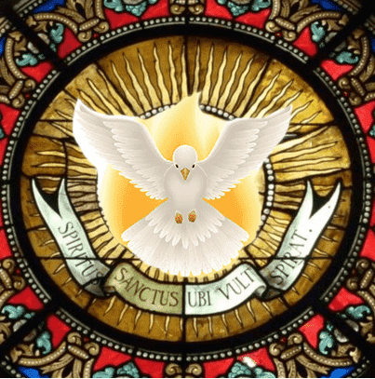

NOVEMBER 20, 2024
SPECIAL ANOINTING OF THE HOLY SPIRIT
I, THE HOLY SPIRIT OF GOODNESS AND KINDNESS, WILL NEVER LEAVE YOU ALONE IN THE MIDST OF STORM AND TRIALS.
I will manifest to each of you in Dreams, Visions, Speeches and within your minds and hearts, giving you guidance as to how to direct your lives.
I will be attentive to ALL YOUR NEEDS, for I as the Paraclete and Guide of the Faithful Remnant, have been sent to all of you in this End Time.
A terrible storm will come, but also a Revival of My Spirit LIKE NEVER BEFORE IN THE HISTORY OF HUMANITY, My Light will spread throughout the Orb and My Wisdom will take the Minds and Consciences of the Human Beings who accept God in their hearts, To give them a supernatural Strength that overcomes any adversity and enables them to Fight and be Strong in this walk through the desert to the Promised Land.
AND JUST AS I WILL NOT LEAVE YOU, NEITHER WILL THE MOTHER OF HEAVEN LEAVE YOU, SHE IS YOUR LIGHT AND GUIDE, THE LIGHTHOUSE THAT ILLUMINATES EACH OF HER CHILDREN IN THE DENSE SEA.
THROUGH HER LOVING AND WARM PROTECTION AS THE BELOVED MOTHER OF ALL HUMANITY, SHE WILL PRESENT HERSELF UNDER DIFFERENT INVOCATIONS TO EACH ONE OF YOU, EITHER IN DREAMS, VISIONS, LOCUTIONS OR APPARITIONS TO LET YOU KNOW THE PATH TO FOLLOW.
There will be many supernatural events, which will dazzle the World and many will be possessed by My Power, to be Guides for their other brothers, I will anoint many people with My Power and they will be endowed with Gifts and Charismas with the purpose of serving their other brothers and to Guide them to the Promised Land.
I WILL GIVE THIS ASSIGNMENT TO A CERTAIN GROUP OF PEOPLE, WHO WILL BE UNDER MY PROTECTION. I WILL GIVE THIS SPECIAL ANOINTING IN THE WARNING TO THOSE WHO COMPLY WITH THE DIVINE PRECEPTS AND ARE A TESTIMONY OF GOD.

I THE HOLY SPIRIT OF GOOD AND TRUTH.

