MESSAGE OF THE VIRGIN OF GUADALUPE GIVEN TO LORENA
NOVEMBER 9, 2024
I THE VIRGIN OF GUADALUPE GIVE MY SEAL OF PREDILECTION TO MY SON DONALD TRUMP
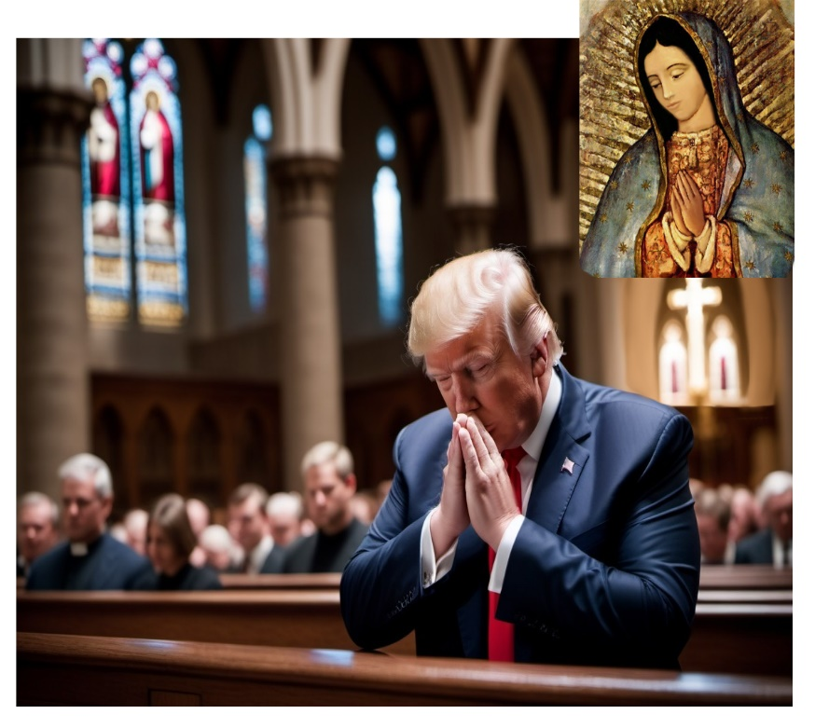
I, AS MOTHER OF ALL HUMANITY, want to give this Message to all My Beloved children that I have called into My Womb of Beloved Mother to be Clothed in My Love to be Given Birth as New Humanity.
Today I hold in My Arms My Favorite Sons, Rulers and Leaders, to tell them that I, as their Mother, want to take care of each and every one of them under My Protective Mantle in their respective positions and to tell them that there are leaders that I hold by My Hand and have decided to follow Me and ARE UNDER MY PROTECTION,
AS MY BELOVED SON DONALD TRUMP WHO HAS BEEN CONSECRATED TO MY MOTHERLY PROTECTION AND WHOM I BLESS AS PRESIDENT OF THE UNITED STATES TO BE THE GUIDE OF MY PEOPLE.
He, whom I have taken with My Maternal Protection to this Presidential Post to govern his People with RIGHTEOUSNESS AND TRUTH AND UNDER THE CHRISTIAN VALUES that are so lacking in this World.
I ASK TODAY, AS HIS BELOVED MOTHER, TO PRAY FOR HIS PRESIDENTIAL OFFICE, SO THAT WITH THE PRAYERS OF ALL HIS COUNTRYMEN AND PEOPLE ALL OVER THE WORLD PRAY FOR HIM, THAT HE MAY BE SUSTAINED IN HIS OFFICE AND BE A LIGHT FOR THIS NATION.
I GIVE HIM TODAY, MY MANTLE OF PROTECTION AND SEAL OF PREDILECTION AS MY BELOVED SON DESTINED TO RULE THIS NATION WITH JUSTICE AND TO BE THE LIGHT OF THE WORLD.
I ASK PRAYER FOR HIM AND FOR ALL THE LEADERS OF THE WORLD who have given me their hearts and who are willing to fulfill God's Will in their lives and in their Nations.
I WELCOME MY BELOVED SON DONALD TRUMP AS THE LEADER OF THIS NATION AND I ASK PRAYER AND FASTING FOR HIM, THAT WITH DIVINE WISDOM HE MAY KNOW HOW TO LEAD THE NATION, I CALL YOU ALL TO PEACE AND CONVERSION AND I GIVE YOU MY BLESSING.
I your Beloved Mother,
THE VIRGIN MARY OF GUADALUPE

