MESSAGE FROM GOD THE FATHER TO LORENA
April 17, 2024

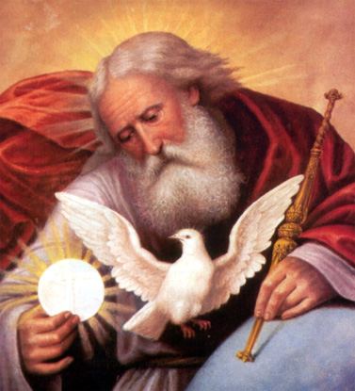

DEVOTION TO THE MOST LOVING HEART OF GOD THE FATHER.

Today My little daughter I want to show you how INFINITE and GREAT My Love is and how I want to take all My Beloved Children that I choose today as soldiers of My Victorious Army to My Immense and Great Heart of Beloved Father.

Today I call all of you to come to My GREAT and SPACIOUS HEART so that there within it you may be placed safe from all dangers and attacks of the enemy, come My Children, My Heart calls each one of you.
BEFORE MY JUST WRATH FALLS WITH FULL RIGOR UPON THE EARTH I WANT TO SHELTER YOU UNDER MY MERCY AND MY SPACIOUS HEART, because before My Just Punishment comes upon the World I WILL SEND MY LAST WORK OF MERCY TO HUMANITY and there I will call those who have not yet come to me to My Great and Spacious Heart of Loving Father.
But My most Loving Father's Heart calls you today, to take refuge in it through a humble heart, where with simplicity and love for Me you can take shelter in My Heart.
Come to Me, My Little Faithful Remnant, and nothing and no one can come against you, BECAUSE MY PROTECTION AS A FATHER IS THE GREATEST THAT EXISTS AND IS WHAT I WANT TO GIVE YOU TODAY AS THE LAST DEVOTION IN THESE LAST TIMES.
The "Devotion to the Most Loving Heart of God the Father", by means of this Devotion you will come to My Father's Heart.

SAY IT WITH ALL DEVOTION AND DEDICATION BECAUSE I, THE ALPHA AND THE OMEGA, WANT TO MAKE THIS MOST IMPORTANT DEVOTION KNOWN THROUGH ME.
Even to the hardest and most stubborn hearts I will wait until the last day, the day of the Illumination of Consciences.

THEREFORE, YOU MUST SPREAD THIS DEVOTION TO MY GREAT AND SPACIOUS HEART OF A MOST LOVING FATHER.

Therefore I will call you to the Devotion to My Most Loving Father's Heart and I will give you this Prayer so that through it, ALL MAY COME TO MY SPACIOUS AND LOVING HEART.
I will give you the Prayer, but before praying it in front of the Blessed Sacrament I will ask you:

• FOR A SINCERE AND HUMBLE CONFESSION OF LIFE,
• A CONTRITE HEART,
• AND THEN YOU WILL OFFER YOURSELVES TO ME THROUGH THIS PRAYER:

PRAYER: Today I …….. Your son, before Your Loving Presence, want to take Refuge in these Last Times in Your Spacious Heart of Loving Father, so that under Your Protection and within Your Most Loving Heart, I may be protected from all attacks of the enemy and under the Protection of my Loving Father, I may carry out my specific Mission in this End Times.

AFTER SAYING THIS PRAYER IN FRONT OF THE BLESSED SACRAMENT:
• You will pray a Mystery of the Rosary
• and Seal a Pact of Love with Me and thus you will be protected from all evil.

And I as your Father, will protect you through My Heart and I will send you before the Warning The Luminous Cross in Heaven, to give you through its Rays the necessary Graces to face the ILLUMINATION OF CONSCIENCES.
THIS PRAYER WILL BE SAID THESE SEVEN DAYS BEFORE THE ILLUMINATION OF CONSCIENCES ON YOUR KNEES AND ASKING FOR MY LOVING PROTECTION.
So that when the day of the Illumination of Consciences arrives, you will be prepared and within My Most Loving Heart, and can face My Harsh Particular Judgment, having within your hearts the CERTAINTY of My Love and Mercy towards every repentant sinner.

Prepare to enter into My Most Loving Heart of a Father, which is the Last Devotion that I give to Mankind before My Righteous Wrath falls on the entire Earth and that will keep you safe and protected from all danger.

Finally:
- You will say Psalm 91
- and will say goodbye praying the Trisagion to the Most Holy Trinity, so that under its protection, you will be shielded from the adversary's evil.
I, your beloved Father, the Alpha and the Omega, call you to My Most Loving, Great and Merciful Heart, I love you and protect you from all evil.
I, Yahweh of Hosts.

---------------- 0 ----------------

Explanation: God the Father calls us to enter into His Most Loving Heart by means of Devotion to His Heart of Loving Father, Consecrating ourselves to Him, by means of a Prayer that has been given to us in the message, and that we will have to make in front of the Most Holy Sacrament, before the Cross appears in heaven, as soon as possible, but first we must make a Confession of Life with a Contrite and humble heart, after this we will go to the most Holy Sacrament and kneeling in front of our Lord we will pray:
- The Prayer dictated in the Message
- A Mystery of the Rosary
- Psalm 91
- Trisagion to the Holy Trinity
Thus, we will remain Consecrated to this important End-Time Devotion, then when the Cross appears in Heaven we will pray the prayer given in the message for 7 days on our knees and with a Contrite and Humiliated heart for our sins and so that God the Father may forgive us, enlighten us and give us His Protection on the day of the Illumination of Consciences.

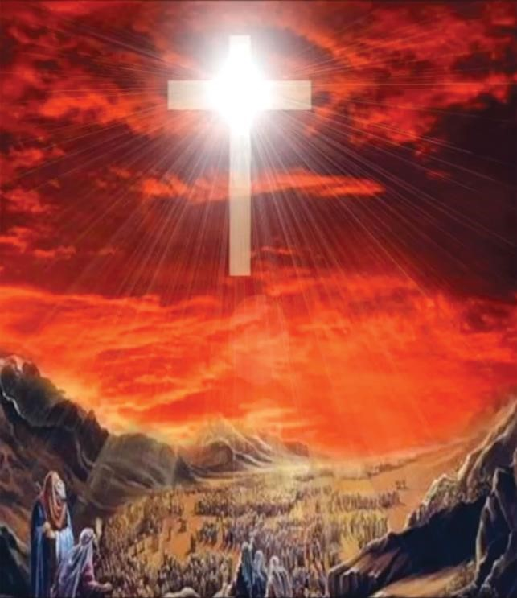
Psalm 91
Whoever dwells in the shelter of the Most High will rest in the shadow of the Almighty.
I will say of the LORD, He is my refuge and my fortress, my God, in whom I trust.
Surely he will save you from the fowler’s snare and from the deadly pestilence.
He will cover you with his feathers, and under his wings you will find refuge; his faithfulness will be your shield and rampart.
You will not fear the terror of night, nor the arrow that flies by day, nor the pestilence that stalks in the darkness, nor the plague that destroys at midday.
A thousand may fall at your side, ten thousand at your right hand, but it will not come near you. You will only observe with your eyes and see the punishment of the wicked, If you say, The Lord is my refuge, and you make the Most High your dwelling, no harm will overtake you, no disaster will come near your tent.
For he will command his angels concerning you to guard you in all your ways; they will lift you up in their hands, so that you will not strike your foot against a stone.
You will tread on the lion and the cobra; you will trample the great lion and the serpent. Because he loves me, says the LORD, I will rescue him; I will protect him, for he acknowledges my name.
He will call on me, and I will answer him; I will be with him in trouble, I will deliver him and honor him.
With long life I will satisfy him and show him my salvation.

THE ANGELIC TRISAGION
This devotion to the Blessed Trinity is the official prayer of the Order of the Blessed Trinity, otherwise known as the Trinitarians. The devotion has been recited by them and their affiliates for centuries in praise of the Trinity.
In the name of the Father, and of the Son, and of the Holy Spirit. Amen.
V. O Lord, open my lips.
R. And my mouth will proclaim your praise.
V. O God, come to my assistance.
R. O Lord, make haste to help me.
V. Glory be to the Father, and to the Son, and to the Holy Spirit,
R. As it was in the beginning, is now and ever shall be world without end. Amen.

- HOLY GOD, HOLY STRONG ONE, HOLY INMORTAL ONE – HAVE MERCY ON US. (3 times)

In the first part of the Angelic Trisagion we pray and thank God the Father, who in His Wisdom and Goodness has created the Universe and in the Mystery of His Love has given us His Son and Holy Spirit. To Him, the source of Love and Mercy we say:
- HOLY GOD, HOLY STRONG ONE, HOLY INMORTAL ONE – HAVE MERCY ON US.
PRAYER TO THE FATHER.
Blessed be You Father most Loving, because in Your Infinite Wisdom and Goodness, You have created the Universe and with special Love, You lowered Yourself to man, elevating him to participation in Your very life. Thank you, Good Father, For giving us Jesús, Your Son, our Savior, Friend, Brother and Redeemer, and for the Gift of Your Consoling Spirit. Grant us Your Presence and Your Mercy, so that our whole life, may be for You, the Father of Life, the beginning without end, the highest good, and Eternal Light, that we might offer to You a Hymn of Glory, Praise, Love and Thanksgiving. Amen

*One Our Father….
V. TO YOU BE PRAISE, GLORY, AND THANKSGIVING, FOREVER BLESSED TRINITY!
(Repeat this 9 times)
R. HOLY, HOLY, HOLY LORD, GOD OF POWER AND MIGHT. HEAVEN AND EARTH ARE FULL OF YOUR GLORY.
V. GLORY BE TO THE FATHER, AND TO THE SON, AND TO THE HOLY SPIRIT,
R. AS IT WAS IN THE BEGINNING, IS NOW AND EVER SHALL BE WORLD WITHOUT END. AMEN. (Bow head or kneel)

In the second part of our prayer, we direct ourselves to the Son, who to fulfill the Will of the Father and Redeem the World, was made our Brother, and in the Supreme Gift of the Eucharist remains always with us. To Him, the source of New Life and Peace, with a heart full of hope, we say:
- HOLY GOD, HOLY STRONG ONE, HOLY INMORTAL ONE – HAVE MERCY ON US.
PRAYER TO THE SON
Lord Jesús, Eternal Word of the Father, give us a clean heart to contemplate the Mistery of Your Incarnation and Your Gift of Love in the Eucharist. Grant that faithful to our Baptism, we live our Faith with persevering consistency, enkindle in us the Love which makes us one with You and our brothers; fill us with the Light of Your Graces, give us the Fullness of Your life offered up for us. To You our Redeemer, to the Father, rich on Goodness and Mercy, to the Holy Spirit, Gift of Infinite Love; Praise, Honor and Glory for Eternal Ages. Amen

*One Our Father….
V. TO YOU BE PRAISE, GLORY, AND THANKSGIVING, FOREVER BLESSED TRINITY!
(Repeat this 9 times)
R. HOLY, HOLY, HOLY LORD, GOD OF POWER AND MIGHT. HEAVEN AND EARTH ARE FULL OF YOUR GLORY.
V. GLORY BE TO THE FATHER, AND TO THE SON, AND TO THE HOLY SPIRIT,
R. AS IT WAS IN THE BEGINNING, IS NOW AND EVER SHALL BE WORLD WITHOUT END. AMEN. (Bow head or kneel)

In the third part of the Trisagion, we give ourselves up to the Holy Spirit, the Divine Breath which enlivens and renews, the inexhaustible spring of communion and of peace, which fills the Church and lives in every heart. To Him, the Seal of Infinite Love, we say:
- HOLY GOD, HOLY STRONG ONE, HOLY INMORTAL ONE – HAVE MERCY ON US.
PRAYER TO THE HOLY SPIRIT
Spirit of Love, Gift of the Father and of the Son, come to us and Renew our life. Make us Obedient, to Your Divine Breath, ready to follow Your suggestions in the way of the Gospel and of Love, Sweetest Guest of our hearts, clothe us with the splendor of Your Light, instill in us Confidence and Hope, transform us into Jesus, so that, living with Him and in Him, we can always and everywhere be fervent witnesses of the Holy Trinity. Amen

*One Our Father….
V. TO YOU BE PRAISE, GLORY, AND THANKSGIVING, FOREVER BLESSED TRINITY!
(Repeat this 9 times)
R. HOLY, HOLY, HOLY LORD, GOD OF POWER AND MIGHT. HEAVEN AND EARTH ARE FULL OF YOUR GLORY.
V. GLORY BE TO THE FATHER, AND TO THE SON, AND TO THE HOLY SPIRIT,
R. AS IT WAS IN THE BEGINNING, IS NOW AND EVER SHALL BE WORLD WITHOUT END. AMEN. (Bow head or kneel)

ANTIPHON: Blessed be the Holy Trinity, who Creates and Governs the Universe, Blessed now and always.
V. Glory to You, Holy Trinity
R. You give us Mercy and Redemption.

LET US PRAY: Father, You sent Your Word to bring us Truth, and Your Spirit to make us Holy. Through Them, we come to know the Mystery of Your Life. Help us to worship You, One God in Three Persons by proclaiming and living our Faith in You. Grant this through Christ our Lord. Amen
I BELIEVE IN YOU, I HOPE IN YOU, I LOVE YOU, I ADORE YOU, O BLESSED TRINITY.

You are our Hope, our Glory and our Salvation, O Holy Trinity, Amen

