Message of the Virgin Mary of Guadalupe
to Lorena
6 June 2024

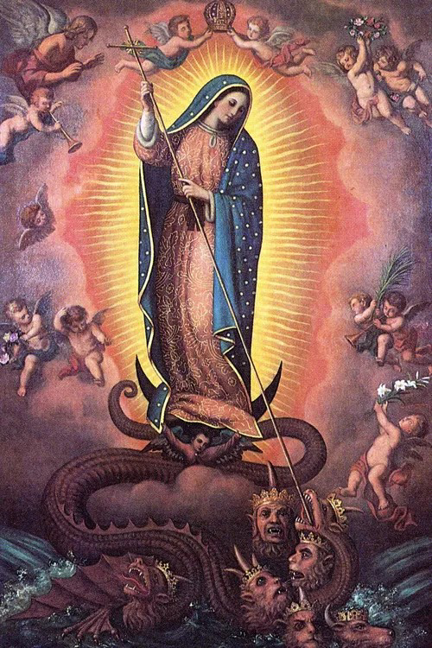

The Woman Dressed in the Sun and the red dragon

My dear children, my heart weeps with sadness to see that the country of Mexico has fallen into the hands of communism.

Oh my children, how much desolation and sadness await you for not turning your eyes to God and putting your trust in man, you have fallen into the hands of Satan who little by little will crush you with pain leading you to despair, but what have you done my children?

If you had trusted in God and bent your knees, communism would not have been able to take over the country, by the force of Prayer.

But I, as your Loving Mother, bring you ONE SOLUTION: Communism can be defeated by Heaven if you put your trust in God and bend your knees. Dress yourselves in sackcloth, people of Mexico and pray a ROSARY for the liberation of Mexico from communism every day at 3 o'clock in the afternoon with this intention, my children. These battles are spiritual and are not fought with wars or demonstrations, they are fought with the strength of Prayer and fasting; therefore FAST on Wednesdays for this intention. PRAY UNCESSED until David has defeated Goliath.

I, the Woman Dressed in the Sun, will fight for Mexico against the red dragon with all my strength and together we will crush Satan's head with the prayer of the Rosary, which is the weapon par excellence. And I, with the prayer of the Rosary will be able to protect you from all danger; if you unite as one with this intention every day at 3 o'clock in the afternoon we will defeat communism.

Courage, people of Mexico, God allows these things for the good of those who love Him; therefore, bend your knees, dress yourselves in sackcloth, pray much and fast. And I will deliver you from communism, I will fight against the red dragon and I will triumph. So Mexico, prepare yourself spiritually so that your liberation will NOT BE LATE.

My people, I live here in my Mexico and I am pained by what this country is going through. Let us fight together for the liberation of communism, and I, together with my faithful army, will defeat communism. Courage my people.

The Virgin Mary of Guadalupe loves you.

NOTE:
+ ROSARY every day at 3:00 pm.
+ FASTING on Wednesdays.

