MESSAGE FROM SAINT MICHAEL THE ARCHANGEL TO LORENA
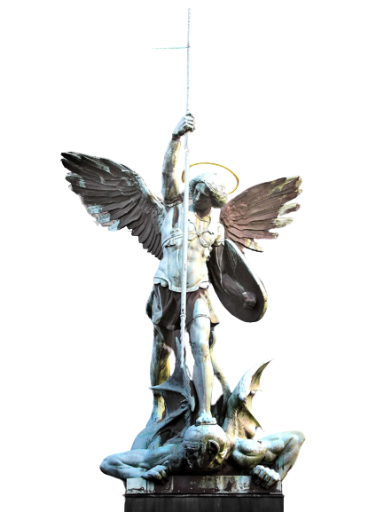
OCTOBER 9, 2023
IMPORTANT MESSAGE FOR THIS OCTOBER 31ST
As Prince of the Heavenly Militia and Leader of my Militant Army, I come to WARN GOD'S PEOPLE OF EVENTS TO HAPPEN IN OCTOBER, especially on October 31st Halloween Day which is celebrated by the Satanic Lodges all over the World, but this 31st of October will be different from all others, because of the beginning of the Strong Pains within the Creation and the whole Universe. These Lodges prepare the appearance of the Antichrist on a Global Level through Satanic Rites but this Halloween will be more special for the witches and satanists because they will open three-dimensional gates to let the Demons of high hierarchies to enter into the Earth.
These High-Ranking Demons, Will Come to Cause Chaos in Humanity, but More Than Anything to Destabilize My Army, Because They Will Attack You Very Strongly So That You Are Weakened and Fall Into Grave Sins, Therefore You Must Protect Yourselves With the Chaplet of St Michael the Archangel - Angelic Crown Especially for This Day of Halloween.
In order for Me to protect you from these perverse Entities that will come with everything to fight to destabilize you and lead you to the CAPITAL SINS, this day the Forces of evil will be counteracted with PRAYER, PENANCE AND FASTING, THEREFORE YOU MUST CONFESS BEFORE OCTOBER 31st, so that you will be in a State of Grace to face the hosts of evil, who will come with their entourage of demons to attack you strongly in your Minds and Spirits.
It is of Utmost Importance to Cover Yourself With the Blood of Jesus Christ and Take Refuge in His Holy Wounds by Means of Invocations to the Blood of Jesus Christ, You Will Be Protected This October 31st and All the Other Months to Come, Since These Demons Will Be Active From October 31st Onwards Trying to Pervert Humanity and Sow Chaos.
Civil Wars Will Come in Several Countries, Especially in Europe, Because of the Lack of Faith and the Forgetfulness of God, Since They Have Turned Churches and Holy Places Into Sewers of Filth, Like Dens and Museums.
The Catholic Faith is Almost Dead in European Countries and the People Live in Debauchery and Sin, That is Why It is Important That in Latin American Countries That Usually Give Light to the World, They Should Stick More to the Catholic Doctrine and Not Discontinue It.
For That Reason It is of Utmost Importance to Fight With the Rosary in Hand for a World That Learns to Live in the Divine Will So That the New Heavens and New Earths Can Be Given.
Please DO NOT be fooled by governments or by the World Health Organization in activities that go against the integrity of the human being such as vaccines.
Do not believe everything that is sold to you by the media and delve deeper into the Holy Scriptures, there you will find the whole truth and ALL that is said will be fulfilled to the letter.
Therefore I Ask You to Be Attentive to the Signs of the Times, the Rain Has Already Begun to Fall Heavily, Becoming a Storm.
It is time to take Refuge in the Arms of the Father, the Wounds of the Son and the Blood of the Son and to be Guided by the Inspirations of the Holy Spirit.
Faithful Remnant, We Await You at the Wedding of the Lamb Your Names Are Inscribed and We Hope That All of You Will Arrive at the Wedding of the Lamb, to Enjoy Eternal Life and to Be Pioneers of the New Humanity, We Are Waiting for You !!!
I SAINT MICHAEL THE ARCHANGEL,
WHO IS LIKE GOD, NO ONE IS LIKE GOD!!!

