URGENT MESSAGE FROM SAINT MICHAEL THE ARCHANGEL TO LORENA
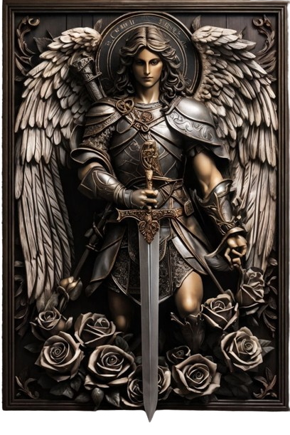
AUGUST 26, 2024
LISTEN TO MY INSTRUCTIONS, SINCE IT IS TIME TO GO UP TO THE ARK, THE STORM HAS RAGING AND THE WEATHER IS BAD.
It is time to pack your bags and get on the Ark of Salvation, Oil your Lamps and put EVERYTHING IN ORDER TO LEAVE, you have been given different recommendations through different Seers, BUT THIS INSTRUCTION THAT GOD THE FATHER INVITES ME TO GIVE IS VERY IMPORTANT AND URGENT.
The Angels have drawn their sword so you must remain awake because it is time to leave and the Last Sealings will take place before the storm begins completely.
THEREFORE MY URGENT INSTRUCTIONS TO ALL OF YOU: The Lord is coming for His People and you need to have the Seal of Predilection that represents you as part of His Faithful Flock.
For this you will do the following next Thursday after Gethsemane at 3:00 AM in the morning and after having prayed this Devotion, you will join in Groups and implore the Father FOR PIETY AND CLEMENCE TOWARDS THE WORLD so that God may reduce His Just Wrath.
For this reason, you will be Sealed by an Angel, who with his Sword of Fire will place a mark on your foreheads as children belonging to the Remnant Church of Christ.
For this, you must already be living in the Desert, far from the false Church and practicing the True Catholic Doctrine, with a life of example before your brothers, Living the Commandments and following the Precepts of God the Father.
FIRST YOU WILL ASK FOR ALL MANKIND: So that God may have MERCY ON EVERY SOUL FAR AWAY FROM HIM, as representatives of Jesus Christ on Earth.
THEN AT 3 A.M. WITH:
- 1 Lit Candle,
- 1 Crucifix
- 1 Image of the Holy Family and One of Mine.
- 1 Image of Saint Michael.

You Will Make a Prayer Asking for Intercession for the Whole World Bowed Down in Front of the Altar You Will Put Roses to the Virgin and Pray Like This:
PRAYER: I, as a son of God the Father, belonging to His Faithful Remnant, ask before the Holy Trinity to give the World the necessary Strength to face the Tribulation with the help of the Holy Spirit, so that it illuminates the Path of EVERY HUMAN BEING. repentant and ready for a CHANGE OF LIFE. I place ALL HUMANITY under the Most Precious Blood of Jesus Christ so that it may be Protected and under the Mantle of the Virgin Mary of Guadalupe I place each Continent of the World, so that under Her Protection of Loving Mother THE ENTIRE ORB may be under special Protection and Tribulation be lessened by the Prayers of the People of Israel. Amen
AFTER THIS PRAYER YOU WILL PREPARE TO RECEIVE THE SEAL FROM THE ANGEL, who will instill in your hearts the FLAME OF THE LOVE OF GOD, so that FOUND WITH THE HEART OF THE HOLY TRINITY YOU MAY BE WORTHY CHILDREN OF YAHWEH, worthy to go with Him, when He comes for His Church and you will ask to be Sealed for this Purpose in this way:
PRAYER: I, as a child of God belonging to the Holy People of Israel, I ask for the Seal through the Angel of God, so that through this Seal of Predilection I may be RECOGNIZED AS PART OF THE REMNANT CHURCH OF JESUS ​​CHRIST, and BE RAPTURED ON THE DAY GOD COMES FOR HIS CHURCH, I ask the Angels and Angelic Choirs to protect me from ALL ATTACKS OF THE ADVERSARY and as a prudent virgin, I oil my lamp with the Word of God, my life of Conversion and Love of God through the FULFILLMENT OF HIS LAW. I give my FIAT before the Holy Trinity and with the Seal of Fire on my forehead I am protected and as belonging to the Faithful Remnant Church of my Lord Jesus Christ, I DECLARE THAT I WILL BE RAPTURED WHEN RECEIVING THIS SEAL OF PREDILECTION, so that through this, THE ANGEL WHO WILL COME TO SEAL US, SEAL US AS FAVORITE CHILDREN OF ISRAEL, AS THE FAITHFUL PEOPLE OF YAHWEH, Amen.
The roses placed on the Altar will be Blessed and they will be able to multiply, serving as Spiritual and Corporal food, since they will heal both physically and spiritually and will serve as food.
Ask to be SEALED as a Remnant Church and ask to be RAPTURED by Jesus Christ.
I, Saint Michael the Archangel,
Prince of the Celestial Militia and Leader of my Militant Army.

WHO IS LIKE GOD, NO ONE IS LIKE GOD!!!

