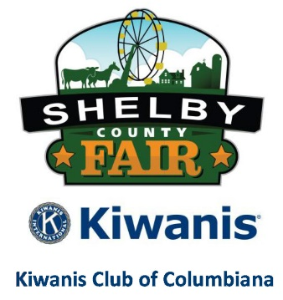
70th Annual Shelby County Fair
Booth Registration
November 4-9, 2019

Forms should be received by Saturday, October 26, 2019
Mail to: Shelby County Fair, Attn: Booths, PO Box 338, Columbiana, AL 35051

Date Received Invoice #

Organization/Business Person in Charge
Mailing Address
Phone Fax
Email
It is the responsibility of all Exhibitors, including those with booths, to read and comply with the General Rules and Special Rules included in the Fair Catalog and on our website (www.alshelbycountyfair.com). Furthermore, the Person in Charge is responsible for informing Booth Staffers of procedures to gain admittance to the Exhibition Center for rules and procedures). Fair Management and Volunteers are not responsible for any misinformation. Printed Rules, Policies and Procedures will take precedence. By signing below, I acknowledge that I have read, understand, and have complied with all rules of the Shelby County Fair.
Signed:

2019 Theme: “HATS OFF TO 70 YEARS
IT’S A FAMNILY TRADITION”

Adult Classes (Circle Class) Division 1801 Youth Classes (Circle Class) Division 2801
01 Agricultural (Governmental Agencies) 01 4-H Clubs (Includes Jr. Master Gardeners)
02 Agricultural (Non- Governmental Agencies) 02 Church Youth Groups
03 Armed Forces 03 Elementary Schools
04 Civic & Public Service 04 FCCLA Chapters
05 Commercial ($100/Booth) ^{1, 2} 05 FFA Chapters
06 Government Agencies (Non-Agricultural) 06 High Schools
07 Homemakers Clubs (Shelby County) 07 JROTC
08 Religious Groups 08 Key Clubs
09 Senior Citizen Centers 09 Middle Schools
10 Veteran’s/Patriotic 10 Other School Clubs
11 Farmer’s Market* 11 Career Technology Education Center (CTEC)
12 Political Candidates/Organizations – ($100/Booth) 12 Scout Troops (Boy, Cub or Girl Scouts)
13 Family & Youth Services 13 School Libraries

¹ Check payable to Shelby County Fair Must Be Attached to Registration Form to reserve a booth.
² Any Booth promoting a product or service for sale is a Commercial Booth.

Please mark the appropriate box to indicate whether your booth will be staffed during the Fair.

□ Booth will NOT be Staffed and we do NOT need Passes
□ Booth WILL be Staffed and we WILL need Passes
Electrical Outlet Needed (Yes/No) #of Booths (Commercial Only)

