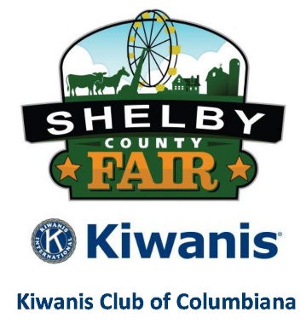

2019 Youth Fun Horse Show
Saturday, November 9, 2019
3:00 pm
www.alshelbycountyfair.com
Fun Horse Show General Rules

- All Shelby County Fair General Rules apply. Please download from our website.
- Exhibitors must be 18 years of age or younger as of Fair Opening Day.
- By entering any class, you are releasing the Kiwanis Club of Columbiana its officers, members, and Board of Directors from any liability of injury or damage to your persons, animals, or property. Under Alabama law, an equine activity sponsor or equine professional is not liable for an injury to or the death of a participant in equine activities resulting from the inherent risks of equine activities, pursuant to the Equine Activities Liability Protection Act.
- There will be no premiums. Ribbons will be presented to all entries in each Class.
- Exhibitors and all family members will purchase a General Admission ticket. Advance tickets may be purchased on our website.
- There will be no entry fees per class.
- Exhibitors are encouraged to register in advance on our website. Online entries must be completed prior to 11:59 pm Thursday, November 7.
- Late entries will be accepted at the show.
- Helmets are HIGHLY ENCOURAGED when mounted.
- A Negative Coggins will be required and will be checked prior to unloading.
- Egg and Spoon
  - Materials: One large spoon (approximately tablespoon size) and either a real egg or an egg substitute (such as a similarly sized rock) for each rider.
  - How to play: Riders place their egg on their spoon, holding the spoon by the handle. The instructor acts as ringmaster, calling out the gaits, as riders circle the arena. When a rider loses her egg, she’s out. The last rider with an egg still on her spoon wins.
- Ride a Buck
  - How to play: Riders place the dollar under their bottom so that half is visible. Different gaits are called. The last person with the dollar wins all the money.
- Boot Find
  - Everyone playing takes off one of their boots and puts them in a pile at the end of the arena.
  - The boots are mixed around.
  - The race begins as one person rides their horse to the boot pile.
  - They get off, find their boot, put in on, mount up and ride back.
  - Best time wins.
  - This can also be done as a team event/relay.
- Costume Class
  - Horse and rider should be in costume.
  - You can ride or lead the horse.
  - Be creative.
  - We will have both group and individual participation.
  - If you do not have a horse that is fine you can participate with a group.

- Stick Horse Race Class
  - Ride your stick horse (mop will be fine if you don’t own one).
  - Race from one end of the arena to the other.
- Ribbon Race
  - Two riders hold a three-foot ribbon as they race around a barrel or pole set at the far end of the arena.
  - Losing or breaking the ribbon results in disqualification.
- Flag Race
  - The course (see fi g.) is set up in the same manner as for the Cloverleaf Barrel Race. Two 5-gallon buckets filled with approximately 4 inches of sand should be placed on the centers of the 1st and 3rd barrels.
  - The length of the flag sticks should be 12 inches to 16 inches above the edge of the bucket. Wooden doweling 3/4 inch in diameter, or other round suitable material, should be used for the flag.
  - The rider will pick up a flag at 1, ride behind 2 and place the flag in the bucket at barrel 3. Riders have the option of riding course A or B:
    - Course A – The entry will cross the starting line and begin following the pattern to the left.
    - Course B – The entry will cross the starting line and begin following the pattern to the right.
    - Disqualifications - Causes of disqualification include:
      - Failing to pick up the flag on the first pass.
      - Failing to place the flag in the bucket on the first pass.
      - Hitting any part of the horse with the flag or stick.
      - Dropping the flag.
      - Knocking over any of the barrels or knocking the bucket off, or over, on the barrel.
      - Dropping the flag into the bucket with the flag end down.
Class List
- Stick Horse (bring your own or a mop) 8 years old & under
- Stick Horse (bring your own or a mop) ages 9-18
- Pony Walk Trot/Favorite Gait
- Horse Walk Trot/Favorite Gait
- Open Pleasure – walk, trot/favorite gait, lope/canter
- Egg and Spoon
- Ribbon Race – (two-person team for this event)
- Flag Race
- Boot Find
- Ride a buck (Bring your own dollar bill. Winner gets it all.)
- Costume Class – Individual
- Costume Class - Group

