Mississippi Bass Nation 2026

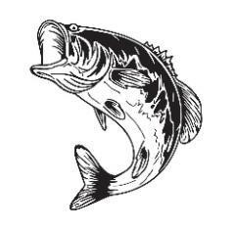
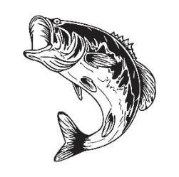
3 Qualifiers / 1 Championship

April 11, 2026 – Pascagoula River @Little River Marina
May 23, 2026 ---Ross Barnett @Tommy’s
June 27, 2026 –-Tennessee-Tombigbee Waterway @ Columbus Pool East

- $1500 / 500 guarantee purse at Qualifier (boater/non-boater)
- Top 15 from each qualifier advance to Championship
- Top 15 from each qualifier vote on lake in that region for championship drawing
- Lake with highest vote from region goes into draw for Championship
- Fish all 3 qualifiers and advance to Championship
- Entry fee Qualifier $150/75
- Entry fee Championship $300/150
- Top angler (boater/non-boater from state Championship goes directly to BASS Nation
Championship, 2nd thru 11th advance to Regional Qualifier with BASS Nation*
- Championship will pay 11 places (100% payout plus 15% of qualifiers) - Bass Nation membership required

Contact: Gary Little 601-369-0516 msbassnation@gmail.com
PayPal accepted plus 3%

*based on 100 members registered with BASS Nation

