Best French Bulldog Breeder in Washington! (2021)

If you are thinking of introducing a French Bulldog to your home, you must find or deal with the right breeder in your area or neighborhood. You want to make sure that the new bundle of joy you just got is in good health and has a fantastic temperament. These are things you can only get when dealing with a reputable breeder.

Finding that reputable or ideal breeder especially given the number of French Bulldog breeders coming up countrywide is not easy. To help you on this, we’ve put together in this post a list of top breeders.

In particular, the best French Bulldog breeders in Washington. So if you happen to be looking for a Frenchie, here is a breeder you should be looking at:

Skymeadow Farm
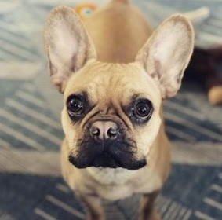
Known to have won awards for the work they do including the 2016 Pawedin best French Bulldog Breeder, Skymeadow Farm is an ideal breeder to settle with if you are looking for a French Bulldog in the Northwest. One of the many notables about this breeder is that their bloodlines are derived from AKC champions. In addition, they do raise their French Bulldogs in a well-spaced environment thus giving them room to play and exercise. This together with the care and love they receive guarantees amazing temperament as they age.
They do pride themselves in breeding quality pups that are happy, well-rounded, and most importantly healthy. Health-wise, all the Frenchies at Skymeadow Farm are up to date on vaccinations and deworming.
What we personally love about this breeder is the variety of Frenchies from which you can choose.

Skymeadow Farm Details
- Name: Skymeadow Farm
- Location: Seattle area
- Website: www.skymeadowfarm.com
- Phone Number: (360) 499-9069
- Email: john@skymeadowfarm.com

Unsolicited Post November 2021

