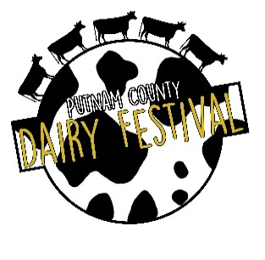
63rd ANNUAL PUTNAM COUNTY DAIRY FESTIVAL
JUNE 1, 2024
SPONSORSHIP PLEDGE FORM
Business/ Individual Name: __________________________________________________________
(Exactly as it should be displayed on banners, posters, etc. Logo Y____ N_____)
Sponsor Contact/Individual Name: ______________________________________________________
Telephone: ________________________________ Fax: __________________________________________________
Email: ____________________________________________________________________________________
Address: _________________________________________________________________________________________
City, state, zip: __________________________________________________________________
LEVEL OF PARTICIPATION
_____ Platinum Sponsor $750
_____ Gold Sponsor $500
______ Silver Sponsor $250
______ Bronze Sponsor $100
______ Donation ______________________________________________________

All donations will be greatly appreciated. The Pilot Club of Eatonton is a recognized 501(c)(4) not for profit organization. Pilot International is a recognized 501(c)(3) not for profit organization. Checks for tax-deductible donations should be made out to “Pilot International”. Other checks may be made out to “Pilot Club of Eatonton”.) Mail application to Pilot Club of Eatonton, P.O. Box 3031, Eatonton, GA 31024. For more information, contact Elaine Uhler at etuhler@yahoo.com or 706-816-1031.
*If you are a new sponsor or have a new logo, please email a digital copy (pdf) of your vector logo to etuhler@yahoo.com.
Visit our website at www.putnamcodairyfestival.com.

Deadline is March 31, 2024. Sponsor Signature________________________________
Pilot Member Signature____________________________
Revised 1/9/24 Date______________________

