MONA LAKE BOATING CLUB
Where Good Friends Anchor
If you're looking for a relaxing place to end your busy day, Mona Lake Boating Club is the place for you. Both relaxing and upbeat, our waterfront Club & Tiki Bar offers an inviting atmosphere with gorgeous views of Mona Lake. It’s no
surprise that Mona Lake Boating Club has become a neighborhood gem that’s great for families and friends.

We encourage our members to volunteer at least twice a year. This is a great way to meet other members and help keep costs low.

We offer:
- Private paved Boat Launch with safe and secure vehicle and trailer
parking
- A 10% discount on Premium Gas for watercrafts
- Dock & beach use for fishing, sunbathing and a roped off swim area
- Picnic area with both charcoal and gas grill
- Willow Point Tiki Bar with full bar and food services
- Free music and entertainment for our members
- Family events
- A varied menu choice for lunch on Wednesday & Friday
- We also have a variety dinner every Friday night. Members receive
$1 dollar off your entrée

We rent our clubhouse and pavilion to members only. The clubhouse holds 250 people and the pavilion can accommodate up to 450. We have a full catering service on the premises if needed.

Our Club has several events throughout the year. Follow our FaceBook page, Mona Lake Boating Club. Once you’re a member, you can sign up for our online newsletter and bulletins.

Annual memberships expire December 31st of each year. To remain a
member in good standing you must renew your dues by December 31st for the following year. You are responsible for maintaining your membership. A notice will not be mailed to you.

YOU MUST BE 21 YEARS OF AGE TO BECOME A MEMBER

Single:_______$125 + one-time Initiation Fee of $75 = TOTAL $200

Family:_______ $175 + one-time initiation Fee of $75 = TOTAL $250
(Includes spouse & children under 21)

Please print legibly:

NAME (S):

PHONE: ( ______)

PHONE: (Spouse) (_________)_________________________________________

E-MAIL: (primary or single member)

E-MAIL: (Spouse)
(by providing my email I agree to receive Club electronic notices and bulletins)

ADDRESS:

CITY_____________________________STATE__________ZIP

Signature:

Have you ever been convicted of a felony? Yes No

Are you registered as a convicted Sex Offender? Yes No

I promise to abide by Club by-laws and to the best of my ability aid and promote its purpose. As the Club functions are run by its members, I understand, that if elected to the membership, I will assist in the future success of the Club by volunteering to work in at least 2 Club activities per year.

SPONSOR (required)
Print Name:_____________________________________DATE:

SPONSOR
Signature: _______________________________PHONE:

MUST COMPLETE BACK OF APPLICATION
The future success of the Club depends on the help of its members. Each member is expected to volunteer for at least 2 activities per year. Please indicate below where we can count on your help:
Property |  | Social Activities
Lawn / Landscape |  | Club parties
Carpentry |  | Kids’ parties
Painting |  | Selling 50/50 tickets
Other: |  | Other:

Member Care |  | Food & Kitchen
Funeral luncheon |  | Friday Variety Dinners
Membership committee |  | Saturday Tacos

Willow Point |  | As a member of MLBC
Wednesday Steak Fry |  | I would like to offer the following specific skills or services:
Spring cleanup / open
Fall cleanup / close
Other:

New membership dues are paid upon application to the Club. You will be notified of acceptance and inducted at a meeting along with your sponsor before Club benefits are available.
Renewal membership dues are accepted October 1 – December 31. You may pay at the Club, online through our member portal, or call the Manager with a credit card. It is your responsibility to pay your renewal dues before the due date. A renewal reminder will not be mailed to you. If membership renewal dues are not paid by January 31, your membership will be discontinued and you will be required to pay the initiation fee again.

Annual renewal membership dues:
Single membership renewal: $125
Family membership dues renewal: $175

MONA LAKE BOATING CLUB
APPLICATION FOR MEMBERSHIP

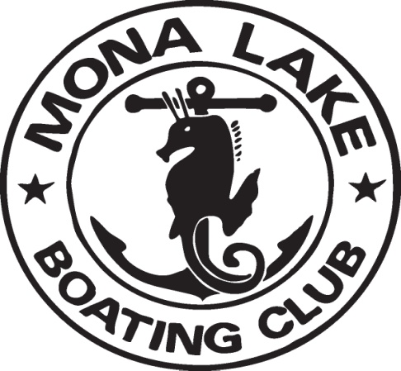

Established 1941

"Where Good Friends Anchor"

372 Randall Road
Norton Shores, MI 49441

www.monalakeboatingclub.net

