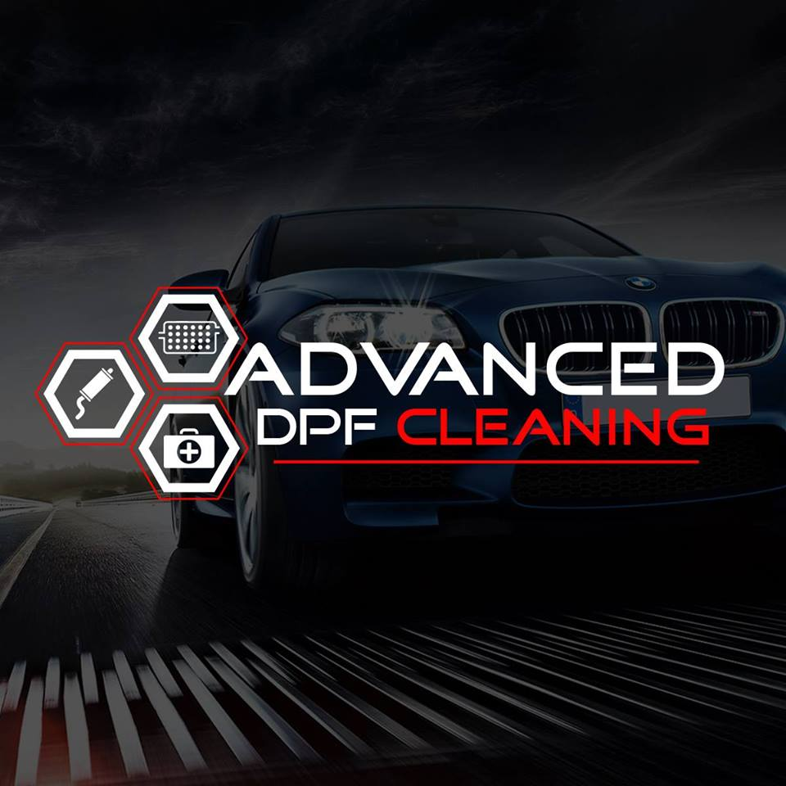

Whilst we take the greatest of care when repairing your vehicle there are some things which are out of our hands.

Before starting the clean we will carry out a full fault code read and some basic health checks including live data (where possible) to make sure your engine is in good enough health to carry out the DPF clean. We cannot be held responsible for any failures and our checks are limited by issues such as

* Fault codes being deleted and not declared to us
* Missed timing belt and service intervals
* Poor maintenance inc oil quality
* Other underlying issues

If we feel your car is not in a suitable condition we may not carry out the clean.

DPF’s operate at extremely high temps and as always there is a risk of fire.

DPF cleaning carries no guarantee as it is often down to driving style, maintenance and ignoring engine warning lights, we do our best to educate and bring this to our Customers attention and you will be offered advice on how best to look after your DPF filter.

We accept absolutely no responsibility for any mechanical, electrical or any other failures during or after our cleaning process, this is carried out at your own risk.

Replying to this email implies you have read and understood this document and give consent for us to carry out a DPF clean.

Please include any information we should be aware of.

Please make sure your vehicle has at least half a tank of diesel.

If this form has been emailed to you please print, complete and bring it with you.

|  |  |  |  |  |  |
| --- | --- | --- | --- | --- | --- |
| **CUSTOMER DETAILS** | | | | | |
|  | | | | | |
| First Name |  | | | | |
| Surname |  | | | | |
| Address |  | | | | |
|  |  | | | | |
| Postcode |  | Telephone Number | | |  |
| Email address |  | | | | |
|  |  | | | | |
| Signature  (Or consent via email) |  | | | Date |  |
|  | | | | | |
| **VEHICLE DETAILS** | | | | | |
|  | | | | | |
| Reg Number |  | Make/Model |  | | |
| Mileage |  | | | | |
|  |  | | | | |