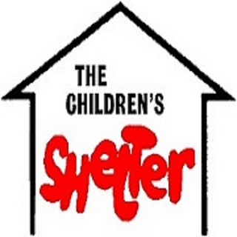
Privacy Agreement

The Community Children’s Shelter and Family Service Center, Inc. follows all HIPAA and privacy laws and ethical guidelines to protect our consumer’s confidentiality. However, during your time spent at CCSFSC, Inc. you may incidentally discover information about someone else and their time here (i.e., see someone you know in the waiting room or hear confidential information during a group counseling session). This form states that you will not share any information that you learn while here with anyone. Parents, this form states that you and your child will not reveal any information to anyone else and you will help your child(ren) to remember this when they are not at CCSFSC, Inc.

____________________________________________
Consumer signature date

____________________________________________
Parent/Guardian signature date

____________________________________________
CCSFSC, Inc. representative date

