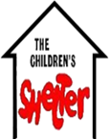
Annual Report
  - FY 2018
Mission: To empower and advocate for children, adolescents and families at risk of abuse, abandonment, delinquency and neglect in Southern Oklahoma.
Contents
To Our Stakeholders 1
Financial Summary 3
Financial Donor List 4
Program Achievements 6.
Contact Information 8

To Our Stakeholders
#WECARE

Strategic Highlights
Our Agency has three initiatives:
- To promote a “trauma informed” environment placing value on the safety of the youth placed in our care.
- To be recognized as the primary agency in the geographical area for the prevention and intervention efforts toward healthy youth and families.
- To have established and proven effective programs that address the identified service area needs within the geographical referral area.

Financial Highlights
The financial impact of the State of Oklahoma Budget crisis is being felt in all areas of our agency. We have built a strong network of 175 community funders along with more than 1650 social media followers. This network along with careful budgetary planning has allowed our agency to continue to meet the demands of the community at-risk families without having to cut services.

Operating Highlights
Our Agency served 104 homeless youth in the emergency shelter, 252 youth through intervention outpatient services, 47 adolescences needing community at-risk services, 56 young people in the First-Time Offender Program, and 28 teens needing community service supervised hours for a total of 487 young adults wrapped in positive supports. Our Agency worked with three area schools to provide trauma informed teaching with an on-site licensed professional counselor and eightr area schools to provide the prevention school based curriculum BOTVIN Life Skills.

Looking Ahead
As the Oklahoma Department of Human Services moves away from the utilization of emergency shelters across the State, our community has embraced the availability of our established and proven effective resources. The necessity to work with teenagers and younger youth trying to heal from abuse, abandonment, delinquency and neglect is not declining. I believe the need to focus efforts on building strong collaborations with other agencies and strengthening our trauma focused and sensitive measures are critical for the young people and families we serve.
#WECARE
We at CCSFSC, Inc. are passionate about the youth, families and communities that we serve. We believe in the healing power of hope, love, laughter and connection. We strive daily to prove to our youth that they are worth fighting for, that they have a future that is bright and happy. We believe in the quote from Josh Shipp: “Every child is one caring adult away from being a success story.”
I encourage you to find others that will join this mission. Our young people need you!

Kaylyn Weldon Gary
Kaylyn Weldon Gary
Executive Director
“Changing the World One Child at a Time”

Financial Summary
This agency has been honored to have wise board member leadership throughout its 49-year history. The board has a tradition of understanding their role to ensure the mission would continue until the goal is met. The outcome of this conservative financial understanding allows services to continue even during the hardest of times.
VISION
Healthy Youth & Families free of abuse, abandonment, delinquency and neglect.

Statement of Financial Position
- Total Assets $5,668,518
- No Liabilities
- Total Net Position $5,668,518
  - The net position includes $102,228 in temporarily restricted net assets.

Statement of Activity
Description | Revenue | Expenses | Net Change
Local | $316,248.94 | $267,153.78 | $49,095.16
Foundational Grants | $135,510.66 | $44,701.50 | $90,809.16
Office of Juvenile Affairs – Shelter | $215,511.19 | $347,415.64 | -$131,904.45
Office of Juvenile Affairs – CBYS | $162,354.76 | $115,011.64 | $47,343.12
Office of Juvenile Affairs - CARS | $11,371.61 | $23,989.58 | -$12,619.97
Title 19 | $63,997.56 | $85,747.82 | -$21,750.26
School Lunch Program | $7,539.08 | $8,505.23 | -$966.15
Total | $912,533.80 | $892,525.19 | $20,006.61

Takeaways
- This financial summary is based upon cash received and cash paid out. These amounts are unaudited.
- The agency completes the independent audit process annually and the report is available upon request.
Financial Donor List
The Merrick Foundation
Pamela Plesher
Wildhorse Operating Company
Sullivan Insurance Agency
Chief Oil & Gas LLC
DOT Foods Inc
Sandra Jones
First National Bank & Trust

$500 - $999
Carrell Trucking, Inc.
Carter County Sheriff’s Department
Claudia Kittrell Realty, Inc.
Clements Electric
Dustin and Candis Stanton
Dirtworks, Inc.
Elaine and Thomas Kittrell
Johnnie Crutchfield
OG&E
SNS Oil & Gas Properties, Inc.
St. Mary's Thrift Shop
Victory Life Church, Inc.
Archdiocese of Oklahoma City
David & Evelyn Clary
First Presbyterian Church

$250 - $499

Coffee Professionals
Elizabeth Bulard
Hilltop Equine Therapy, Inc.
Joel and Mioslava Stephens
Kevin and Patty Howard
Don Demoss
Bob or Nanette Bramlett
Mr. and Mrs. John F. Snodgrass
Thomas Balmer
Gary and Tammy Thompson
Helen Clifton

Thank you to our Supporters:
$25,000 – 49,000
Charles B. Goddard Foundation
Mullen Trust
United Way of South Central Oklahoma
Southern Oklahoma Memorial Foundation

$10,000 – $24,999
Daube Foundation
Samuel Roberts Noble Foundation
The McCrory Foundation
Valero Energy Foundation

$5,000 – $9,999

Chamber of Commerce Foundation
Kohaw Foundation
Milo Baptist Church
Drummond Endowment

$2,500 - $4,999

Beverly Westheimer Wellnitz
Kohaw Foundation
Jermaine Gresham
North Texas Community Foundation
The Daube Family Foundation
MTC Federal Credit Union- Ardmore
Micheal Thomas
Cash Donations
We make a living by what we get
But we make a life by what we give
-Winston Churchill

$1,000 - $2,499

Ardmore Dragway, LLC
Fred Chapman
Titan Oil Tools, Inc.
Josefina Vazquez Trust
Forsaken Few MC

Under $250
First Baptist Church
Chamber of Commerce Foundation
Michelle Porter
Loco Joe’s Liquor
Larry and Jamie Roberts
Darcy K. Jordan Family Trust
Francis Woodward
Clayton and Leslie Christian
Jimmie and Joel Hicks
Larry G. Wilson
Sara C. Cope
Brad and Linda Blackburn
Cindy Faustner
James D. Dixson Trust
Syble C. Roring
William and Diana Knox
Frances #1 Realty
The UPS Store #3332
St. Mary’s Womens Club
John and Marilyn Kriet
Opengate Technologies
BancFirst
Keith or Jane Nance
Jarod Don Ray
Kane or Sarah Bass
Joyce Baggett
Bulard Family Trust
Sue M. Clowe
Helen Thompson
Jim and Joanne Coble
Darla Herndon
Eva Wells
Jamee J Smith
Judith R Kenaga
Luanne Snodgrass
Maggie E Davenport
First United Methodist-Wesley
Samuel J. Veazey
Richard and Carol Daube Simms
Marth Ann Hill Rev. Trust
D. Allen or Marilyn Wint
Carlene Hadwin
Jason and Jennifer Langley
Jack and Gloria Davenport
Tanya and Darrell Weldon
Girls on the Run- Lone Grove

Jamee J. Smith
Devry Sparks Jenkins
Vincent Renita Dotson
L.L. Clay
Sylvia Fore-Harrell
American Colonists
Bramlett Agency
IBC Bank
Chris and Jessie Nance
David and Pat Vineyard
Cynthia Bryant
Belinda Morris
Earlene White
Peggy or S. Neil Sission
Doug and Michele Dean
First United Methodist Church
Cynthia Bryant
Joyce Hallum
Russell Noble Trust
Jan Shores
Marjorie B. Dolman
Seventh Day Adventist Church
Merrick Drive Church of Christ
Neustadt Charitable Foundation
Patsy Bulard
Robin Boldt
Camille Randow
Mary Jane or Arlen Fowler
Freddy’s Frozen Custard & Steakburgers
Brandi Johnson
Samson R. Buck
William & Ramona Kelley
Wells Vision and Laser Eye Center
Ann Whitchurch
Sue and John Gibbs
Doug and Michele Dean
Outcasts 4 Christ Ministries
Meghan Shayhorn
AFLAC
Bargain Lady Name Brand Consignments
Charla Salyer
Dale and Kelly Archer
Janie Horton
Solid Rock Church
Mildred Williams
Stage Store #52- Ardmore

In Memory of Donations

Michael Gunnels
Marlon Hicks

Peggy Duke
Clayton and Leslie Christian

Forrest Lynn Boyer
Ramsey Ward Electric

S. Jordan
Sara C. Cope

Liv Hobbs
Marsha McGuire

Program Achievements
Increasing Graduation Rates

Lowering Dropout Rates

Lowering Recidivism Rates

BOTVIN LifeSkills Program
Ardmore Charles Evans & Middle School, Healdton, Wilson, Turner, Greenville, Dickson and Springer schools of Carter and Love County were provided the evidence‐based, research supported substance abuse prevention program proven to reduce the risks of alcohol, tobacco, drug abuse, and violence by targeting the major social and psychological factors that promote the initiation of substance use and other risky behaviors.
Christmas Program
27 families were provided a Christmas party for 72 children that included Christmas gifts, clothes, food and caring support.

Community At-Risk Service Program
47 adolescents were provided quality prevention, early intervention, and treatment services to at-risk youth and families.

Emergency Shelter Program
104 youth were provided a safe and secure place from abuse, abandonment, delinquency, homelessness and/or neglected for a total of 2109 shelter days.

First Time Offender Program
56 youth and parents were provided a 12-hour alternative diversion program designed towards intervention and prevention of youth from further developing characteristics and behaviors of juvenile delinquents.

Food Basket Program
308 families were provided emergency food baskets. We were able to give approximately 25 food baskets to the homeless through the Outcast for Christ Program.

Juvenile Community Service Program
28 adolescents were provided a total of 653 supervised community service hours to pay restitution for delinquent acts in the community.

Child Abuse Prevention Awareness Program
Carter and Love County Communities were provided awareness during April Child Abuse Prevention Month with activities throughout the area.

Program Achievements
Increasing Graduation Rates

Lowering Dropout Rates

Lowering Recidivism Rates

Out Patient Individual Counseling Program
252 youth were provided crisis intervention; individual, family, and group counseling.

Parenting Class Program
22 parents were provided parenting classes targeting positive behavioral interventions with their children.

Trauma Informed Teaching Program
Long Grove Primary, Dickson Elementary, and Greenville Elementary were provided trauma informed teaching utilizing the researched based Managing Aggressive Behavior national curriculum and Trust Based Relational Intervention to address students suffering from adverse childhood experiences. Three of the schools were provided an on-site licensed professional counselor.

Collaborative Programs
The agency partnered and worked with the following programs to ensure the youth of the community are getting the best coordinated care possible:

Ardmore Behavioral Health Collaborative Trauma Informed Care Initiative
Arbuckle Life Solutions Substance Abuse Counseling
Cities In Schools Summer Groups
HFV Wilson Summer Groups
Second Chance Academy Habitudes Program
TAKE II Building Relations & Groups
The Landing Substance Abuse Support Groups

Contact Information

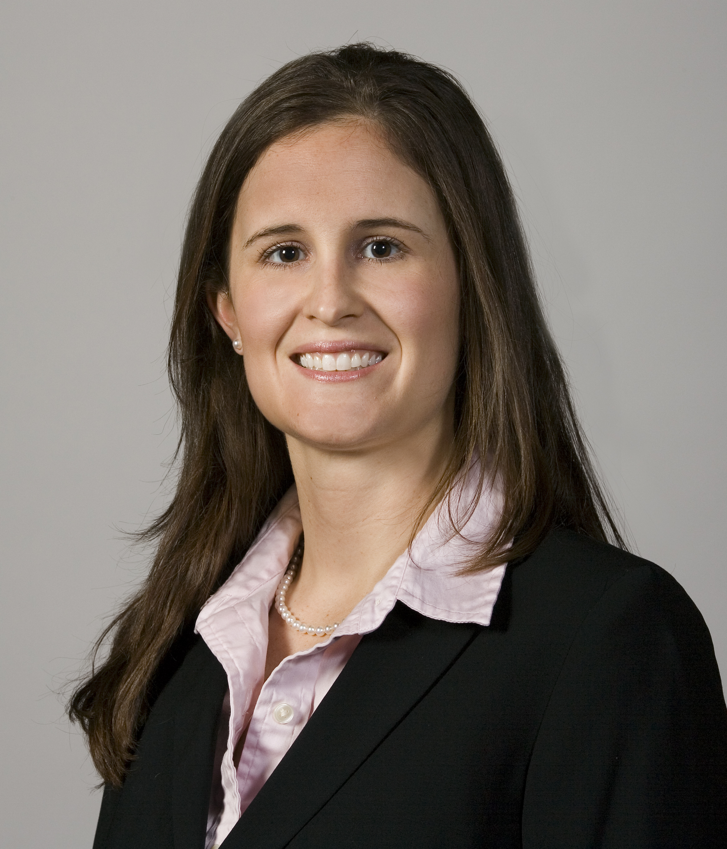 | Jessie Nance  Board President  Tel 580.220.7943  jnance@quiensabe.net | 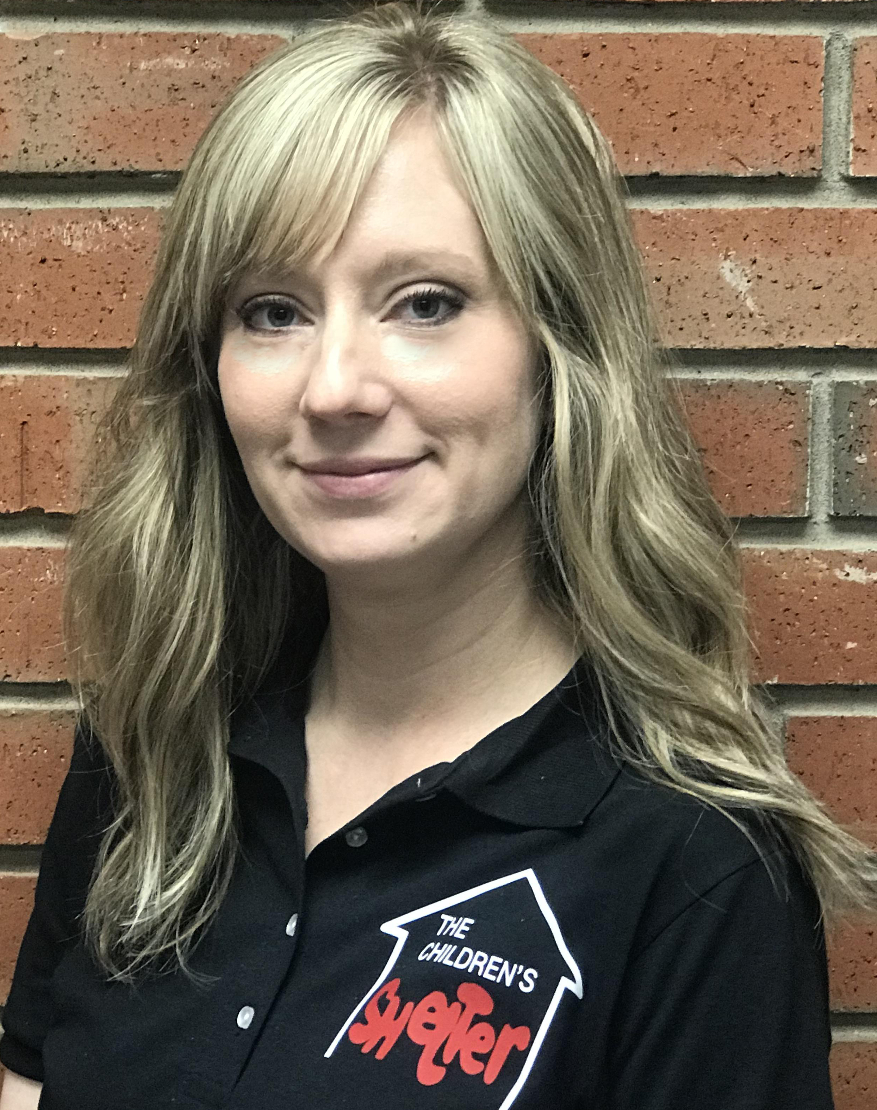 | Kaylyn Weldon Gary  Executive Director  Tel 580.276.1838  kweldongary@childrenshelter.org

The Community Children’s Shelter & Family Service Center, Inc.
15 Monroe Street Northeast, Ardmore, Oklahoma 73401
Tel 580.226.1838 | Fax 580.223.7856
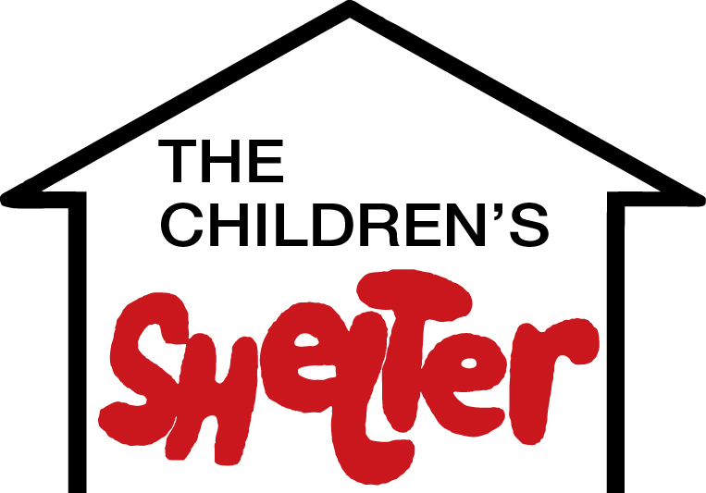
www.childrenshelter.org
Facebook at www.facebook.com/ccsfsc

