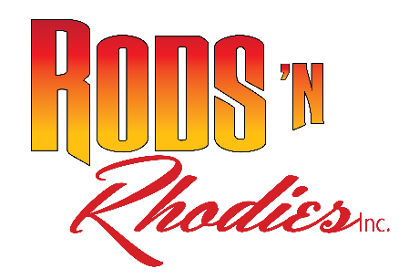
June 5, 2022

Rods N Rhodies, Inc.
501 (c) (3) Nonprofit EIN 83-2503956
Gary Cargill (President)
PO Box 2443, Florence OR 97439
541-999-6513
gncargill@charter.net

Rods N Rhodies Car Show Sponsorship Opportunities

Rods N Rhodies Car Show 2022 will be here on September 9th and 10th 2022, and you will want to be part of this community coming-together event. You can be a major part of the success of this year’s event with a financial contribution that will deliver miles of value for your buck.
As a $500.00 Event Sponsor you will be part of an advertising campaign worth several hundred dollars in promotion. You will be honored for your sponsorship in 10 radio commercials on KCST and 10 radio commercials on KCFM, plus two 1/8 page ad in the Siuslaw News. In addition, you will be included on the Event Sponsor Banner; Receive a Sponsor Participation Plaque to proudly display in your place of business or office; receive presence on Facebook and Website as well as e-blasts, news releases and PSAs; listed on Event Program, in DJ Announcements, and participate in the Merchant Award Sponsor program.
As a $250.00 Event Sponsor you will be included on the Event Sponsor Banner, receive a Sponsor Participation Plaque to proudly display in your place of business or office, Facebook and Website presence as well as e-blasts and news releases and PSAs, Event Program, DJ Announcements and participate in the Merchant Award Sponsor program.
As a $100.00 Raffle & Goodie Bag Sponsor you will receive a Sponsor Participation Certificate to proudly display in your place of business or office, Facebook and Website presence as well as e-blasts and news releases and PSAs, Event Program, DJ Announcements and participate in the Merchant Award Sponsor program.
As a $50.00 Merchant Award Sponsor you will receive Facebook and Website presence as well as e-blasts and news releases and PSAs, Event Program, DJ Announcements and participate in the Merchant Award Sponsor program.
Rods N Rhodies Car Show is one of the highly desired shows on the Oregon Coast. The event would not be possible without community members like you to put on such a wonderful show.

Rods N Rhodies Car Show Sponsorship
____________________________________________ _____________________________________________
Business or Individual Name Mailing Address,

________________________ ____________________________________ $__________________
Phone Number Contact Name Sponsor Level

