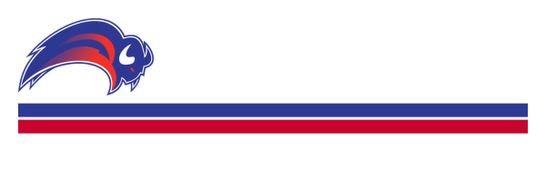
Position Title: Digital Coordinator
Club: Boronia Buffaloes Basketball Club
Reports To: Executive Committee
Term: 1 year – Renewable

Position Description:
The Digital Coordinator is responsible for managing the Boronia Buffaloes Basketball Club’s online presence, primarily through social media platforms and website. This role promotes club events, shares achievements, and strengthens community engagement. The coordinator ensures content is timely, inclusive, and aligns with the club’s values.

Key Responsibilities:
Content Creation & Management:
- Develop and schedule regular posts on platforms such as Facebook, Instagram (others as they are used)
- Create graphics, write captions, and share news, match results, and event details.
- Capture or collect photos and videos from games and club activities (with permission).
- Maintain club website as required.
Community Engagement:
- Respond to messages, comments, and inquiries in a timely and respectful manner.
- Promote the club’s values, programs, and sponsors.
- Celebrate player achievements, milestones, and team spirit.
Coordination & Compliance:
- Liaise with committee members and coaches for accurate updates.
- Ensure all posts comply with child safety, privacy, and communication guidelines.
- Assist in developing a simple content calendar or strategy if needed.

Preferred Skills & Attributes:
- Experience using social media platforms and basic content tools
- Creative and positive communication style
- Understanding of audience engagement and online etiquette
- Ability to maintain a respectful and inclusive tone

Time Commitment:
Requires weekly updates and increased activity during special events or announcements.
Should stay responsive to messages and coordinate closely with the committee and coaches.

