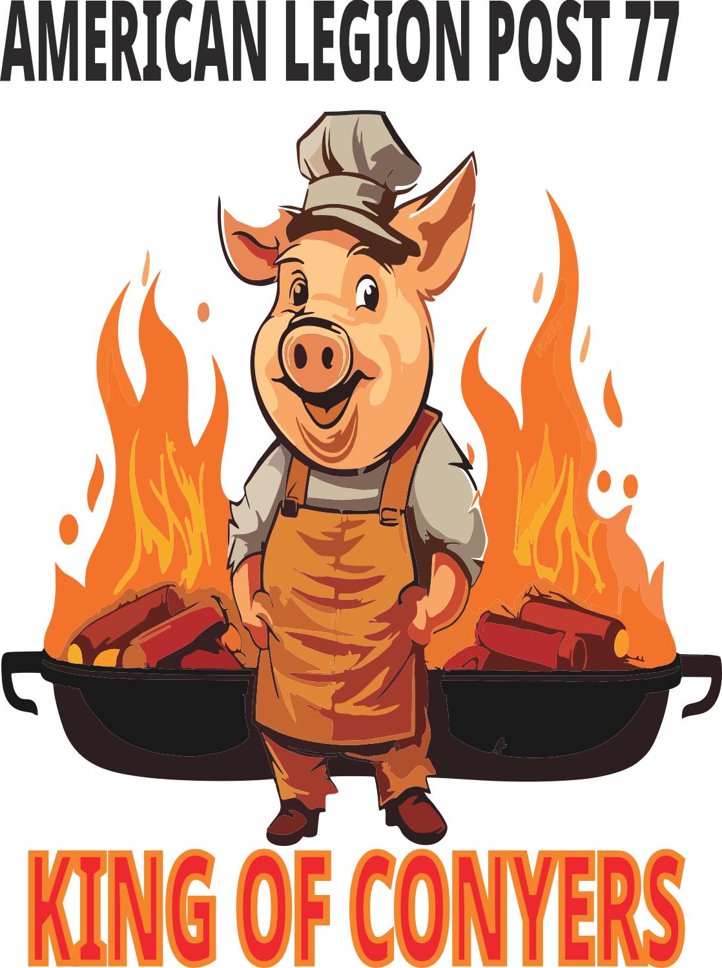

VENDOR APPLICATION
COMPANY INFORMATION

LEGAL BUSINESS NAME

BUSINESS ADDRESS (CITY) (STATE) (ZIP CODE)

EMAIL ADDRESS BUSINESS WEBSITE
_____________________ _____________________
CONTACT PERSON BUSINESS PHONE #
CONTACT INFORMATION

(NAME) (TITLE) (PHONE NO.) (EMAIL)

INSURANCE INFORMATION
INSURANCE PROVIDER__________________________________________
POLICY NUMBER________________________________________
POLICY COVERAGE AMOUNT___________________________
EXPIRATION DATE_______________________________________
COI SUBMITTED______________
Please request your insurance agent to name The American Legion as a Certificate Holder and send a copy of your Certificate of General Liability Insurance showing The American Legion as the Certificate Hold with the application.
PRODUCT CATERGORY
 | ACCESSORIES / JEWELRY |  | DECORE
 | ART, BOOKS, & MUSIC |  | HOUSEWARES
 | BATH & BEAUTY |  | PAPERGOODS
 | CANDLES |  | PLANTS
 | CERAMICS & POTTERY |  | CLOTHES
 | WOODWORKS |  | HATS
 | NEEDLECRAFT |  | SPORTS EQUIPMENT
 | DOLLS & TOYS |  | YARD EQUIPMENT
 | FURNITURE |  | OTHER

PRODUCT DETAILS
Please provide a brief description of the items that you will sell at the event.
th

INGREDIENTS & ALLERGENS
Please provide information about potential allergens.

COMPLIANCE AGREEMENT
I certify that the information provided in this application is true and correct to the best of my knowledge. I understand that falsified information may result in the refusal and termination of my application including the forfeiture of my application fees.
I agree to comply with all local, state and federal food safety and handling regulations.

________________________________________ _____________________
(SIGNATURE) (TITLE) (DATE)
Waiver & Signature:
I am authorized to sign on behalf of the above company, and I hereby release and hold harmless American Legion Post 77 and its representatives from any liability, loss, or damage related to participation at The Kings of Conyers event on Labor Day, September 1, 2025.
________________________________________ _____________________
(SIGNATURE) (TITLE) (DATE)

VENDOR RULES AND REGULATIONS
VENDOR FEES:
Fees: $50
FEES ARE NOT REFUNDABLE
FEES ARE NOT TRANSFERABLE
In case of inclement weather the event will move to the
following Saturday.
CHECK IN, SETUP, AND BREAKDOWN:
Check in time: Check in will start at 7 AM. Vendors must be completely
Setup by 9 AM. Vendors that arrive after
9 AM may forfeit their application fees due to safety reasons.
Set-up:
Space assignment and number will be displayed to make it
easy for the vendor to find their space.
Each vendor is responsible for their area, tables, chairs and
displays, merchandise. Vendors can display banners and signage
to identify their company.
RULES
No display of vulgar and indecent materials
Area must be kept clean and orderly
Vendors are prohibited from selling alcohol beverages
Provide courteous and professional customer service
Comply with all Federal, State, and Local Laws
Prohibited from having animals on site

DISCLOSURE:
All vendors are required to submit a COI with their application. The American Legion will not provide insurance coverage for vendors. Vendors agree to hereby indemnify and hold harmless the American Legion and it’s subsidiaries, affiliates, officers, directors, shareholders, agents and employees free clear and harmless, from and against any and all losses, liabilities, cost, and expenses (including amounts paid in settlements, and attorney fees), claims, penalties, judgements and damages, arising from or arising out of by reason of any act or omission or negligence of the client or its representative agent, employees or vendors in any way connected with or arising out of any accident. Injury or damage-and these can include and be detailed-any breach of representation, injury to person or property, any activity conducted or action taken by the American Legion, directly or indirectly in conjunction with this agreement. If for any reason beyond it’s control, but not limited to strike, labor disputes, accident, acts of war, act of GOD, fire or flood or other emergency conditions, The American Legion is unable to perform it’s obligation under this agreement, such as non-performance is excused and The American Legion may terminate the agreement without further liability of any nature. In no event shall The American Legion be liable for consequential damages of any nature for any reason whatsoever.

