Cordova City Council Meeting
THURSDAY March 13, 2025
6:30 P.M.
Agenda

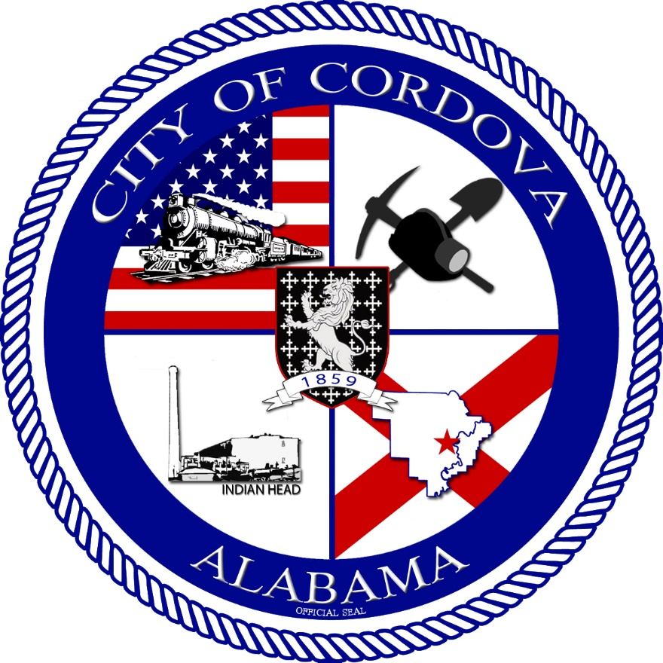
- CALL TO ORDER
    - Invocation
    - Pledge of Allegiance
    - Roll Call
- Public Hearing to Rezone 625 Amory Avenue from R-2 to R-3
- Review Meeting Minutes from 02/11/2025
- Review Accounts Payable
- Ordinance 04-2025 Code Enforcement Manual
- Resolution 02-2025 Authorizing the Retention of Council
- Resolution 03-2025 Establishing Use of Electronic Vote Counting Devices
- Proclamation for the Two Lights for Tomorrow
- Voting Delegate Authorization
- Request for Quote for RAISE Project
- Hire of Denise Vance for part-time administrative clerk
- Appoint Member to CEIDA Board
- Contract with ML&H Group for property development
- Public Works Update
- Fire Department Update
- Police Department Update
- CEIDA Update
- Planning and Zoning Update
- Benjamin Thorpe
- Other Business
- Adjourn

