Cordova City Council Special Meeting
Tuesday April 22, 2025
6:30 P.M.
Agenda

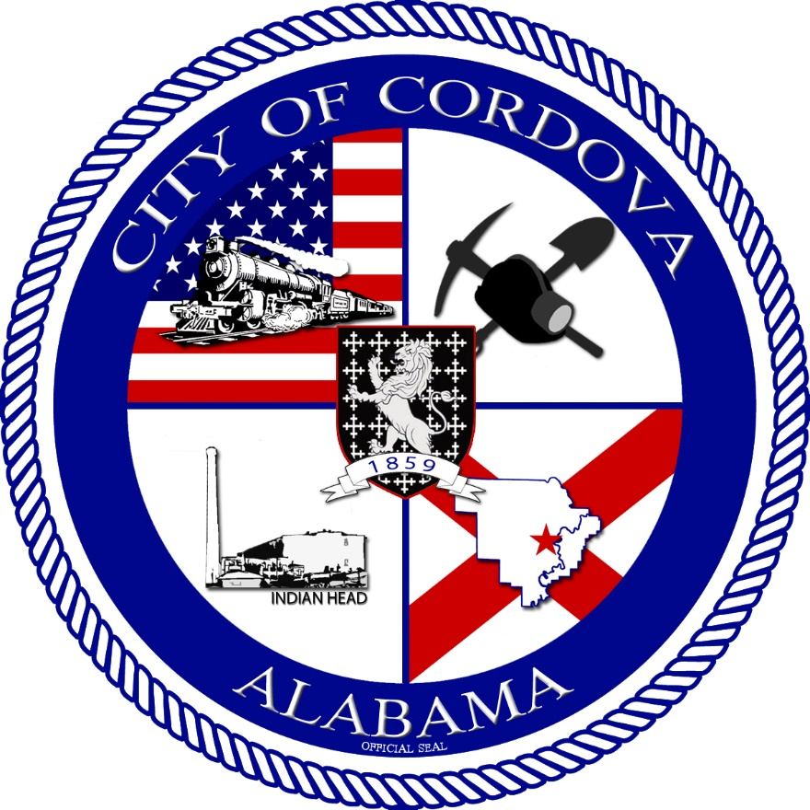
- CALL TO ORDER
    - Invocation
    - Pledge of Allegiance
    - Roll Call
- Review Meeting Minutes from 04/08/2025
- Review Budget Actuals FY25 Q2
- Resolution 05-2025 Retention of Council – Cordova Manor Apts.
- Resolution 06-2025 Bid Approval Phase 2 CDBG Demolition
- Update Milage Rate for Probate Judge Office
- Adjourn

