Cordova City Council Meeting
TUESDAY June 10, 2025
6:30 P.M.
Agenda

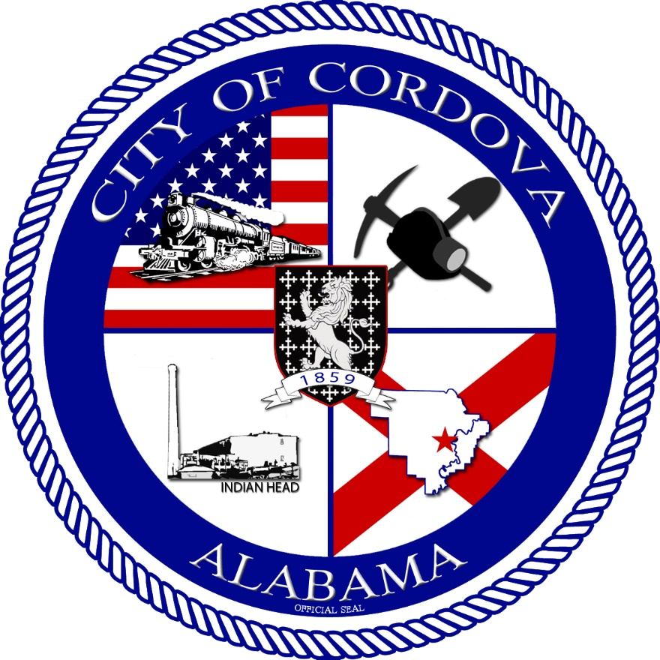
- CALL TO ORDER
    - Invocation
    - Pledge of Allegiance
    - Roll Call
*OATH OF OFFICE – POLICE CHIEF*
- Review Regular Meeting Minutes from May 13, 2025
- Review Accounts Payable
- Notice of Election
- Resolution 07-2025 Liquidate 2 Zero Turn lawn mowers
- Approve Hire of Maggie Benson
- Approve Hire of Cordova Works Employees
- Public Works Update
- Fire Department Update
- Police Department Update
- CEIDA Update
- Planning and Zoning Update
- Capstone
- Other Business
- Adjourn

