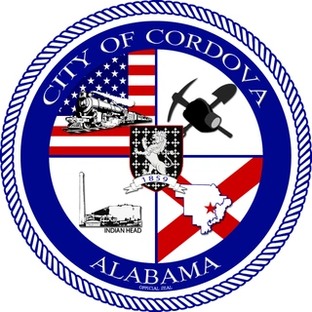

Join us for the City of Cordova’s
COMMUNITY DEVELOPMENT BLOCK GRANT
CLOSEOUT PUBLIC HEARING
Tuesday June 2, 2026 || 6pm
City Hall, 154 Main Street, Cordova, AL 35550

