Cordova City Council Meeting
TUESDAY May 13, 2025
6:30 P.M.
Agenda

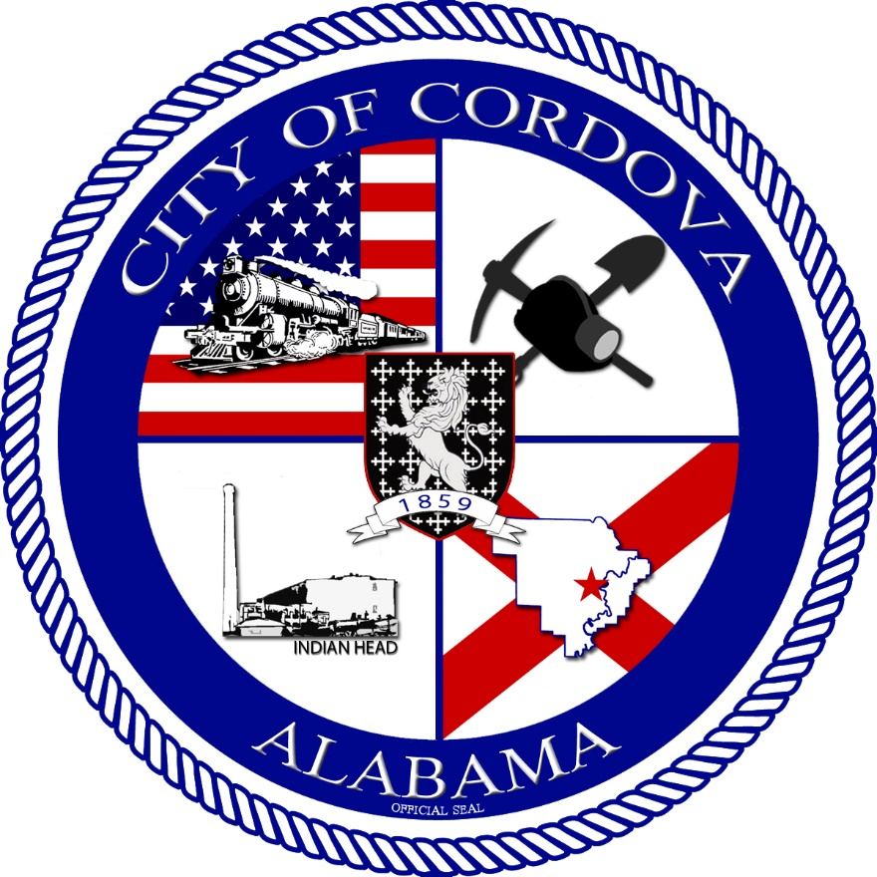
- CALL TO ORDER
    - Invocation
    - Pledge of Allegiance
    - Roll Call
- Review Special Meeting Minutes of 04/22/2025
- Review Accounts Payable
- Changes to Personnel Manual to eliminate DEI language
- Ordinance 10-2025 Amendment of Ordinance 09-2025
- Ordinance 11-2025 Amendment of Ordinance 05-2025
- Approve Hire of Part-time Dispatcher William Ambridge $12.50/hr
- Approve Hire of Part-time Cordova Works Applicants
- Mutual Aid Agreement with Parrish
- Tyler McKeller – Living Water Services
- Public Works Update
- Fire Department Update
- Police Department Update
- CEIDA Update
- Planning and Zoning Update
- Other Business
- Adjourn

