Cordova City Council Meeting
Tuesday February 11, 2025
6:30 p.m.
Agenda
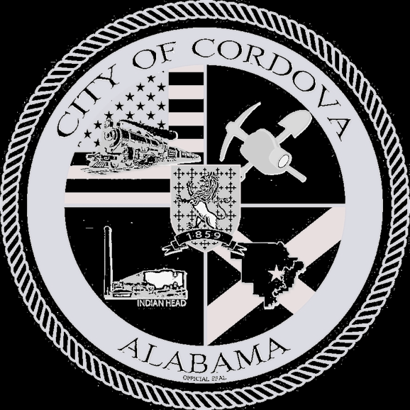

- CALL TO ORDER
- Invocation
- Pledge of Allegiance
- Roll Call
- Vote on and Swear in New Council Member
- Review Regular Meeting Minutes of 01/14/2025
- Review Special Meeting Minutes of 01/17/2025
- Review Accounts Payable
- Review FY25 Q1 Budget Actuals
- Proclamation for Paul Kenneth “Dago” Meserole
- Ordinance 02-2025 Ordinance setting salary for Mayor and Council
- Ordinance 03-2025 Ordinance Setting Compensation for Absentee Election Manager
- Ordinance 04-2025 Ordinance for Code Enforcement
- Ordinance 05-2025 Ordinance for Lodging Tax
- Ordinance 06-2025 Ordinance for Non-Judicial Fee Schedule
- Board Appointments
- Cost of living raises for full-time employees
- Pay increase for Dispatch Supervisor
- Permission to issue Sealed Bid for Phase 2 of CDBG Demolition
- Pepsi contract for Park and Rec
- Public Works Update
- Police Department Update
- Fire Department Update
- CEIDA Update
- Planning/Zoning Update
- Other Business
- Adjourn

