Cordova City Council Meeting
THURSDAY April 8, 2025
6:30 P.M.
Agenda

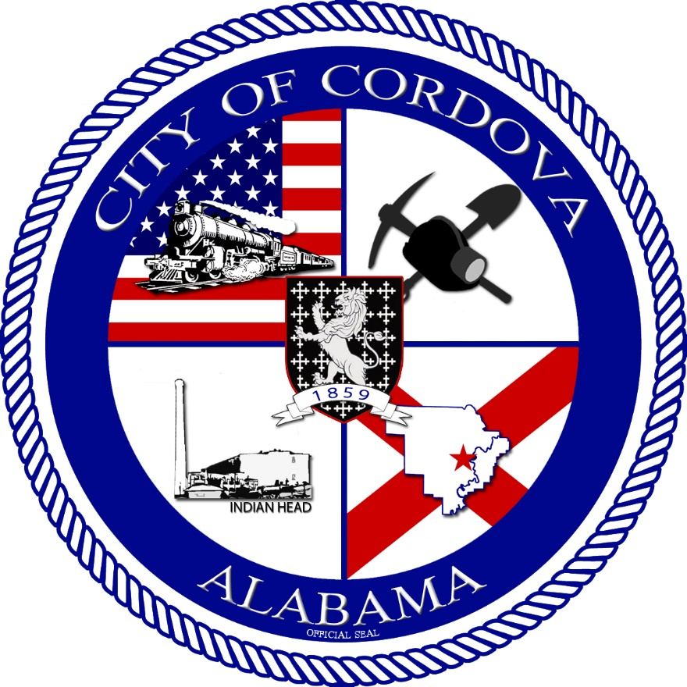
- CALL TO ORDER
    - Invocation
    - Pledge of Allegiance
    - Roll Call
- Review Meeting Minutes from 03/13/2025
- Review Accounts Payable
- Update on USDA Loans
- Ordinance 07-2025 Business License
- Ordinance 08-2025 Zoning
- Resolution 04-2025 Debt Management Policy
- Proclamation for Child Abuse Awareness
- Hire Genesis Wallace as part-time dispatch at $12.50/hr
- Housing Board Appointment
- Public Works Update
- Fire Department Update
- Police Department Update
- CEIDA Update
- Planning and Zoning Update
- John Sahagun
- Other Business
- Adjourn

