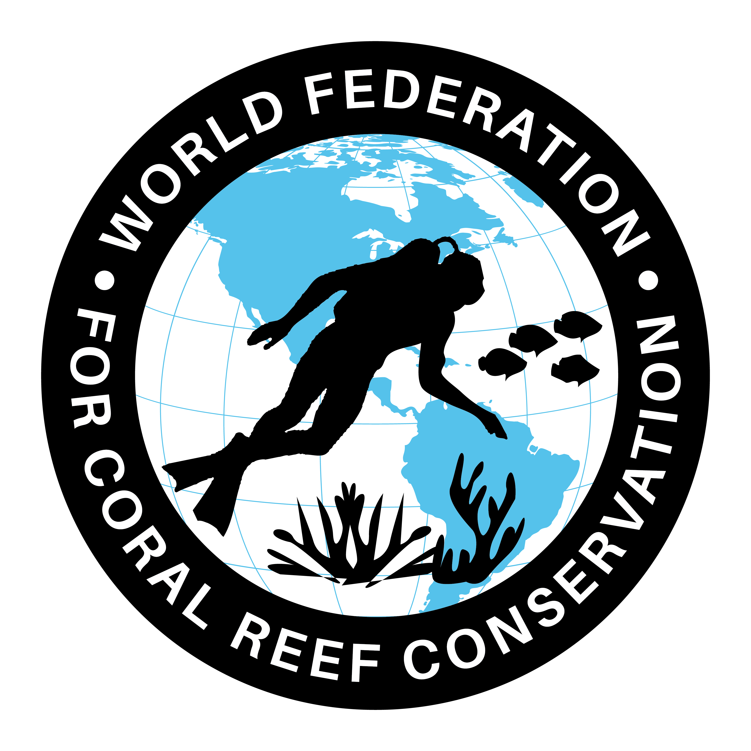
Mission Blue Keys Hope Spot
Join WFCRC

The World Federation for Coral Reef Conservation 512.986.1902 4010 Skipper Rd. Sebring, Florida 33870
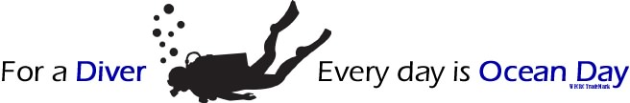
Vic Ferguson Executive Director/Founder vic.ferguson@wfcrc.org chair@wfcrc.org
8/20/20

Abstract
The combination of environmental and anthropogenic stressors has driven the global decline of coral reefs. Changing demographics of the human population and growing dependence on coral reef resources have necessitated mitigation measures to improve the sustainable use of the reef ecosystem. While management measures are useful in slowing the unprecedented loss of coral reefs, active restoration and monitoring can be pivotal to facilitating the recovery of impacted reefs. With the rapid development of reef restoration techniques in the past decade, there is a need for a review and synthesis of restoration initiatives to identify factors that contribute to its efficacy. An analysis was made to elucidate the effects of biological, management and socio-economic challenges faced by restoration practitioners and used to examine how these factors might synergistically impact the success of future reef monitoring and restoration efforts. This study provides a comprehensive identification and understanding of the drivers that contribute to the success of reef restoration as a tool for sustainable coastal development and resource management. (from The Asian Conference on Sustainability, Energy & the Environment 2013.)
In response to the combination of environmental and anthropogenic stressors, The World Federation for Coral Reef Conservation has created this ESRI Geo Portal that high lights our ability to bring together Socio-economics, current technology with the “Science of Where”, coastal and coral monitoring, and a portal for citizen scientists to share their observations in a single location for all to see. It is comprised of 30 plus data sets with 55 feature class items to identify potential locations for coral and coastal programs. This portal is a living and thriving document that is updated regularly and is freely shared with our network members.
The AOI covers the same extent as the National Marine Sanctuary which is just one of the data sources used in the portal. Other sources include: Florida Fish & Wildlife, NOAA, Turtle Conservation, and a continued effort to involve other likeminded organization and individuals. We would like to share a connection with you as an autoreactive source.
PROJECT DESCRIPTION AND GOALS
There are five components to the WFCRC Geoportal:
1) Web mapping applications
2) Search and discovery mechanism
3) Citizen reporting and crowdsourcing
4) Real-time alerts
5) Content gallery
Web Mapping Application
The system contains dynamic and interactive web maps, based on the following pertinent coastal and marine themes, and are subject to the availability of up-to-date data:
- Coral reef locations-healthy, stressed, and bleached
- Turtle nesting areas, goliath grouper locations and other marine life information
- Wind and ocean currents
- Shorelines
- Oil producing areas of the world co located with coral reefs and other sensitive environmental areas
- Ocean floor topography and ESRI EMU
- Natural and man-made marine disasters including red tide, seismic/tsunami, floods, hurricanes, oil spills, shipwrecks, sediment transport, and land-based threats etc.
- Satellite imagery and Unmanned Aerial Vehicles (UAV’s)
- Georeferenced research, reports and documents related to coral reefs and coastal conservation
- https://documentcloud.adobe.com/link/review?uri=urn:aaid:scds:US:b0e9b058-fc1d-48f4-8592-1e3c6448fa40

These maps are available both as individual thematic maps and combined together in a web mapping application. The latter will be a visually pleasing and intuitive mapping interface that uses RIA (Rich Internet Application) technologies such as JavaScript, Adobe Flex or MS Silverlight, that supports basic mapping functions.

SOME IMPORTANT DEFINITIONS

There are lots of terms used when talking about monitoring. We use the same definitions throughout to make it simple to follow.
- A survey is collecting data and information in project locations
- Monitoring is when surveys (or parts of them) are repeated
- A monitoring program consists of series of monitoring protocols that together provide a manager with the information needed to manage their reefs
- Protocols are the selections of methods and how they are used to gain information at a site. This will include numbers of replicates, lengths of transect lines, specific information gathered, e.g. animals or plants to be counted or measured
- A method is the description of how the information is collected
- line or point intercept transect or how to lay the transect;
- Ecological monitoring Ecological monitoring is monitoring the natural environment, e.g. the fish or coral. This includes both biological and physical monitoring
- Socio-economic monitoring is monitoring the way humans use the natural resources, e.g. the methods used to catch fish
- A monitoring site is the area of coral reef selected for monitoring
- A sample is the area where you count the animals and plants e.g. along a transect or inside a quadrat. The sample areas selected for monitoring will depend upon the type of information needed and the type of things you want to count. You will need to use a number of separate samples to survey one site.
Vic Ferguson
The World Federation for Coral Reef Conservation
Executive Director/Founder
Relief without Borders
March for the Ocean
4010 Skipper Rd.
Sebring, Florida 33875
vic.ferguson@wfcrc.org (best method of contact)
512.986.-1902
The only thing necessary for the triumph of evil is that good men do nothing”….Edmund Burke

