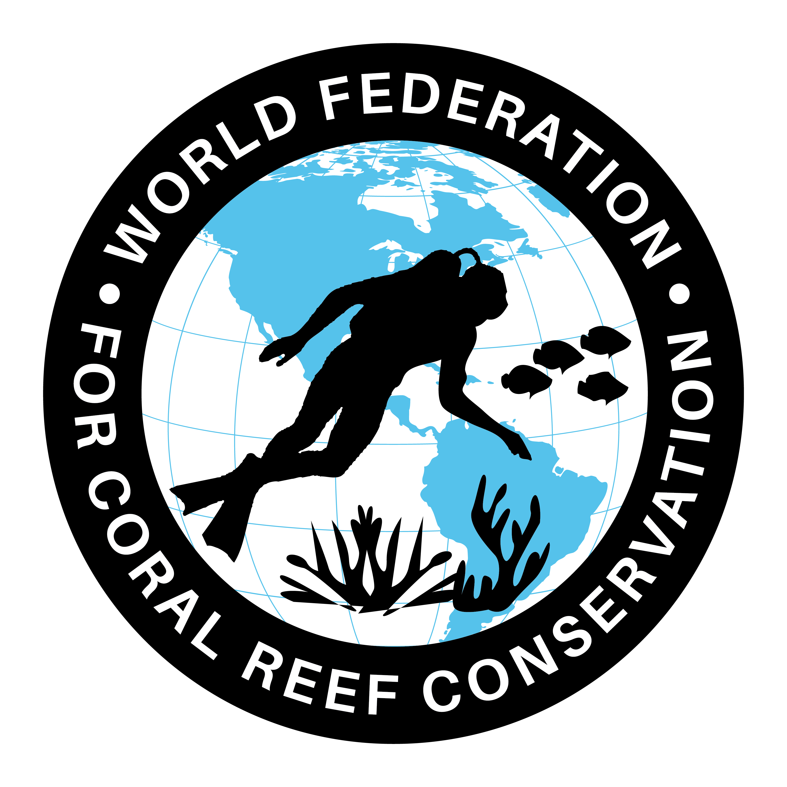
Bouguer Anomaly Map of Flordia
Join WFCRC

The World Federation for Coral Reef Conservation 512.986.1902 4010 Skipper Rd. Sebring, Florida 33870

Vic Ferguson Executive Director/Founder vic.ferguson@wfcrc.org kyle.mathes@wfcrc.org
Reprinted 4/20/20

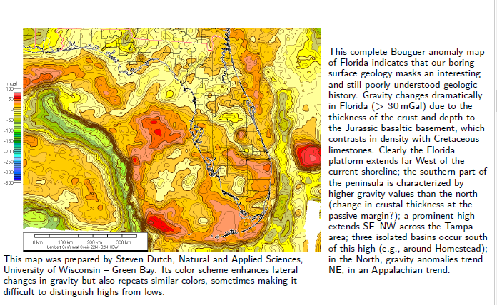
Vic Ferguson
The World Federation for Coral Reef Conservation
Executive Director/Founder
Relief without Borders
March for the Ocean
4010 Skipper Rd.
Sebring, Florida 33875
vic.ferguson@wfcrc.org (best method of contact)
512.986.-1902
The only thing necessary for the triumph of evil is that good men do nothing”….Edmund Burke

