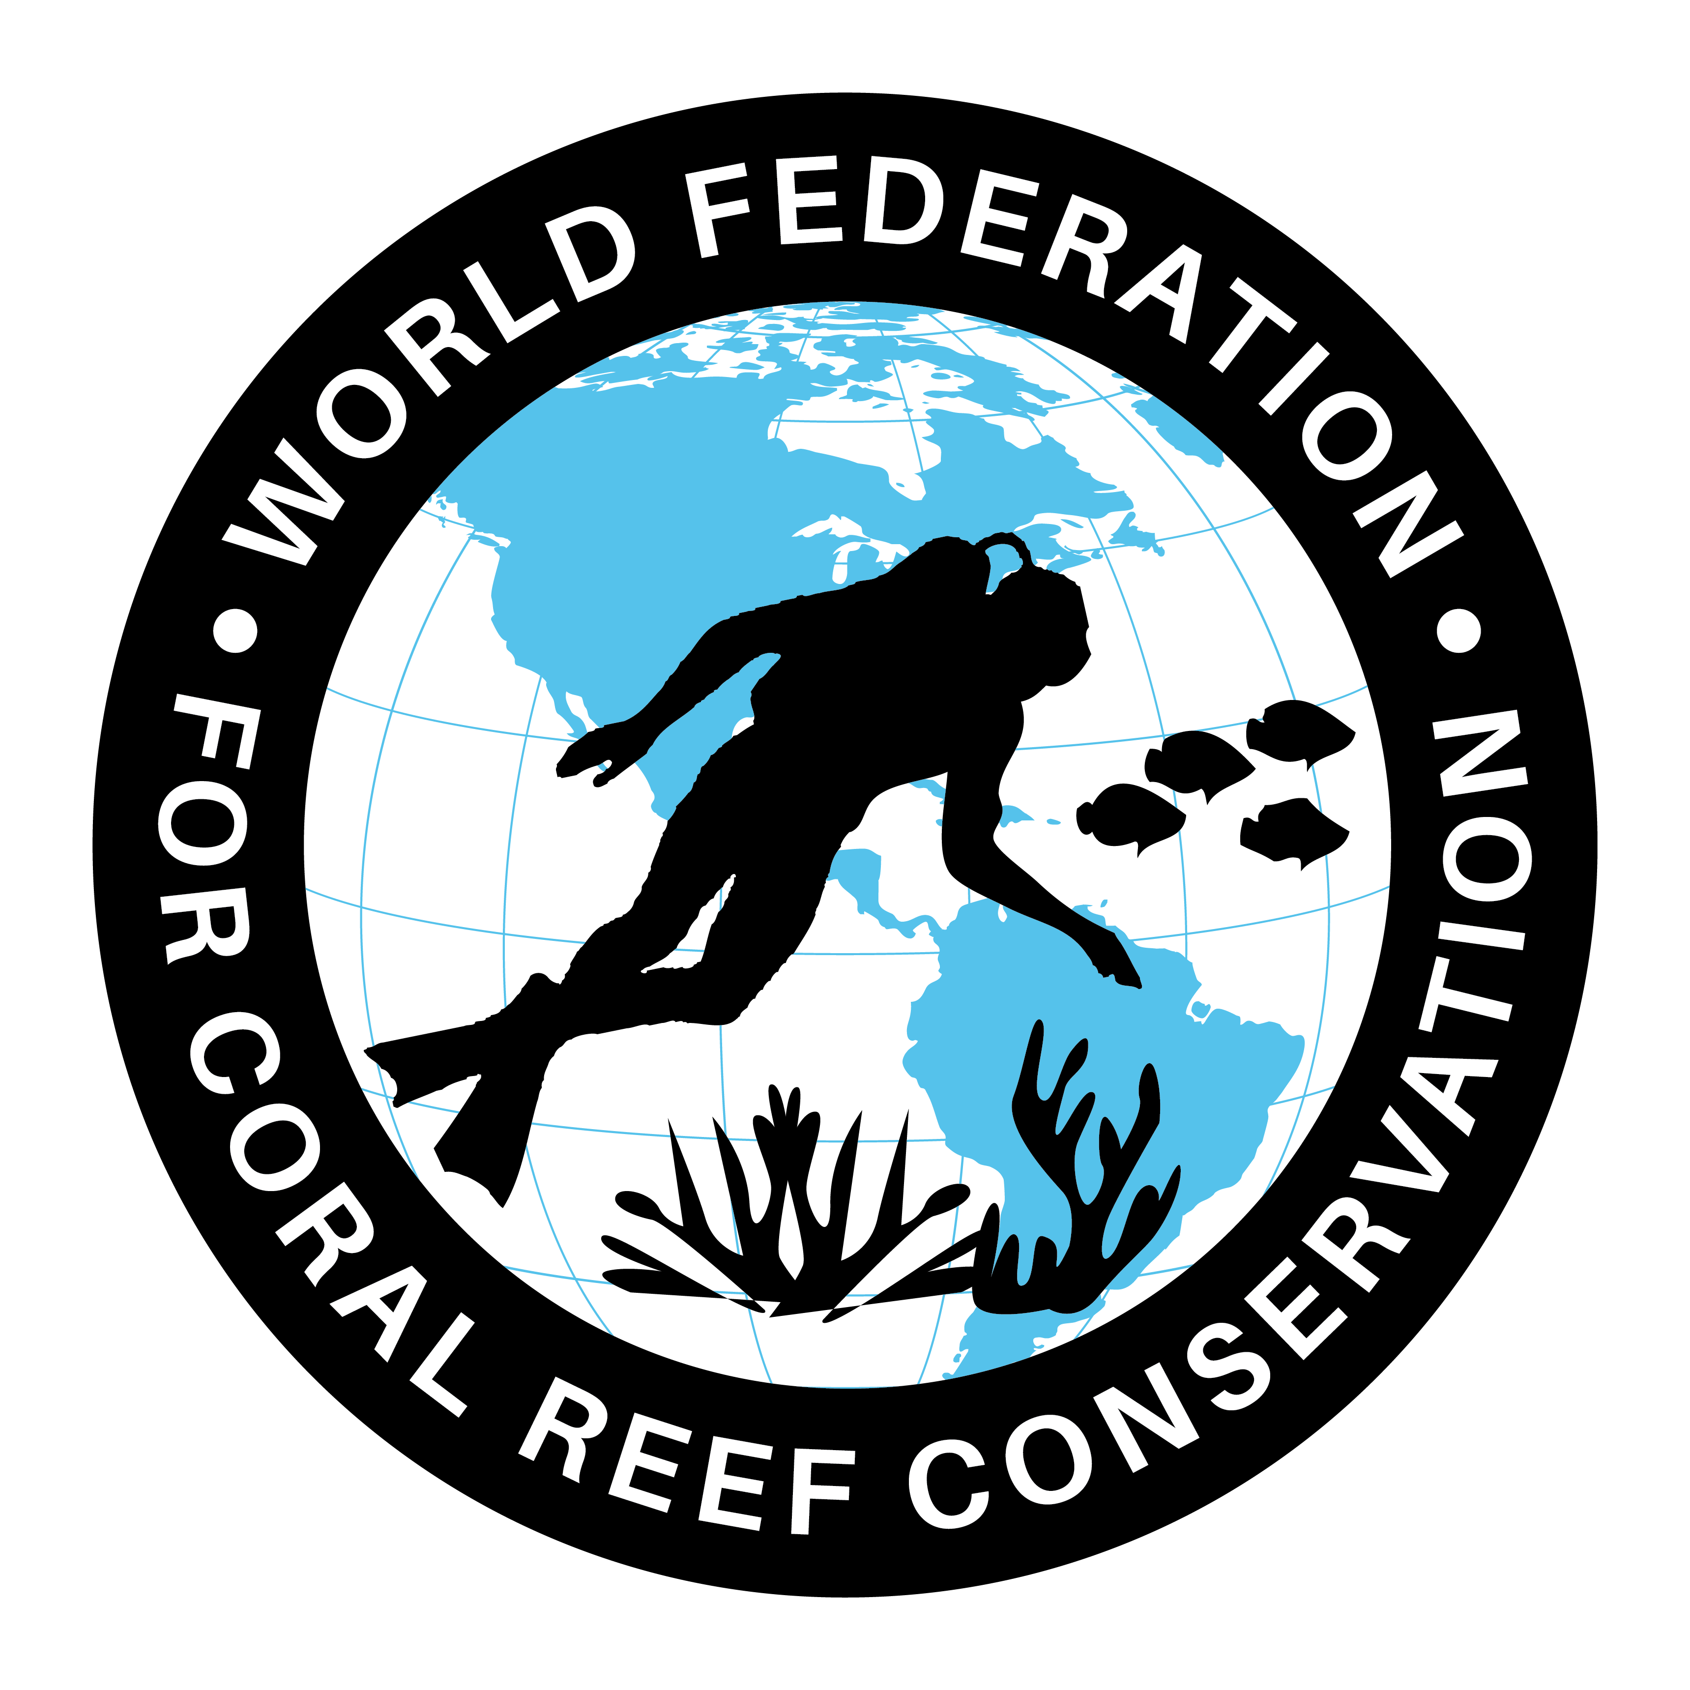
CAN-147- Save coral reefs in the
Florida Keys
Join WFCRC

The World Federation for Coral Reef Conservation 281.971.7703 642 S. Commerce Sebring, Florida 33870
Vic Ferguson Executive Director 512.986.1902 vic.ferguson@wfcrc.org info@wfcrc.org

Reprinted 9/5/18

September 5, 2018
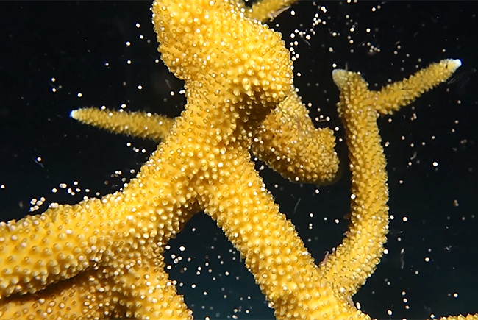
Photo: Florida Aquarium

Scientists return from a mission to save coral reefs in the Florida Keys
| 8/10/2018

Tampa, Fl. August 9, 2018- A team of Florida Aquarium scientists and divers just returned after spending 15 days in the Florida Keys for a coral spawn. The team collected 150,000 coral gametes (coral eggs and sperm) during the coral spawn that only happens once a year after a full moon. The team fertilized the eggs and then released thousands back into the wild. The remaining fertilized eggs, or embryos, are being distributed to The Florida Aquarium Center for Conservation, Georgia Aquarium, Mote Marine Laboratory and Aquarium, and Nova Southeastern University to continue research and to grow the coral for a future release.
This comes at a critical time since Florida is in the middle of the largest coral disease outbreak ever recorded, which is rapidly killing 20 different species of coral in the Florida Keys. The staghorn coral species, the primary species that was collected during the coral spawn, is not at immediate threat from the disease. However, it is listed as threatened under the Endangered Species Act.

Scientists are trying to figure out what's causing the outbreak and how to stop it. The outbreak makes the work on reproducing corals even more important because it’s necessary to raise their offspring.

“This work is more critical than ever due to the current disease outbreak in the Florida Keys,” said Keri O’Neil, Coral Nursery Manager for The Florida Aquarium. “These laboratory fertilization techniques can be used to save many coral species in the future.”

O’Neil believes practicing the techniques could restock Florida's damaged reefs with the corals raised in the laboratory at The Florida Aquarium’s Center for Conservation in Apollo Beach. The lab already houses corals collected from last year’s spawn that will be celebrating their one year birthday and will be released back into the ocean later this year.

The gametes were collected from the Coral Restoration Foundation Coral Nursery, with the work conducted by permit from the Florida Keys National Marine Sanctuary. The team worked with several partners including the Keys Marine Laboratory, Coral Restoration Foundation, Nova Southeastern University, University of Florida, South-East Zoo Alliance for Reproduction and Conservation (SEZARC), Mote Marine Laboratory and Aquarium, Sea World, Georgia Aquarium, and Horniman Museum and Gardens.

“I think it’s a really good example of the strengths in partnerships that The Florida Aquarium has formed to help save coral reefs,” said O’Neil.

More on The Florida Aquarium:
Voted a Top 3 Aquarium in North America by the readers of USA Today (May 2018)
Earned Trip Advisor Hall of Fame Rating (2018)
Earned a 4-Star rating from Charity Navigator (2018)
Additional information on Coral:
Corals are not plants, they're actually animals.
Called “the rainforests of the sea,” coral reefs only take up about 2% of the ocean floor, but host about 25% of all ocean species.
Coral reefs grow very slowly, at an average rate of just two centimeters per year.
Each individual coral is known as a polyp.
The annual synchronized spawning of corals is a spectacular event. This mass reproduction only happens once a year.
It involves colonies and species of coral polyps simultaneously releasing tiny egg and sperm bundles into the water.
The Florida Aquarium is a 501(c)(3) not-for-profit organization whose mission is to entertain, educate and inspire stewardship of the natural environment. The Florida Aquarium is accredited by the Association of Zoos & Aquariums (AZA).

For additional reading see The WFCRC Document Gallery for articles about:

- Public Service Announcements (PSA)
- Coral Alert Network (CAN)
- Emergency Reporting Reports (ERR)
- Call to Action (CTA)
- Marine Protected Areas (MPA)
- Marine Life Alert (MLA)
- Seismic and Oil Production Threats
- Natural Science Reports (NSR)
- Oil Spill Alerts (OSA)
- And other miscellaneous documents

