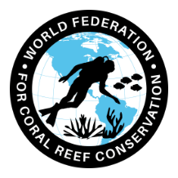

CAN-222-Coral Dying Faster Than Expected
Join WFCRC

The World Federation for Coral Reef Conservation 512.986.1902 4010 Skipper Rd. Sebring, Florida 33875
Vic Ferguson Executive Director/Founder vferguson001@gmail.com
Reprinted 1/20/23.

Florida's 350-mile-long reef tract is now shrinking faster than it's growing.
WLRN 91.3 FM | By Jenny Staletovich
Published December 8, 2022 at 4:15 PM EST

National Oceanic And Atmospheric Administration

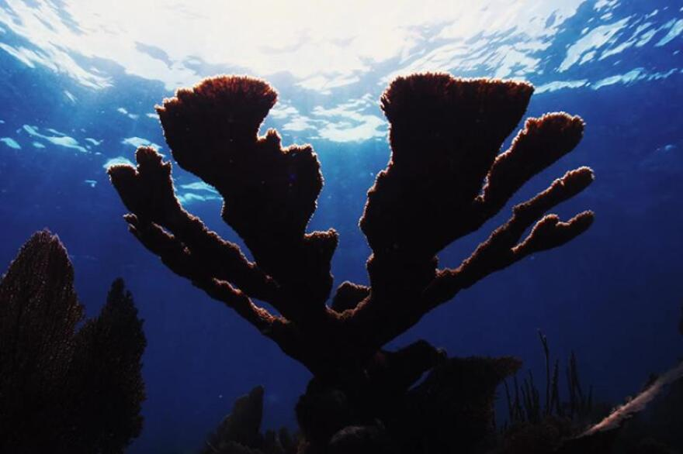
A new study based on modeling conditions along Florida's reef tract found 70 percent of reefs are eroding faster than they're growing, confirming findings from a study earlier this year that focused on the Florida Keys.
The largest wellness check ever performed on Florida’s ailing reef tract has reached a dire conclusion: The tract is in a “net erosional state” and shrinking faster than it’s growing.
The study by the National Oceanic and Atmospheric Administration and University of Miami’s Cooperative Institute for Marine and Atmospheric Studies covered the length of the 350-mile long tract from the Dry Tortugas to St. Lucie County.
Using data from NOAA’s reef monitoring network, researchers built a complex model to determine change that factored in coral, water chemistry and parrotfish, the colorful, sometimes blue-lipped fish that scour the reefs for algae.
Your generous support ensures that this trusted public news service is accessible to all, no matter what. Please donate today.
While pockets showed some growth, overall 70 percent of reefs were getting smaller.
The findings confirmed what other federal scientists looking at Keys reefs earlier this year suspected: That after 3,000 years of near stability, Florida’s reefs are succumbing to disease and impacts from climate change as scientists race to find solutions.
“We all have known that the Florida reef tract is struggling,” said John Morris, a reef ecologist and lead architect of the model. “It's when you see something at this scale, 723 sites, that is of course surprising.”
While the news is grim, Morris said the model can now help scientists target restoration work, an effort that has grown increasingly urgent as stony coral disease continues to spread.
“That was one of the bigger takeaways I was hoping for,” Morris said. “Here's the data. Here's where the risks are now. Now, how do we go from here?”
Hammered by disease and bleaching events.
In September, NOAA announced it was investigating a suspected outbreak in the Gulf of Mexico’s Flower Garden Banks marine sanctuary, a dangerous northern spread near the Texas/Louisiana coast and into the protected salt domes that form a magical underwater mountain range of coral.
Stony coral is just the latest affliction for the Florida tract, which has been hammered over the last half century by disease and bleaching events that have become more intense and longer lasting as climate change warms water.
By the 1980s, fast-growing staghorn and elkhorn that turned the reef into a powerful barrier to hurricane storm surges had been largely wiped out. What was mostly left was slower growing mounding corals that do less to expand the reef and provide little habitat for fish and other reef wildlife.

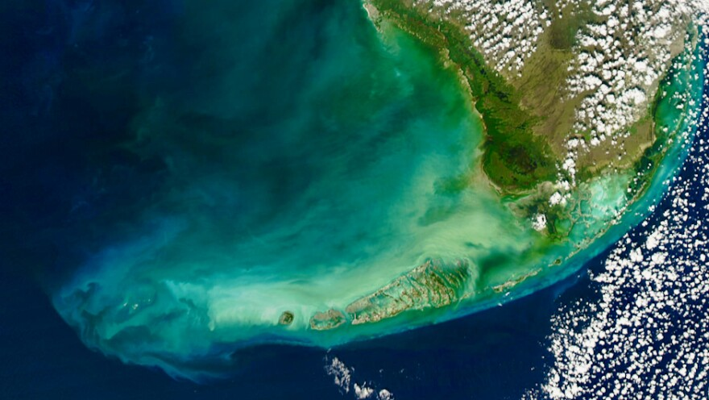
University Of Miami Rosenstiel School Of Marine, Atmospheric And Earth Science
/
The study found the worst conditions on northern reefs off dense urban areas in Broward and Miami-Dade where 98 percent were eroding faster than they were growing and sustainable habitat no longer existed.
In 2014, scientists already worried about warming water and increasing acidification driven by climate change, first detected off Virginia Key. It quickly spread up and down the tract and into the Caribbean and Yucatan.
NOAA issued an emergency response plan to battle the disease in October. But while the disease is being fought, scientists say rebuilding the reef can’t wait.
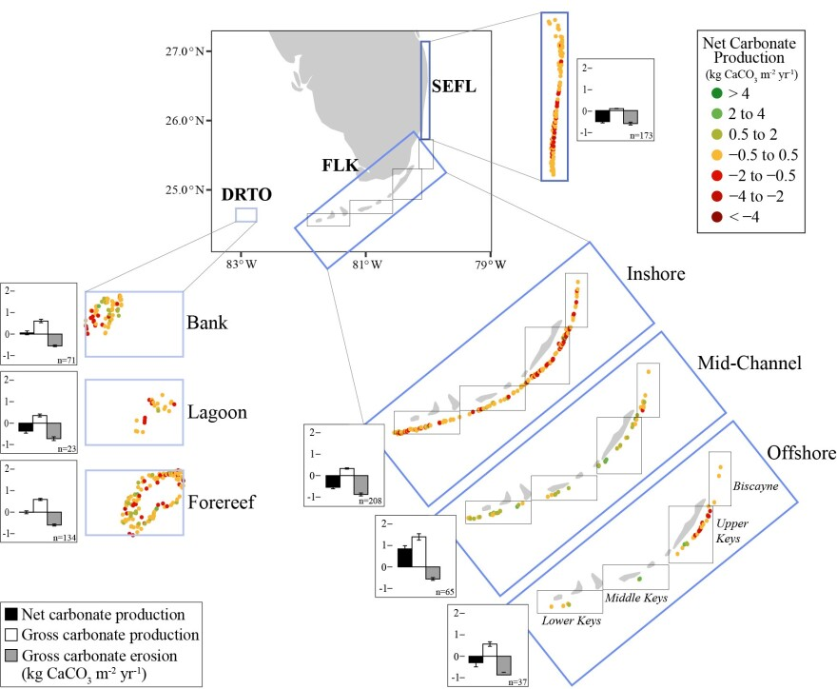
“This is proof that they're not doing well,” said Erica Towle, the coordinator for NOAA’s reef monitoring network. “We do need to physically restore the reef structure that has been lost. And the best way to do that is active coral reef restoration. So literally out-planting corals back out onto Florida's coral reef.”
The model can guide that work, she said, because it determines conditions at specific points, which can tell scientists what kind of restoration might work.
Not surprisingly, reefs have shrunk the closest to dense urban areas off Broward and Miami-Dade counties. About 98% of the reef in the region has shrunk.
“There's no actual sustainable habitat growth in the northernmost part of the reef tract,” Morris said.
NOAA Scientists calculated reef development, or carbonate production, to determine growth and erosion along the reef tract.
Better news in the Keys
But in the Middle and Lower Keys, conditions are less grim.
Near the remote Dry Tortugas, in an area protected by the national park and helped by flushing and nutrients from the nearby Loop Current, the model found reefs in equilibrium, not growing but also not shrinking. In the Middle Keys, reefs sandwiched between the inshore and offshore reefs showed signs of growth.
“So, there is room for hope that these mid-channel reefs might persist and we have to look at them for how to protect the other 70%,” Morris said.
Creating the model, Towle said, was no easy feat.
While others have looked at the specific factors that lead to healthy reefs — either the amount of coral growth or water chemistry — the model is the first to combine them, she said.
“So, all of those co-located data sets at 723 sites is really, really powerful,” she said.
To work, she said, the model had to factor in the differences in those things: varying growth rates for different species of coral and the size and number of parrotfish, which eat algae and can either help clean the reef or harm it by wiping out algae. Ocean chemistry can also affect coral growth and resilience.
“It really puts all of those data streams together, and really for one of the first times allows us to have the most holistic picture of what's really happening in the Florida reef tract," Towle said.

Tags
Environment News Local News coral reefs Florida reef NOAA
Jenny Staletovich
Jenny Staletovich has been a journalist working in Florida for nearly 20 years.

See stories by Jenny Staletovich
Related Content
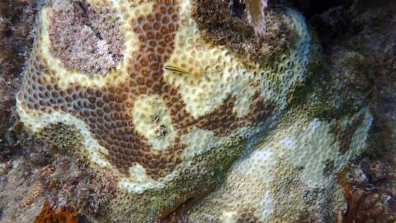
- Research Breakthrough Finds Hope For Corals Infected With Stony Coral Disease — They Can Fight Back
- After thousands of years of near stability, Florida reefs are now shrinking
- As Mysterious Disease Kills Florida’s Reefs, A Massive ‘Noah’s Ark’ Effort Tries To Save Them

Support your local coral reef conservation organization.

Thank You
Vic Ferguson
The World Federation for Coral Reef Conservation
vferguson001@gmail.com
512.986.1902

The only thing necessary for the triumph of evil is that good men do nothing”….Edmund Burke

