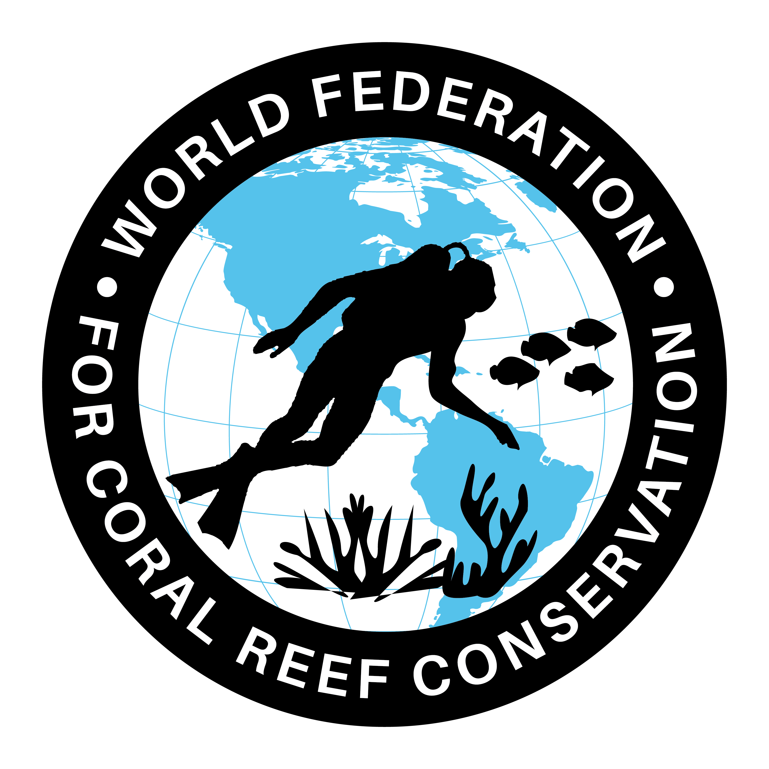
CTA-080-Ocean Free of Plastics-World’s Oceans
Join WFCRC

The World Federation for Coral Reef Conservation 281.971.7703 P.O. Box 311117 Houston, TX 77231
Vic Ferguson Executive Director 512.986.1902 vic.ferguson@wfcrc.org info@wfcrc.org

Reprinted 9/17/17

Sunday, September 17, 2017, 00:01 by G. Kathleen Hill

An ocean free of plastic - G. Kathleen Hill
The fight against plastic pollution is one of four main strands of the 2017 Our Ocean Conference that will be hosted by the European Union in Malta on October 5 and 6, 2017.

High-level ocean champions from around the world will gather under the motto ‘Our Ocean – an Ocean for Life’ to underscore the importance of ocean protection and sustainability.

Initiated by the United States in 2014, the Our Ocean Conferences have produced 250 concrete actions across the world, committed over €8.2 billion and designated 9.9 million square kilometers as new Marine Protected Areas (MPAs).

During this October’s Our Ocean Conference, international delegates will discuss ways to create protected marine areas, encourage a sustain-able blue economy and prevent marine pollution.

In conjunction with the Our Ocean Conference, I am very proud to say that the interactive exhibition, ‘An Ocean Free of Plastic’, is now open to the public at the Malta National Aquarium in Qawra up to October 11.

I would like to thank our partner, the Malta National Aquarium, for its invaluable support. We hope that readers will visit the exhibition to learn more about the impact of plastic pollution in the ocean and what we can all do to prevent it. We encourage readers to contact the Malta National Aquarium to learn about different activities that are being organized for children and youth.

The health of our planet’s oceans determines in large part the health of our own bodies and the health of our economies
Plastic pollution is a serious threat to our oceans, putting fragile ecosystems, marine life, economic livelihoods and human health at risk. Every year 10 million tons of plastic are discharged into the ocean, where they can remain for up to 400 years. ‘An Ocean Free of Plastic’ describes the impacts of micro-plastics on the ocean environment and provides examples of actions individuals can take at home to prevent plastic from ending up in the sea.
Twice a year, the US Embassy organizes clean-ups at various beaches around the island with many local partners. It always amazes me that the bulk of the trash is plastics like water bottles, plastic bags and containers.

Coastal trash is a serious pollution problem that affects the health of people, wildlife and local economies. It is our personal responsibility to keep our beaches and seas clean and be better stewards of our environment. We must not rely only on the authorities, or anyone for that matter, to clean up outdoor spaces. Each one of us has a duty to reduce the amount of garbage we generate but we also have a duty to ensure that we dispose of our garbage responsibly.

By keeping our beaches, seas and oceans clean we can maintain a healthy and productive marine environment and marine ecosystems.
One of Malta’s commendable initiatives, as president of the European Commission, was to organize a conference on ‘Marine Protected Areas: Initiatives and Opportunities’. The goal was to discuss best practices in marine environmental management and to exchange views on the impact of marine pollution and biodiversity. The results of this conference will feed into the discussions on marine protection in the upcoming Our Ocean Conference.

Our oceans feed us, protect us and provide our industries with services, from transportation to tourism to trade of all kinds. The health of our planet’s oceans determines in large part the health of our own bodies and the health of our economies. Future generations depend on our responsible stewardship.
Rest assured that the US government remains committed to environmental initiatives, from lowering its greenhouse gas emissions through innovation, to protecting the environment.

The United States has a strong record of reducing greenhouse-gas emissions through technology, innovation and entrepreneurship. We will continue to be a world leader in innovation, particularly the development of next-generation energy technology. We will continue to champion ocean protection and sustainability.

As Karmenu Vella, European Commissioner for Environment, Maritime Affairs and Fisheries, has said: “Forests are our planet’s green lung, but oceans are its blue heart. It is now up to all of us to keep this blue heart beating.”

G. Kathleen Hill is the US Ambassador to Malta.

