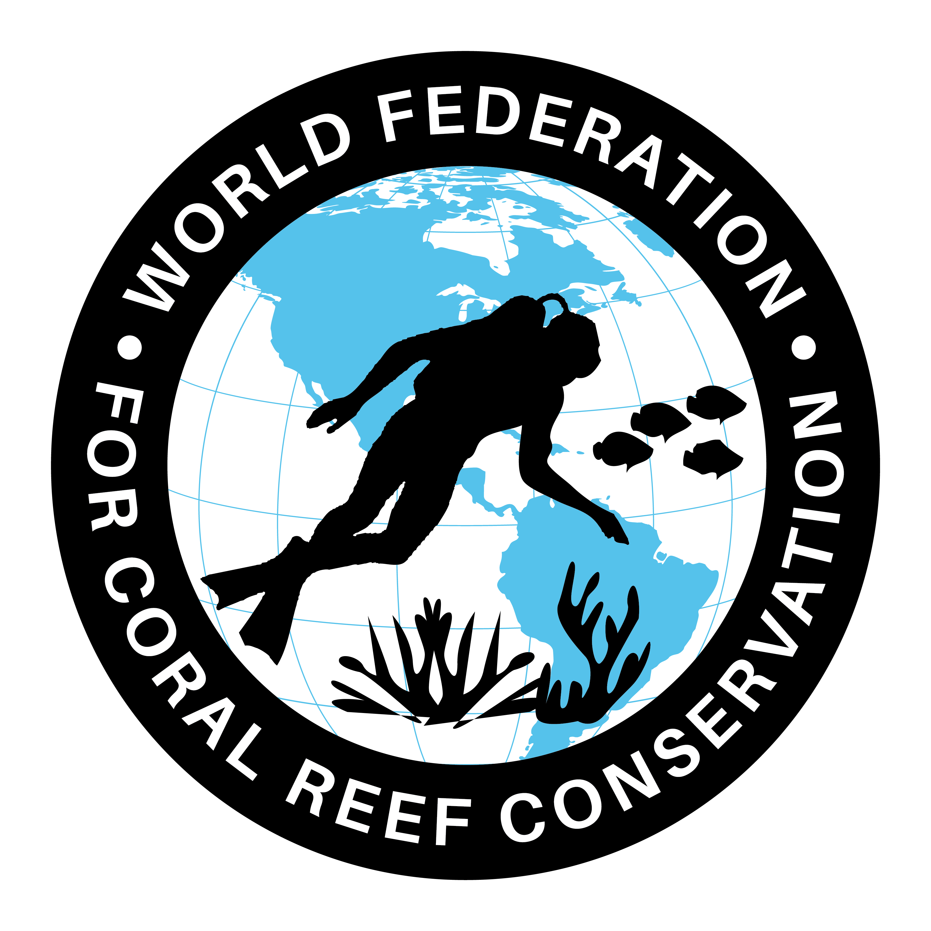
CTA-082-Marine Litter undermines Enviornment
Join WFCRC

The World Federation for Coral Reef Conservation 281.971.7703 P.O. Box 311117 Houston, TX 77231
Vic Ferguson Executive Director 512.986.1902 vic.ferguson@wfcrc.org info@wfcrc.org

Reprinted 9/19/17

Marine litter undermines benefits
of coastal environments
July 15, 2015

Marine litter can undermine the psychological benefits of coastal environments, a study has shown.
The beneficial effects of the blue environment to human health and well-being are well documented, but there has been little research into how the growing global issue of marine litter might negate them.

To measure this, Plymouth University secured funding from the Natural Environment Research Council (NERC) and the Economic and Social Research Council (ESRC) to assess public reaction to the differing conditions of coastlines.

Participants were shown images of clean beaches and some featuring seaweed (natural debris), but also ones with quantities of fishing debris (such as rope, nets and packaging) and public litter (including drinks cans, plastic bottles, sweet and crisp wrappers).

The results - published in the journal Environment and Behaviour—showed the clean condition was consistently rated most positively, whereas the two littered conditions were rated more negatively, with the public litter condition being rated the worst.

The paper's lead author Dr Kayleigh Wyles undertook the research as part of her PhD studies, and is now working as a Post-Doctorate Research Fellow at Plymouth Marine Laboratory (PML). She said: "When clean, the coast is associated with many psychological benefits including making us feel revitalised when experiencing it, but the reality is the coast is commonly degraded by the presence of marine litter. The interesting finding in this work is that not only does litter undermine the psychological benefits typically provided by coastal settings, but the type of litter is important. We hope this work strengthens the importance of addressing marine litter, for human health and well-being, as well as for the environmental and financial costs."

The research, a collaboration between psychologists and marine scientists, used both quantitative and qualitative methods where individuals rated the varied series of coastal scenes.

From this, the researchers could examine the precise influence of litter in terms of perceived restorative quality and psychological impacts, with the results showing scenes with litter were rated negatively on a number of measures, with litter stemming from the public having the most adverse impact.

Whilst studies of this kind in the past have focused on pristine, clean environments, the images used in this study were contextually much more realistic, using photos of marine environments which were spoiled from abundant marine litter, an increasing real-life issue in coastal environments worldwide.

Dr Sabine Pahl, Associate Professor in the School of Psychology at Plymouth University, says: "We know that stated preferences directly translate into visits, and economic data shows tourism suffers when coasts are littered. For our research, only a small quantity of litter was added to the scenes, covering less than 10% of the beach. This is much less than would be washed up after a storm, but still, we found these very consistent negative psychological effects. Given the increasing litter on our coasts and in our seas, the psychological effects can be expected to get worse."

Professor Richard Thompson, of the School of Marine Science and Engineering at Plymouth University, has been working on the effects of marine litter for over 20 years. He said: "Marine litter is a global environmental problem, with habitats form the poles to the equator and shorelines to the deep sea contaminated with debris. We have previously shown marine litter is harmful to numerous species of marine life and it is clear there are major financial costs keeping tourist beaches and ports and harbours clean. Yet it is a problem that can be solved, and our work underscores the need for action to reduce emissions of litter to the environment and educate about its many harmful effects."
Explore further: Over 50 years of marine litter research now available to all in new book
Journal reference: Environment and Behaviour
Provided by: University of Plymouth
Read more at: https://phys.org/news/2015-07-marine-litter-undermines-benefits-coastal.html#jCp

For additional reading see The WFCRC Document Gallery for articles about:
- Public Service Announcements (PSA)
- Coral Alert Network (CAN)
- Emergency Reporting Reports (ERR)
- Call to Action (CTA)
- Marine Protected Areas (MPA)
- Marine Life Alert (MLA)
- Seismic and Oil Production Threats
- Natural Science Reports (NSR)
- Oil Spill Alerts (OSA)
- And other miscellaneous documents

