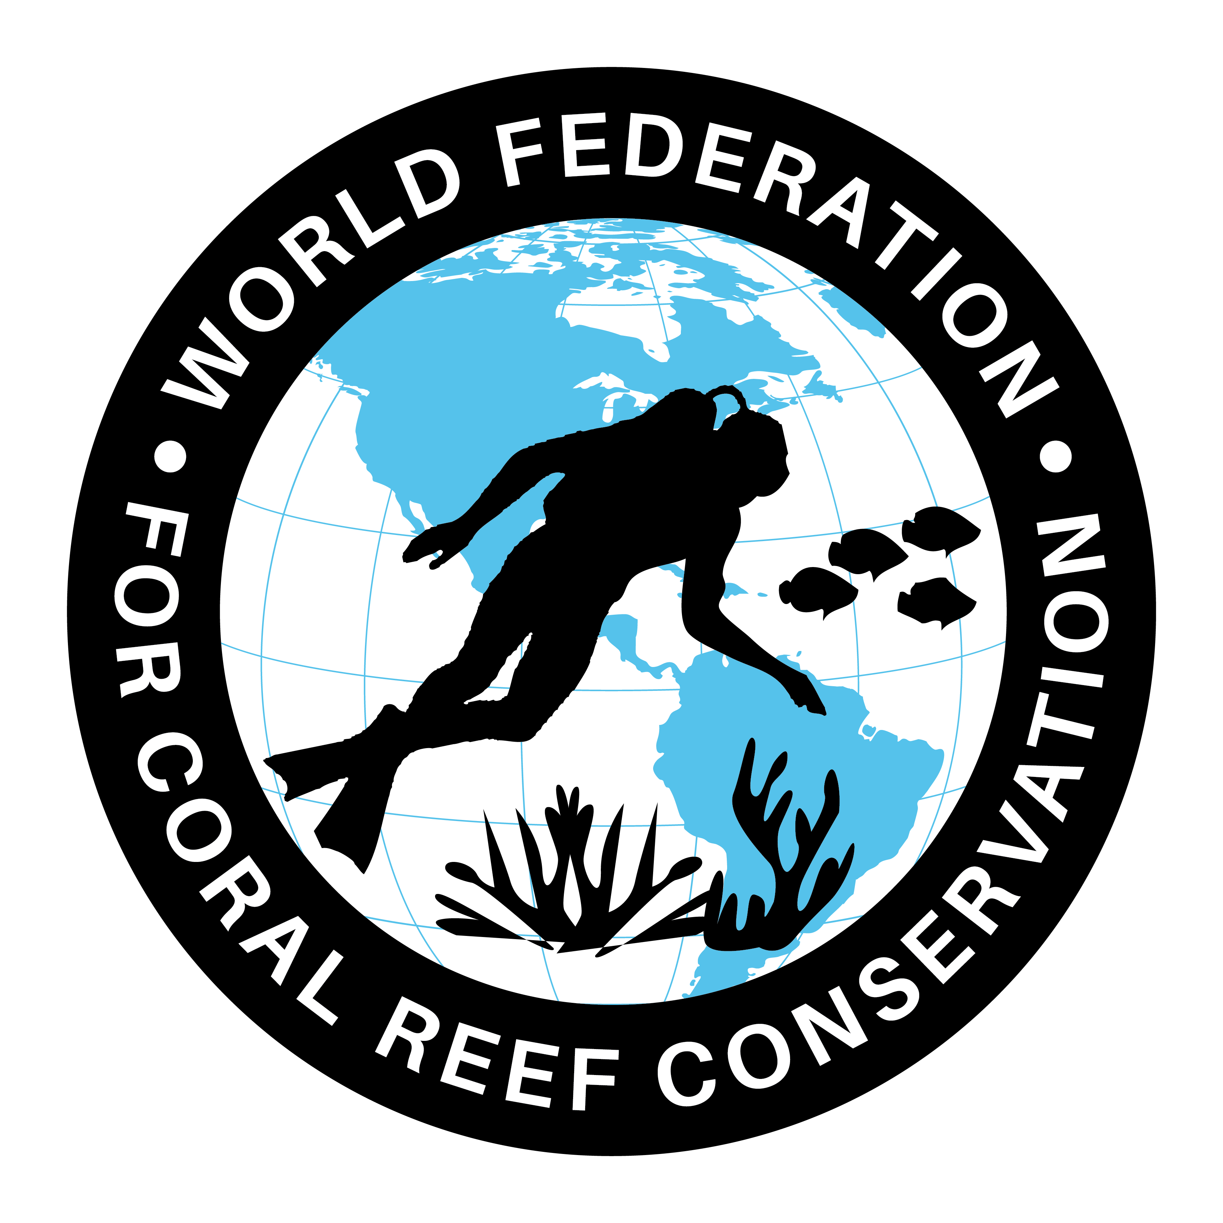
CTA-086-Prince Charles on Ocean Pollution
Join WFCRC

The World Federation for Coral Reef Conservation 281.971.7703 P.O. Box 311117 Houston, TX 77231
Vic Ferguson Executive Director 512.986.1902 vic.ferguson@wfcrc.org info@wfcrc.org

Reprinted 10/6/17

'Supreme wake-up call': Prince Charles urges action on ocean pollution
Prince says catastrophic hurricanes are consequence of climate change and welcomes growing awareness of plastic pollution
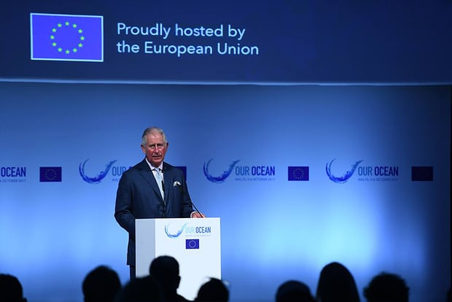

‘We must never mistake [the oceans] for a new frontier for endless economic exploitation,’ the Prince of Wales told the Our Ocean conference. Photograph: Courtesy EU Maritime Affairs and Fisheries
Fiona Harvey in Malta
Thursday 5 October 2017 11.42 EDTFirst published on Thursday 5 October 2017 10.29 EDT
The world’s oceans are at last receiving the attention they deserve, as the scale of plastic pollution is finally becoming clear, the Prince of Wales has said, hailing this growing awareness as the first step to saving the marine environment.
Prince Charles said it had taken years for the enormity of the problem to emerge, but promised to make it a key priority of his campaigning, alongside rainforests.
But he also confessed to mounting despair over how little has been achieved in his four decades of environmental campaigning, fearing we are “no longer a rational civilisation” but are driven by economic ideology.

Fish mistaking plastic debris in ocean for food, study finds

Read more
He pointedly chose not to mention President Trump, who has denied climate change, but warned: “If the unprecedented ferocity of recent catastrophic hurricanes is not the supreme wake-up call that it needs to be, to address the vast and accumulating threat of climate change and ocean warming, then we – let alone the global insurance and financial sectors – can surely no longer consider ourselves part of a rational, sensible civilisation.”
He blamed “some strange, ideological urge to test the world to destruction”.
The prince, who has long been a campaigner on rainforests, told a marine conference that oceans were now a twin passion for him. “While we should be relieved that the health of the ocean is now understood, alongside rainforests, to be one of the essential prerequisites for our physical and economic survival, I wonder if the ocean’s fragility is yet truly grasped and how susceptible it is to the impacts of our economic activities … We must never mistake [the oceans] for a new frontier for endless economic exploitation.”
At the Our Ocean conference, the EU also announced plans to devote more than €550m to protecting the health of oceans, with more than 30 initiatives including efforts to combat piracy and illegal fishing, a satellite monitoring system, and a new plastics strategy for the bloc.
Federica Mogherini, the EU’s high representative for foreign affairs and security policy, said: “The sea is a global common. We all have a responsibility to preserve it as a treasure and avoid that it turns into a threat. The EU believes that a globalised world needs a more cooperative global governance. It is impossible to imagine global governance without a cooperative oceans governance.”
Mogherini hoped that other countries would come forward with funding to bring the total to more than €1bn.
Karmenu Vella, the Maltese EU environment commissioner, said: “The EU has been a driving force behind the truly global effort [to protect marine life]. We have EU commitments on ocean governance, illegal fishing and the Arctic.”
One new EU initiative is to establish the first marine-protected area in the Adriatic. About 90% of fish stocks in the Mediterranean are currently over-exploited.
Another initiative announced at the conference to reduce the impact of plastic pollution was the consumer goods group Procter and Gamble’s plan to produce a new Fairy Liquid bottle made entirely of recycled plastic, including some retrieved from the ocean.
Sky announced it would remove all single-use plastic products from its operations and supplychains by 2020. The company will also invest £25m in a fund for startups and other businesses working on technology to solve the plastic problem.
In the Pacific, the small island of Niue, with the help of National Geographic and the UN development programme, is creating a marine-protected area covering approximately 127,000 sq km, more than 40% of its sea area. The island, a self-governing community in free association with New Zealand, is one of the world’s biggest raised coral atolls.
Chile is creating two new reserves, one around the Juan Fernández archipelago and another around Cape Horn, covering more than 1m sq km, bringing to 29% the amount of its seas surface area covered by reserves where fishing and extractive activities are banned.
For additional reading see The WFCRC Document Gallery for articles about:
- Public Service Announcements (PSA)
- Coral Alert Network (CAN)
- Emergency Reporting Reports (ERR)
- Call to Action (CTA)
- Marine Protected Areas (MPA)
- Marine Life Alert (MLA)
- Seismic and Oil Production Threats
- Natural Science Reports (NSR)
- Oil Spill Alerts (OSA)
- And other miscellaneous documents

