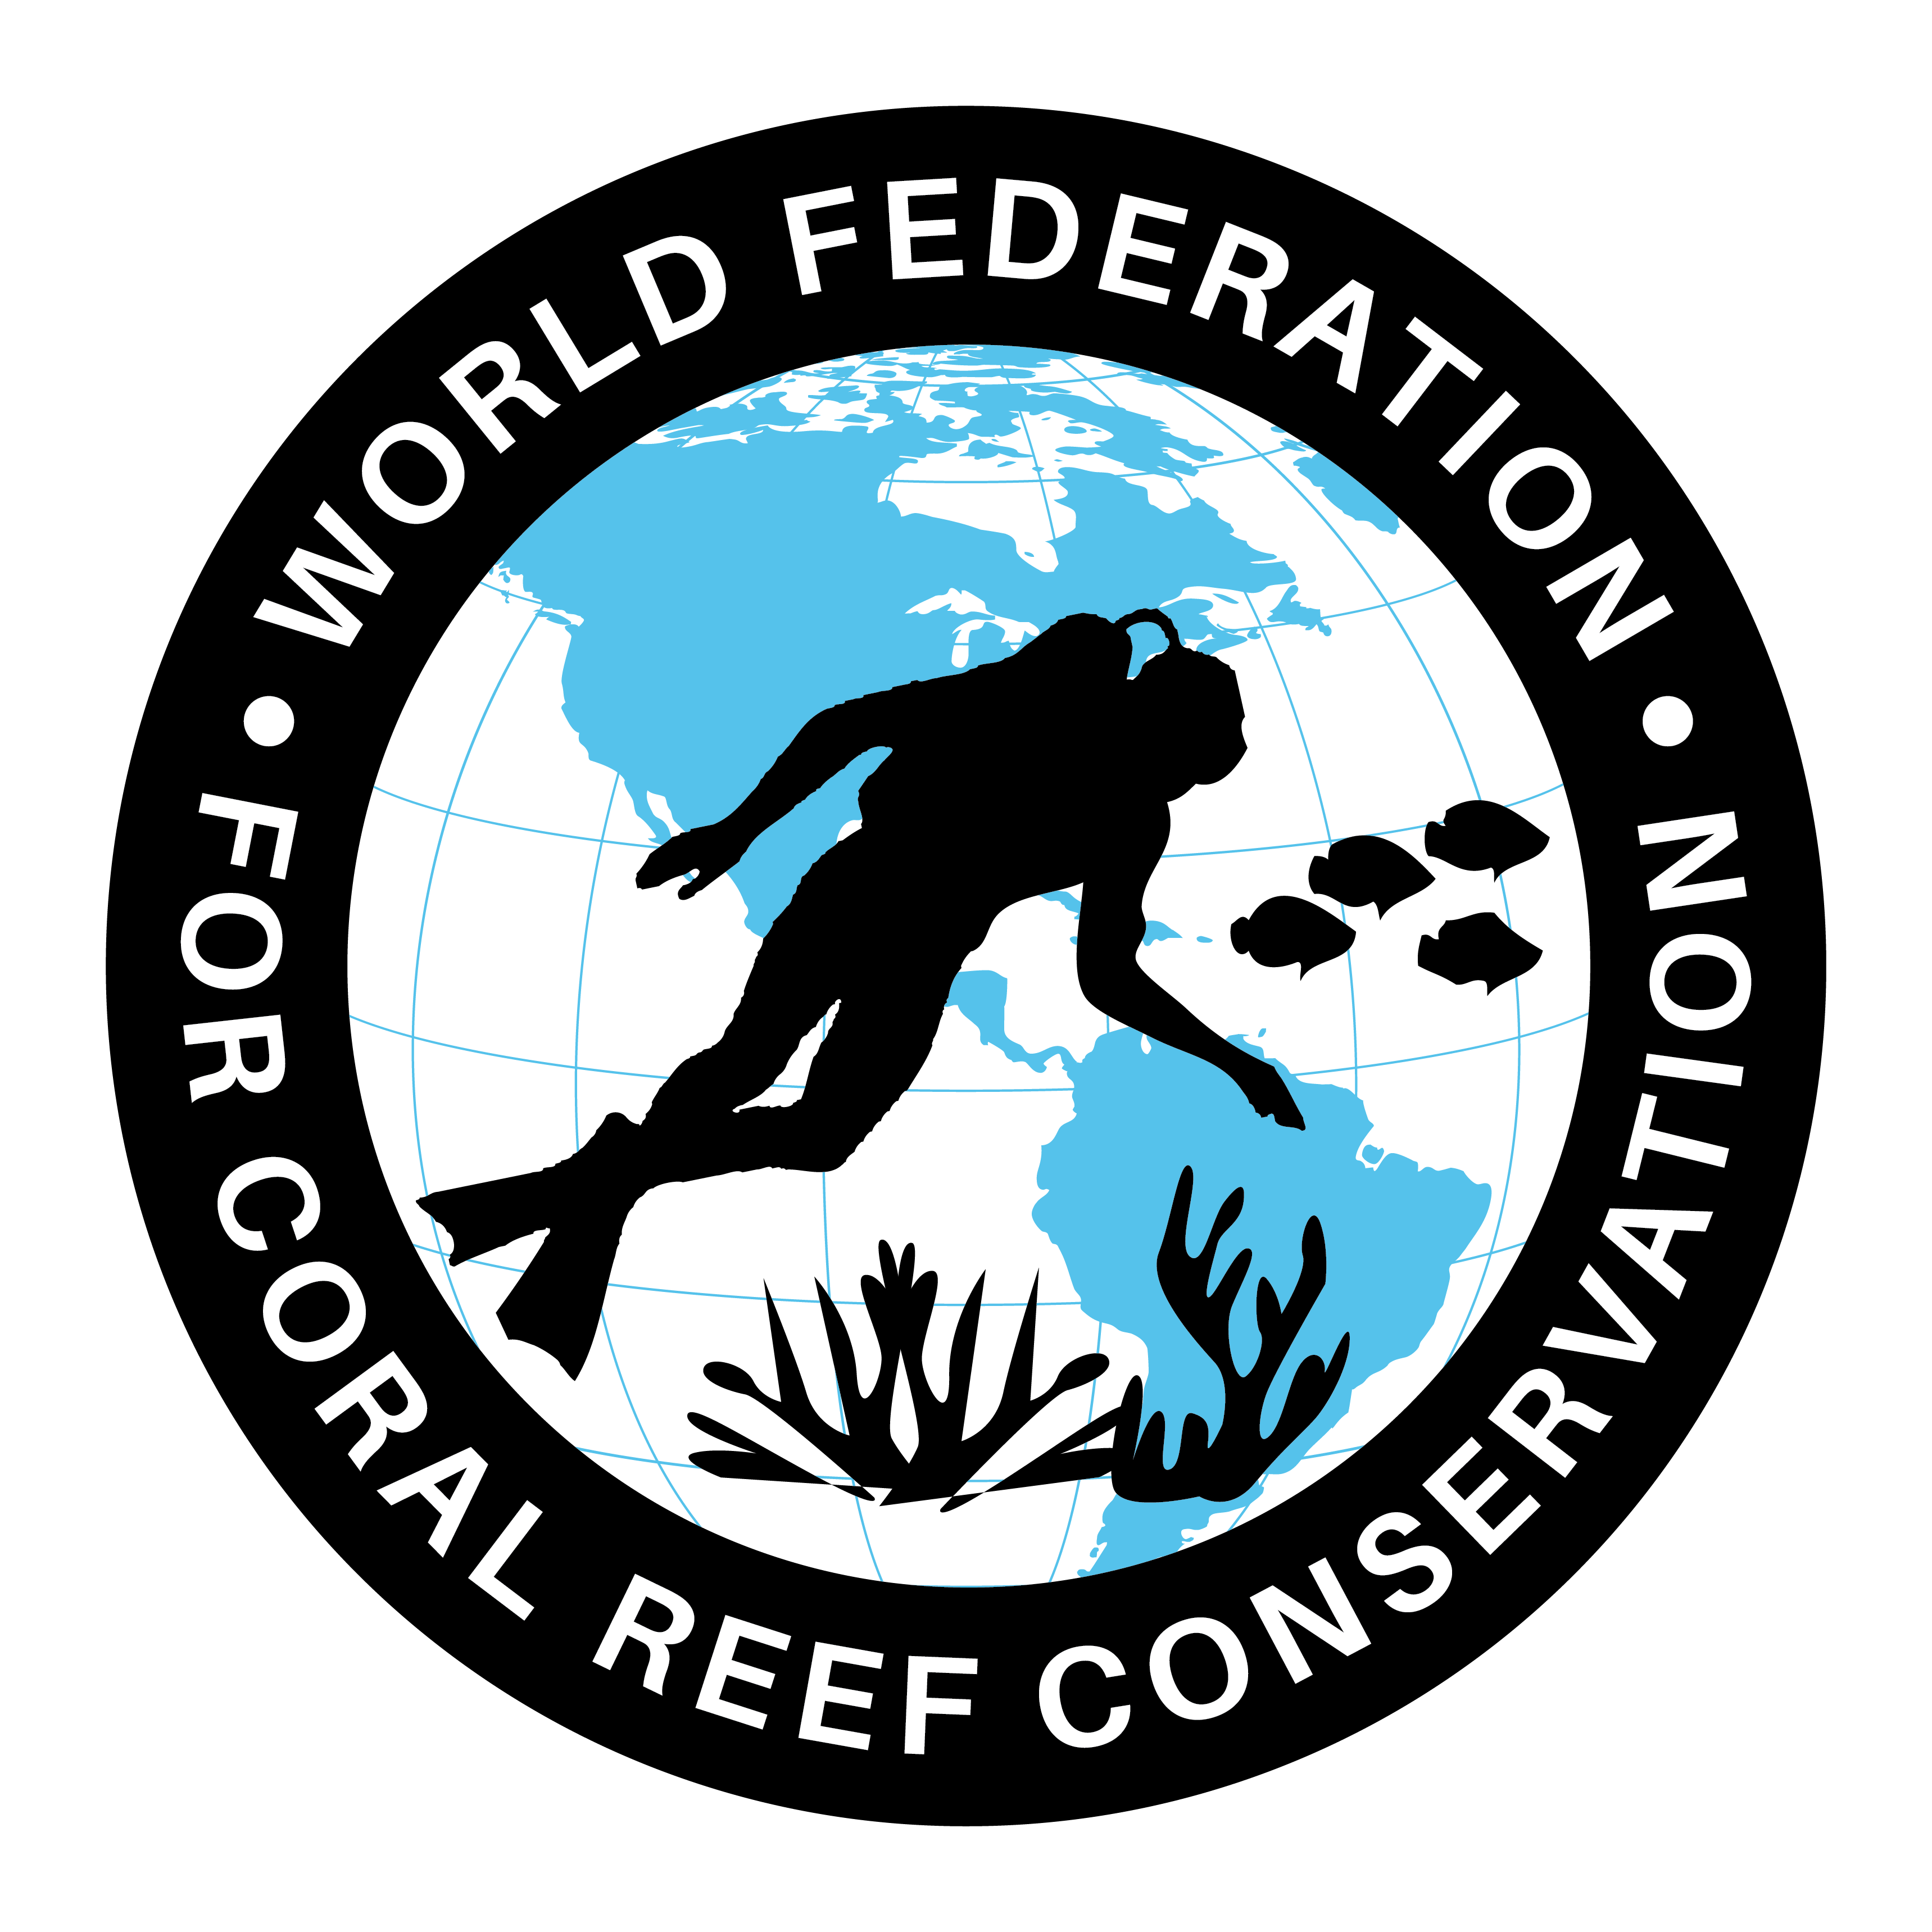
CTA-088-Finance for Ocean Plastic Clean Up
Join WFCRC

The World Federation for Coral Reef Conservation 281.971.7703 P.O. Box 311117 Houston, TX 77231
Vic Ferguson Executive Director 512.986.1902 vic.ferguson@wfcrc.org info@wfcrc.org

Reprinted 10/8/17

Newsroom

A VOICE FOR OUR OCEAN

New Initiative Launches at Our Ocean to Finance Solutions to Ocean Plastic
OCTOBER 4, 2017

Ocean Conservancy, the Trash Free Seas Alliance® and Closed Loop Partners to raise $150 million for a new funding mechanism to address waste management in Southeast Asia
MALTA, October 5, 2017 (Ocean Conservancy) – At the Our Ocean 2017 conference, a global gathering of world leaders to address some of the world’s most pressing ocean challenges, Ocean Conservancy and its partners, including the Trash Free Seas Alliance®, Closed Loop Partners, PepsiCo, 3M, Procter & Gamble, the American Chemistry Council, and the World Plastics Council announced an initiative to raise over $150 million for a new funding mechanism to prevent plastic waste from leaking in to our ocean.
The initiative is designed to fund waste management and recycling solutions in Southeast Asia, with a focus on investments to improve collection, sorting and recycling markets. Nearly half of the plastic that flows into the ocean every year – an estimated 8 million metric tons – escapes from waste streams in just five rapidly developing economies in Asia (Indonesia, Philippines, Vietnam, Thailand and China).
“This is a major breakthrough in the fight for trash free seas,” said Susan Ruffo, managing director of international initiatives at Ocean Conservancy. “Our research has found that by improving waste management in Southeast Asian countries, we can cut the flow of plastic going in the ocean by half by 2025. A funding mechanism will take this goal from dream to reality, and support efforts by governments and local groups on the ground to improve their livelihoods and well-being while also improving ocean health.”
Scientists estimate that over 150 million metric tons of plastics are currently in the ocean today, entangling wildlife, polluting beaches, and costing coastal communities hundreds of millions of taxpayer dollars. That number could grow to 250 million metric tons in less than a decade if immediate action isn’t taken.
The new funding mechanism will be operated by Closed Loop Partners, an investment firm that invests in companies, technology and recycling facilities to turn waste into value and advance the circular economy. This new mechanism will catalyze new investments from the private sector, governments, and development finance institutions; demonstrate eco-system solutions; and build a pipeline of bankable waste management projects to demonstrate investment viability and maximize recycling profitability.
“Through this initiative, we will invest in and support the municipalities, entrepreneurs, investors and NGOs working to reduce ocean plastics and improve waste management in Southeast Asia,” said Rob Kaplan of Closed Loop Partners. “Our investments across North America — from recycling collection in Tennessee to developing new end markets for waste plastics in Louisiana — have resulted in tangible improvements to waste collection and recycling. Our model is to take the best practices in waste management investment, leverage the world’s largest consumer goods supply chains, and marry them with on-the-ground partner expertise and work.”
Effective waste management reduces plastics waste leakage, leads to healthier citizens, creates jobs, and reduces emissions of toxins and carbon. It is also a critical component to making a circular economy function, ensuring that materials can be recovered for reuse and recycling. This initiative aims to solve the root causes of plastics in the ocean by investing in the systems and emerging technologies needed to capture and transform waste into valuable commodities before it reaches marine environments, while also providing tangible benefits to communities.
Consumer goods companies and plastics manufacturers support the project. Early commitments from PepsiCo, 3M, Procter & Gamble, the American Chemistry Council and the World Plastics Council have fully funded the design phase of the fund.
“P&G is proud to be a part of this initiative,” said Jack McAneny, Director of Sustainability, Procter & Gamble. “Plastics play an important role in commerce, but they clearly don’t belong in our waterways and oceans. Thanks to the vision of Ocean Conservancy, we now have a multi-stakeholder collaborative effort that can drive the kind of innovation and scale that we need to stop the flow of plastics to the environment and ideally give these materials a second life.”
The initiative aims to share the results of its initial phase of work within the next year to help build the field of investors looking to deploy capital into this market.
The Trash Free Seas Alliance is comprised of:
Ocean Conservancy, Algalita Marine Research and Education, The Coca-Cola Company, Covanta Energy, The Dow Chemical Company, ITW, Keep America Beautiful, The Marine Mammal Center, The Ocean Recovery Alliance, Project AWARE Foundation, Amcor, American Chemistry Council, Bank of America, Cox Enterprises, DANONE, Dart Container Corporation, Georgia Aquarium, Nature Works, Nestlé Waters NA, Procter & Gamble, REDISA, Rozalia Project for a Clean Ocean, The Consumer Goods Forum, Vancouver Aquarium, Walmart, World Animal Protection, The World Plastics Council, World Wildlife Fund www.trashfreeseas.org

Ocean Conservancy is working to protect the ocean from today’s greatest global challenges. Together with our partners, we create science-based solutions for a healthy ocean and the wildlife and communities that depend on it.
www.oceanconservancy.org
Closed Loop Partners
Closed Loop Partners invests in sustainable consumer goods, advanced recycling technologies and the development of the circular economy.
www.closedlooppartners.com

For additional reading see The WFCRC Document Gallery for articles about:
- Public Service Announcements (PSA)
- Coral Alert Network (CAN)
- Emergency Reporting Reports (ERR)
- Call to Action (CTA)
- Marine Protected Areas (MPA)
- Marine Life Alert (MLA)
- Seismic and Oil Production Threats
- Natural Science Reports (NSR)
- Oil Spill Alerts (OSA)
- And other miscellaneous documents

