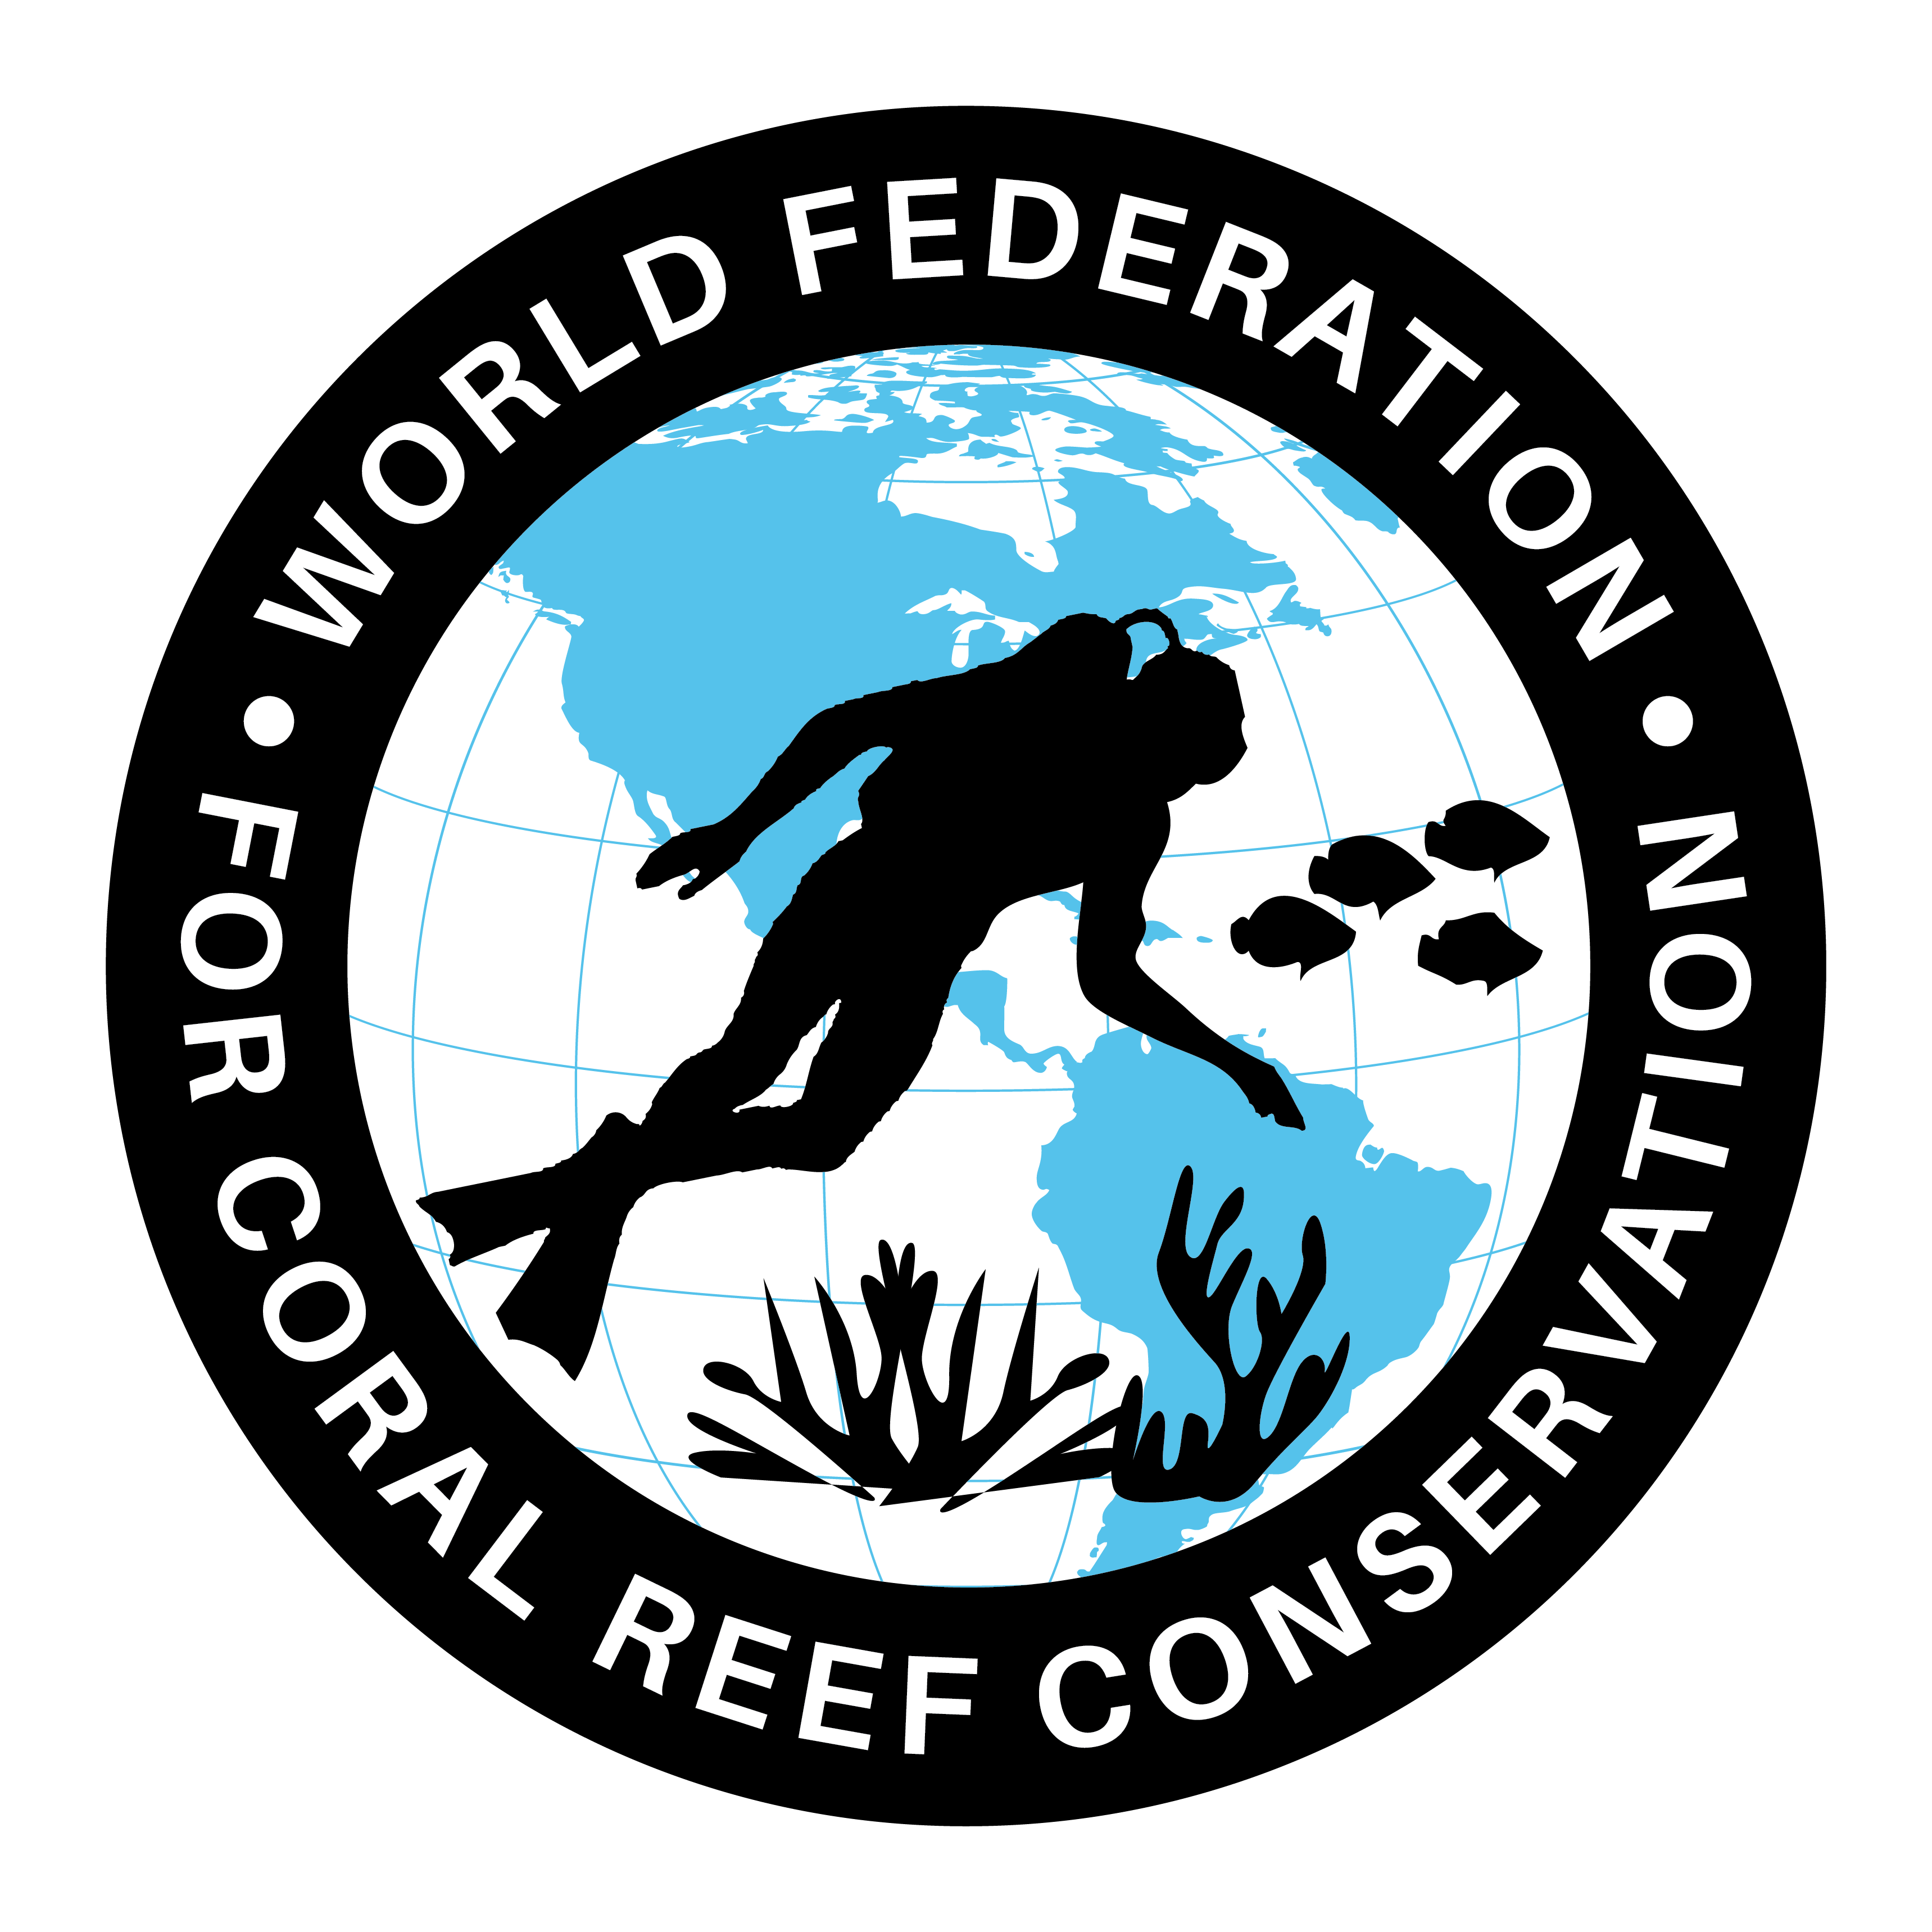
CTA-091-UN Report on Plastic in the Ocean
Join WFCRC

The World Federation for Coral Reef Conservation 281.971.7703 P.O. Box 311117 Houston, TX 77231
Vic Ferguson Executive Director 512.986.1902 vic.ferguson@wfcrc.org info@wfcrc.org
Reprinted 10/16/17

U.N. Report: Little Known About Ocean Plastic’s Impact on Human Health
An FAO study finds that more than 100 commercial seafood species ingest micro plastic, which can be contaminated with toxins. More worrying are the unknown health effects of even smaller Nano plastics.
WRITTEN BYErica Cirino | PUBLISHED ONσ Aug. 21, 2017 | READ TIME Approx. 4 minutes
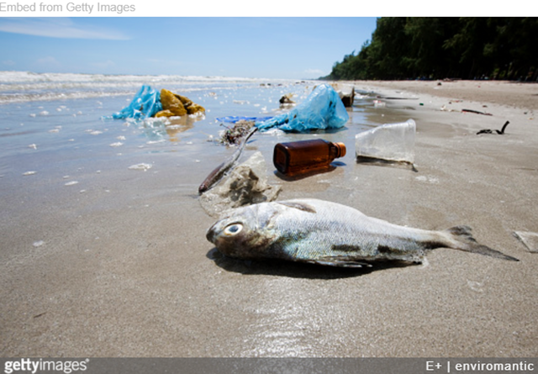

There’s an estimated 51 trillion pieces of plastic in the ocean, most of it broken up into bits smaller than the nail on your pinkie finger. Marine animals eat this plastic when they mistake it for fish eggs, plankton and algae. And so do people when they slurp down oysters, consume crab or eat other types of fish and shellfish, according to the latest research on the presence of plastic in fisheries and aquaculture issued by the United Nations Food and Agriculture Organization.

The report’s authors wrote that 121 commercially important seafood species are known to ingest tiny bits of plastic, called microplastic, yet the implications for human and ecosystem health is not well understood. The scientists are even more concerned about the tiniest pieces of microplastic, called nanoplastic, that are not visible to the eye and which fish and shellfish, and ultimately humans, also consume.

“Larger particles are not absorbed and will leave the gut,” said Peter Hollman, an expert on plastics in the food chain and one of the report’s three authors. “The particles smaller than 150 nanometers may be absorbed across the gut epithelium and may cause effects in the body. However, toxicological data on these effects are largely lacking.”

He and his coauthors, plastics experts Amy Lusher and Jeremy Mendoza-Hill, discussed the latest scientific literature in their report, which was reviewed by an international panel in Rome last year. The authors found that annual plastic production has skyrocketed since the early 1950s, reaching 322 million metric tons in 2015. In addition, 61 million tons of synthetic fibers for clothing, rope and other products were produced in 2016. The researchers wrote that this number is only expected to increase in the future, possibly doubling by 2025. An estimated 8 million tons of that plastic ends up in the ocean each year after being discarded.

The authors noted that the exponential increase in plastic production is coupled with an eightfold increase in fish catch and consumption worldwide since 1950, when the U.N. began collecting data, that’s outstripped population growth. An all-time high of 170 million metric tons of fish and shellfish were produced by aquaculture farms in 2015, the most recent year for which data is available, according to the report. Farmed fish now accounts for nearly 20 percent of the protein consumed by people worldwide.

The tiny pieces of microplastic and nanoplastic that marine animals are eating come from larger plastic items that break up with exposure to sunlight, wind and waves. According to the report, microplastics both leach and absorb chemicals from their surrounding environment. Plastic is capable of emitting and taking in all types of toxins, including flame-retardants and pesticides.

The researchers found evidence that small pieces of plastic can serve as a vector for chemicals to get into the bodies of marine animals, where they can accumulate in the fat cells of animals. Hypothetically, plastic and chemicals are also making their way into people who eat seafood. What’s more, chemicals accumulate in animals as one moves up the food chain in a “trophic transfer,” meaning that top predators like bluefin tuna absorb the greatest amounts of toxins.

“For example, if a bivalve contaminated with microplastics from the surrounding environment is preyed upon by a crustacean, the microplastic load would be transferred to the crustacean, if this crustacean is preyed upon by a fish the contaminant load may be passed to this next trophic level and so on,” said Hollman.

He noted that trophic transfer of some chemicals that cause hormonal and reproductive problems in humans and animals has been extensively studied in laboratory and field conditions. Yet he said trophic transfer with microplastics has only been observed in the laboratory so scientists cannot make a clear connection between the phenomenon in wild animals or people.

Human consumption of microplastic through seafood appears minimal. In a worst-case scenario less than 0.1 percent of a person’s total dietary exposure to some common toxins in microplastic would tend to come through microplastic in seafood, according to the report. But Hollman said that human consumption of the chemicals found in microplastics is still a concern, especially if they’re contained in nanoplastics, as they tend to remain in the body once ingested. He emphasized the need for more research and a drastic reduction of plastic waste into the environment.

David Santillo, a Greenpeace research fellow at the University of Exeter who studies plastic pollution, said he agrees with the need for a severe reduction in plastic pollution to mitigate potential environmental harm, as well as more research into its effects and implications. He said that while he thought the FAO report was generally comprehensive and balanced, readers should focus on the fact that what’s not known about the plastic contamination could potentially be very dangerous. Santillo noted that the worst-case scenario described in the report tested for some but not all contaminants commonly found in microplastic.

“What is perhaps likely to catch the eye of many readers, for example, is the conclusion in the abstract that consumption of microplastics as contaminants in bivalves would likely have a negligible effect on overall chemical exposures for seafood consumers,” said Santillo. “It is vital, however, to view this ‘worst case’ scenario against the background of very substantial uncertainties, unknowns and gaps in research that are acknowledged elsewhere in the body of the report itself, including those related to the full extent and diversity of exposure, especially to the smaller sizes of microplastics and their likely behavior in human tissues.”

