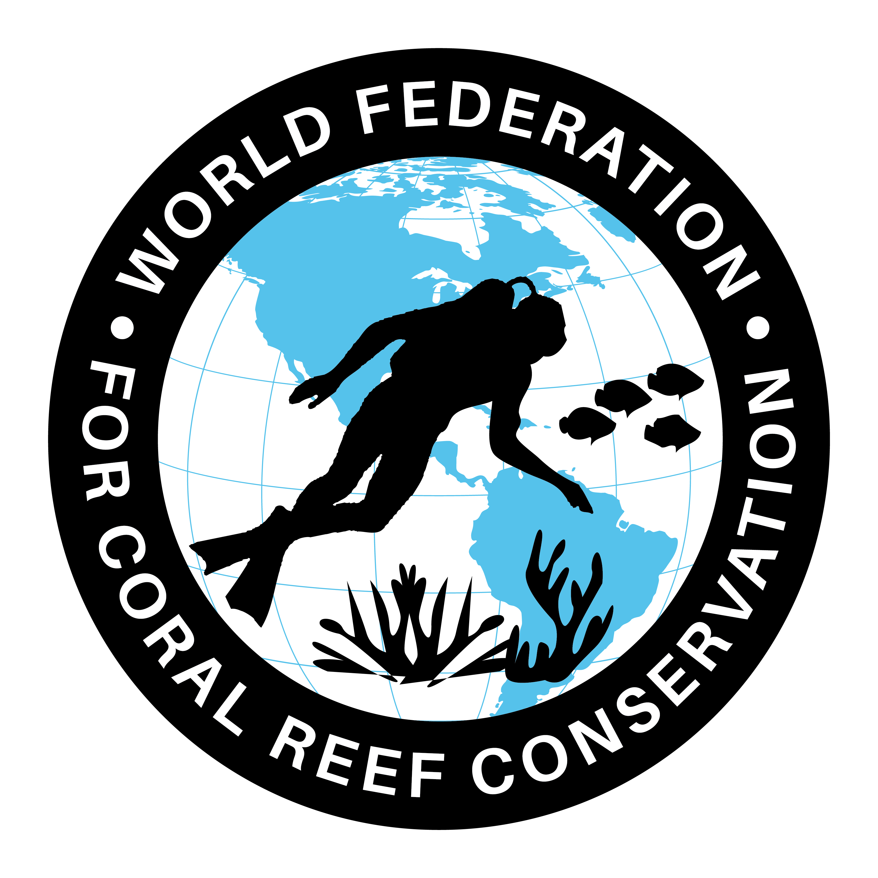
CTA-092-Hurricanes-St. Eustatius

The World Federation for Coral Reef Conservation 281.971.7703 P.O. Box 311117 Houston, TX 77231
Vic Ferguson Executive Director 512.986.1902 vic.ferguson@wfcrc.org info@wfcrc.org
Reprinted 10/28/17
Nature
On St. Eustatius Hit Hard By Hurricanes
Would you like to share a news item? Please e-mail us: research@DCNAnature.org Nature on St. Eustatius has been heavily affected by hurricane Irma and Maria that struck the island in the early morning of Wednesday 6 September and 19 September. Most visible are the effects on land. During a preliminary nature damage assessment St. Eustatius National Parks Foundation (STENAPA) counted hundreds of uprooted trees and snapped trunks. The quick scan of the island revealed that in The Quill National Park 80 to 90% of the trees on the outer northwestern slope and the inner south-eastern slope lost their leaves. As a result the Quill looks brown-greyish, instead of vibrant green.
At least 20 trees were uprooted and fell blocking the main Quill trail and hundreds of limbs and branches littered the ground. This means that hundreds of trees overall on the Quill are down and many more limbs and branches. The south-eastern part of the crater and the crater trail are also affected, and STENAPA has advised hikers not to enter the crater until the trails have been cleared.
Outside the National Park STENAPA counted 250 trees over a diameter of 1 meter either down or snapped. Of all the districts Oranjestad showed the most damage. Trees provide shade, stabilize the soil, provide food, provide shelter for wildlife, absorb carbon dioxide and release oxygen. Around 95% of the trees along the Caribbean cliff side in Lower Town, many of them old trees, lost their leaves. In the National Marine Park seven of the most important dive sites have weathered the storm relatively well.
There has been minor damage to the reef and corals, hard and soft corals such as sea fans were intact and coral cover is unaffected although there has been some damage to medium sized Giant Barrel Sponges. STENAPA has been working on coral restoration projects and unfortunately the coral gardens in Jenkins Bay (6m under water, 10 coral ladders) and Crooks Castle are gone. The coral gardens are part of an EU funded project to grow Elkhorn and Staghorn coral fragments on tree like structures. Mother colonies of Staghorn have been negatively impacted too. The sand on the beaches on the Caribbean Sea coast (Orange Bay) has been washed away.
Due to this sea turtles won’t be able to lay their nest on the short term. Conversely 1 to 2 meters sand was deposited on Zeelandia Beach on the Atlantic side. All sea turtle nests laid pre-Maria appear to have been inundated by the sea. Survival rate of these nests are expected to be zero to extremely low. There were roughly 25 nests on Zeelandia beach. Also in the Botanical Garden trees are down, including numerous branches and limbs. The shade house is destroyed and 2 of the 4 solar panels were blown off the roof of the visitor’s center. Due to this the drip system doesn’t function any more.
STENAPA has submitted a report about the results of the preliminary nature damage assessment to the Public Entity of St. Eustatius and other stakeholders.

