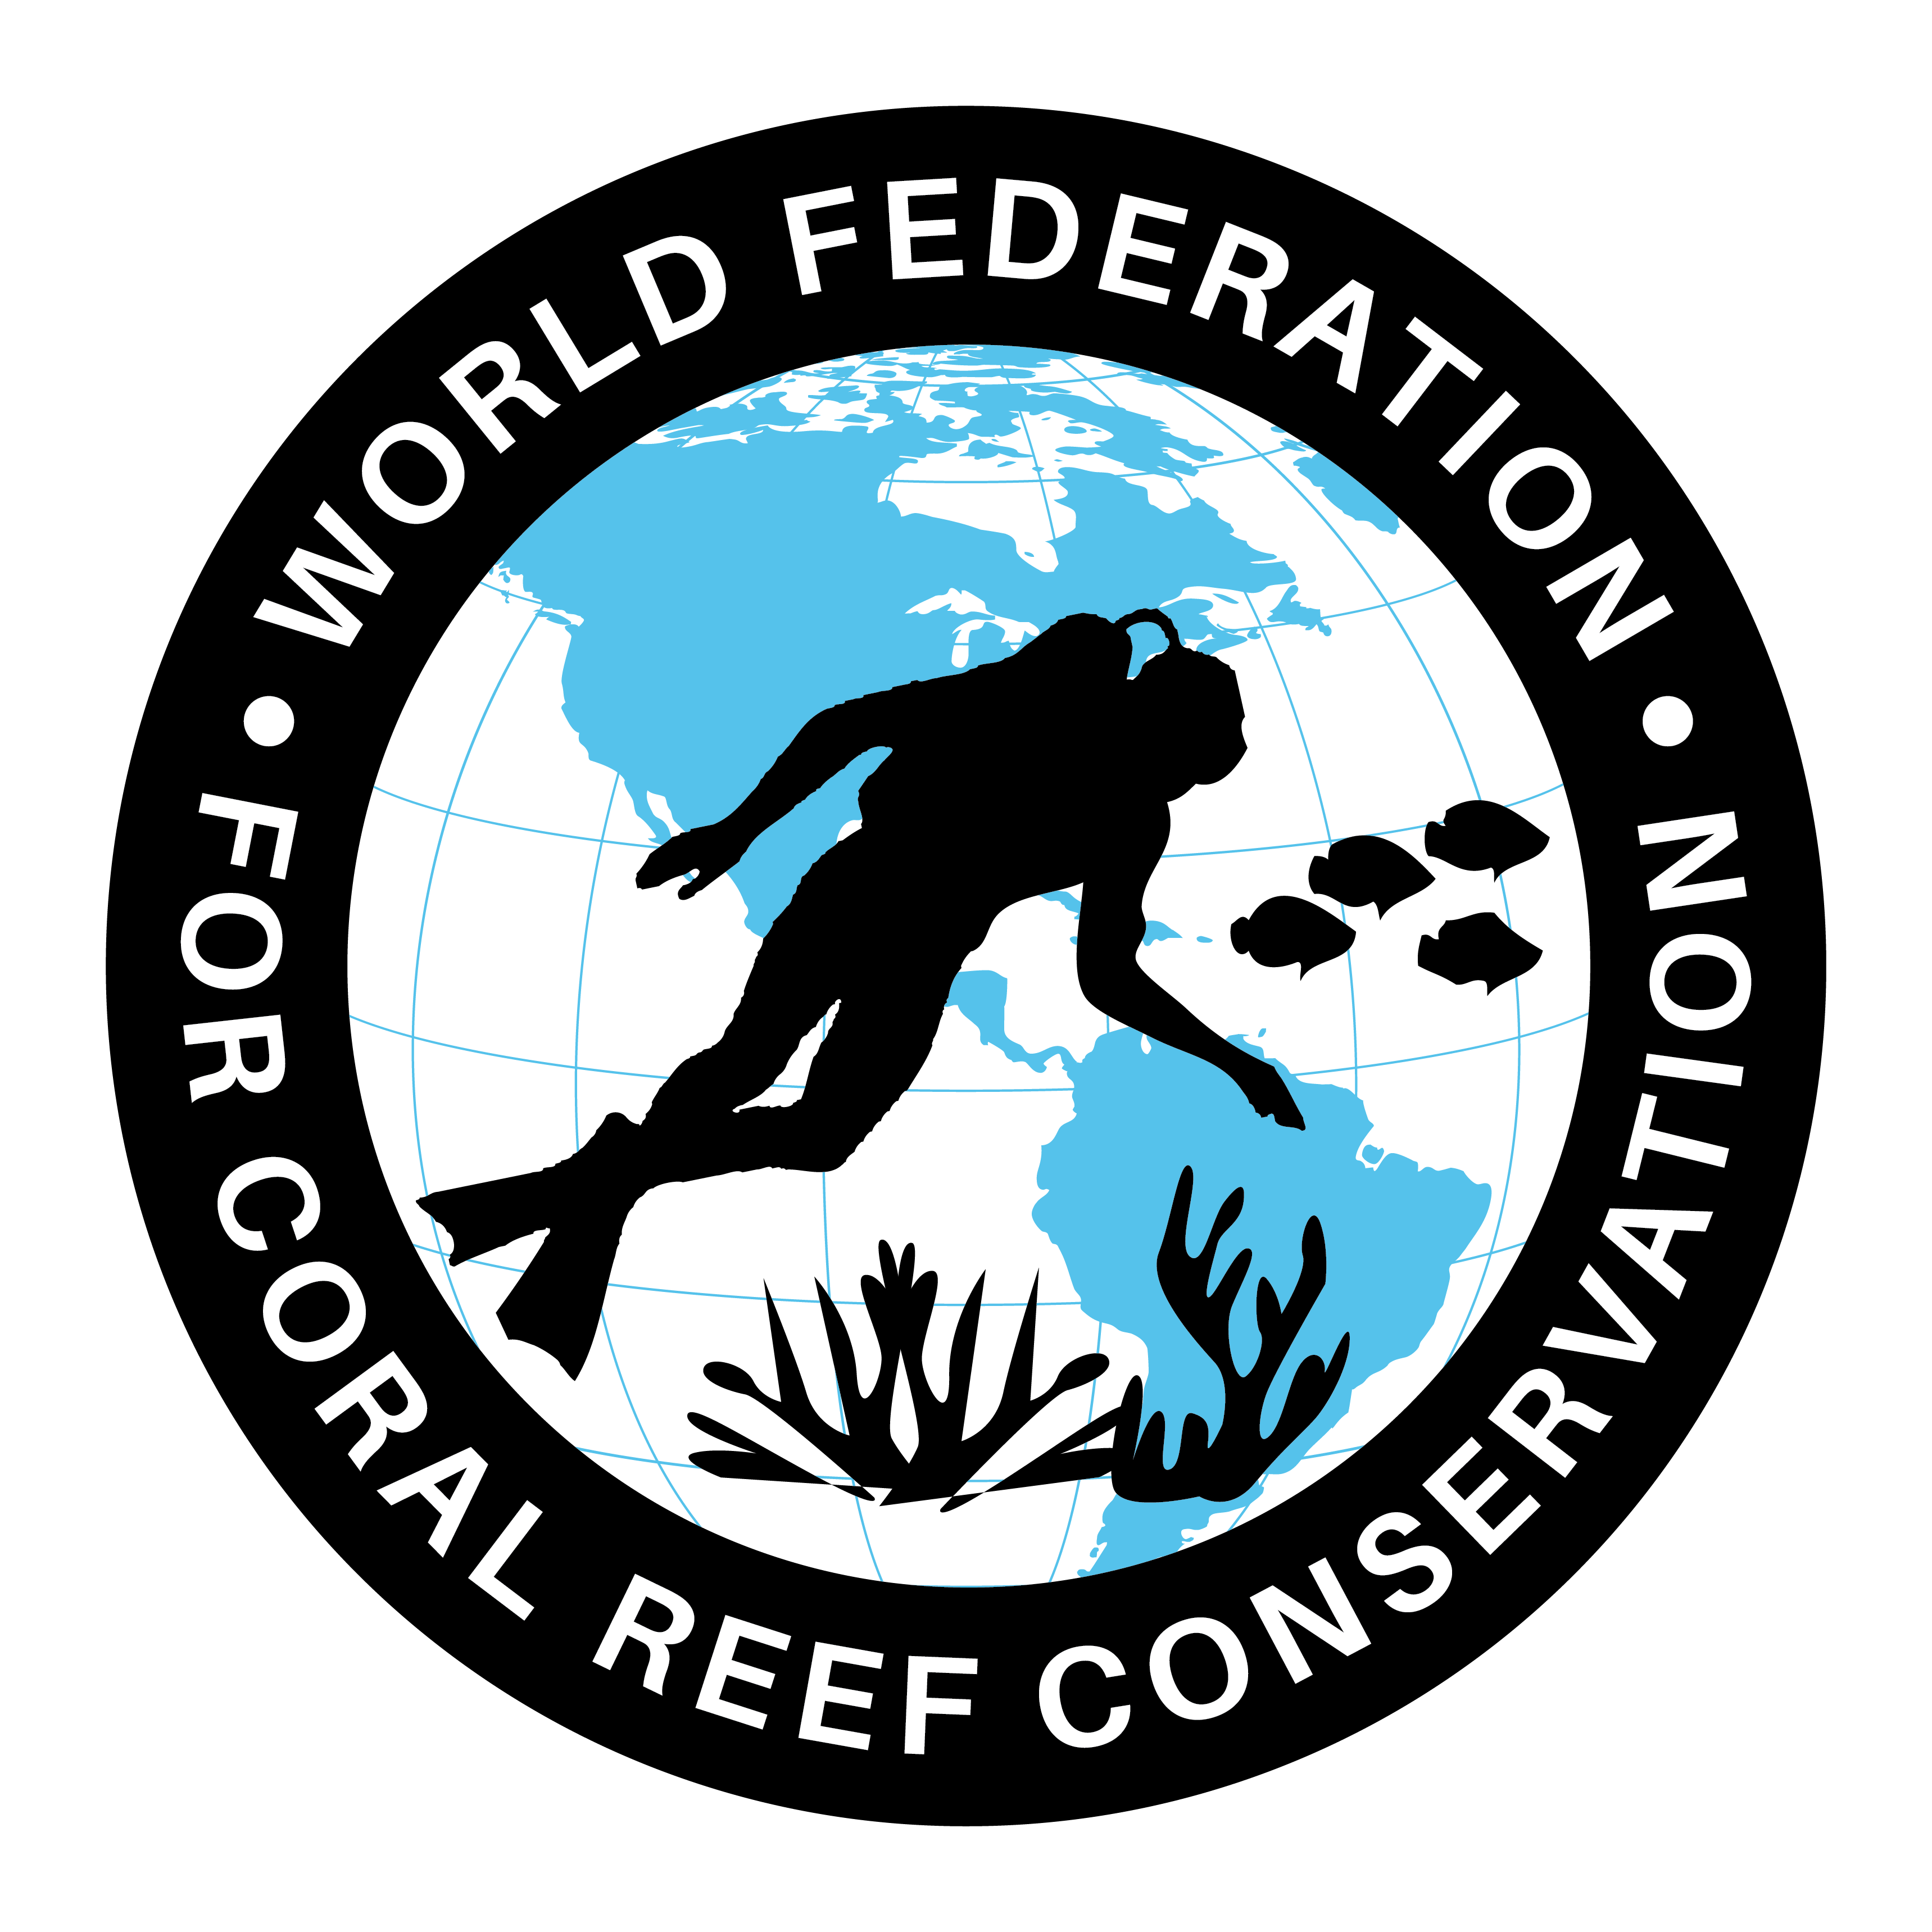
CTA-093-The Anthropocene

The World Federation for Coral Reef Conservation 281.971.7703 P.O. Box 311117 Houston, TX 77231
Vic Ferguson Executive Director 512.986.1902 vic.ferguson@wfcrc.org info@wfcrc.org
Reprinted 11/1/17

Science News
The Anthropocene, when did it start?
from research organizations
Determining when humans started impacting the planet on a large scale
October 25, 2017
American Chemical Society
Summary:

Humans have so profoundly altered the Earth that, some scientists argue, our current geologic epoch requires a new name: the Anthropocene. But defining the precise start of the era is tricky. Would it begin with the spread of domesticated farm animals or the appearance of radioactive elements from nuclear bomb tests? Scientists report a method to measure levels of human-made contaminants in sediments that could help pinpoint the Anthropocene's onset.
Share:
Earth from space.
Credit: © Vadimsadovski / Fotolia
Humans have so profoundly altered Earth that, some scientists argue, our current geologic epoch requires a new name: the Anthropocene. But defining the precise start of the era is tricky. Would it begin with the spread of domesticated farm animals or the appearance of radioactive elements from nuclear bomb tests? Scientists report in ACS' Environmental Science & Technology a method to measure levels of human-made contaminants in sediments that could help pinpoint the Anthropocene's onset.
The geologic record can sometimes provide clear-cut evidence of epoch changes. For example, when a meteorite collided with Earth 66 million years ago, levels of the metal iridium from the space rock spiked in sediments around the world. This clearly marked the end of the Cretaceous period. However, trying to define the start of the proposed -- and much debated -- Anthropocene could be more complicated. Human influence over the climate and environment began with the Industrial Revolution in the 1800s, and accelerated dramatically in the second half of the 20th century. Many markers of human impact on the planet from agriculture, waste disposal and other activities have been archived in the planet's sedimentary records. The rise in industrial chemicals, such as pesticides and pharmaceuticals, is another example of a human-driven activity that has been captured in sediment layers. To explore the record of synthetic compounds as a possible marker to help define the Anthropocene, Aurea C. Chiaia-Hernández, Juliane Hollender and colleagues turned to a new analytical technique combined with sophisticated data analysis to characterize patterns of contamination over time.
The researchers applied high-resolution mass spectrometry to investigate synthetic chemical contamination in two lakes in Central Europe. They examined 1-meter long cores from each lake bottom, capturing the past 100 years of sediment layers. According to the analysis, the lakes' sediments contained few synthetic contaminants before the 1950s. But during the 1950s, concentrations of industrial chemicals started to appear in the samples, which is consistent with the boom in industrial activities post-World War II. The researchers say this record clearly demonstrates the beginning of large-scale human impact on the environment. It also shows a decline in contamination following the installation of wastewater treatment plants in the 1970s, providing evidence for successful mitigation measures. Additionally, the introduction of new pollutants that are now finding their way into surface waters can be discovered.

Story Source:
Materials provided by American Chemical Society. Note: Content may be edited for style and length.

Journal Reference:
- Aurea C. Chiaia-Hernández, Barbara F. Günthardt, Martin P. Frey, Juliane Hollender. Unravelling Contaminants in the Anthropocene Using Statistical Analysis of Liquid Chromatography–High-Resolution Mass Spectrometry Nontarget Screening Data Recorded in Lake Sediments. Environmental Science & Technology, 2017; DOI: 10.1021/acs.est.7b03357

Cite This Page:
American Chemical Society. "Determining when humans started impacting the planet on a large scale." ScienceDaily. ScienceDaily, 25 October 2017.
<www.sciencedaily.com/releases/2017/10/171025090501.htm>.
For additional reading see The WFCRC Document Gallery for articles about:
- Public Service Announcements (PSA)
- Coral Alert Network (CAN)
- Emergency Reporting Reports (ERR)
- Call to Action (CTA)
- Marine Protected Areas (MPA)
- Marine Life Alert (MLA)
- Seismic and Oil Production Threats
- Natural Science Reports (NSR)
- Oil Spill Alerts (OSA)
- And other miscellaneous documents

