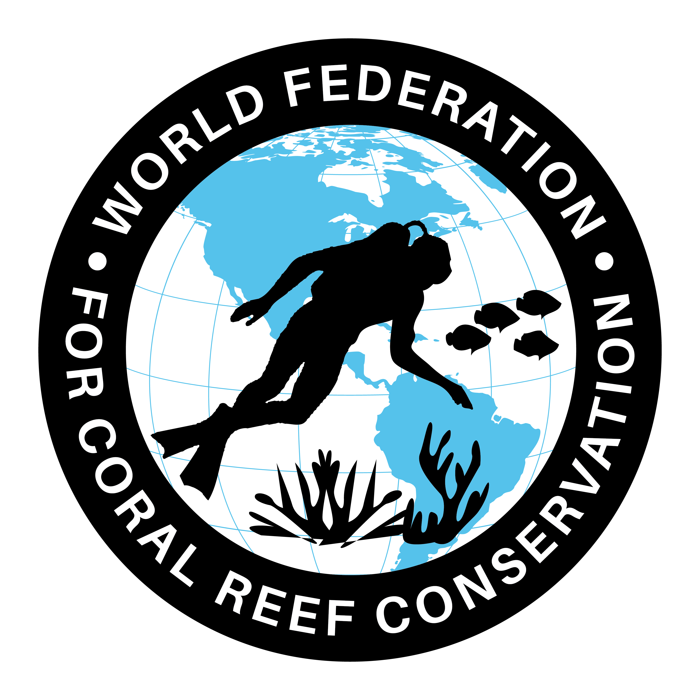
CTA-212-Single Platform for Change Management
Join WFCRC

The World Federation for Coral Reef Conservation 512.986.1902 4010 Skipper Rd. Sebring, Florida 33875
Vic Ferguson Executive Director/Founder vferguson001@gmail.com
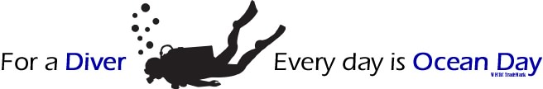
5/6/21

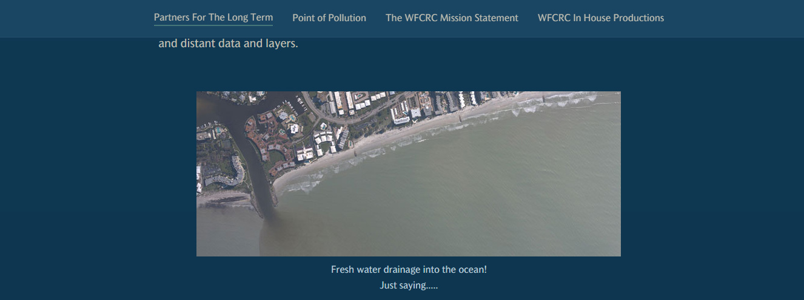
One Platform for Coral Reefs and Coastal Change Management.
- Improving Situational Awareness will allow WFCRC members to have the information they need to be fully aware of the science of reefs in their local area, local events, see local observations, being aware of marine based and land based threats and see in relation to the viewers location. (Where am I feature)

- P2P communication is supported for improved understanding and users can view and analyze local data in other ArcGIS apps, such as ArcGIS Dashboards or ArcGIS Insights, to improve their understanding of mission critical activities. And to manage both planned and unplanned missions, events, and operations. As a single platform, users will create, manage, and save mission data that can be accessed remotely. This makes it easier for teams to plan, execute, and review mission critical activities.
- Tactical Situational Awareness allows for both in the field and/or in your living room to see the locations of members in real time. This makes it easier to coordinate movements among team members based on in-progress events and activities. Everyone participating in the program can monitor the situation and quickly make adjustments. Participants can also use location, photos, and other information from the field to identify vulnerabilities early and plan effective responses.
- Create a stronger collaboration and real-time decision making. By sharing locations and location tracks, map markups, photos, and videos so What’s Our Mission?
- The Collaborative Coral Reef Registry is a premium app that individuals and organizations can use to manage their local areas, and distribute mission content and to better administer to change management.
- The Collaborative Coral Reef Registry is a mobile app that members can use on the beach to share location tracks, map markups, and photos.

Imagine in the future being able to look back into past history and see authoritative accounting of not only the science behind coral reefs and coastal environments, but how we impacted them. What did we do that worked and what did not work. Were there patterns that we just missed? Will they occur again and again? Will we be able to preclude some or any of the past mistakes we have made if we are reminded of what we did?
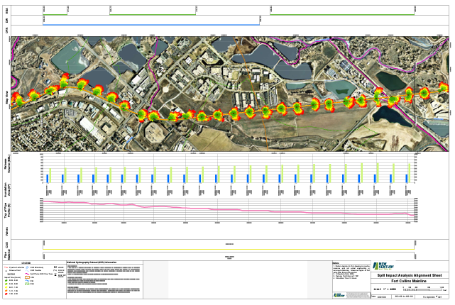
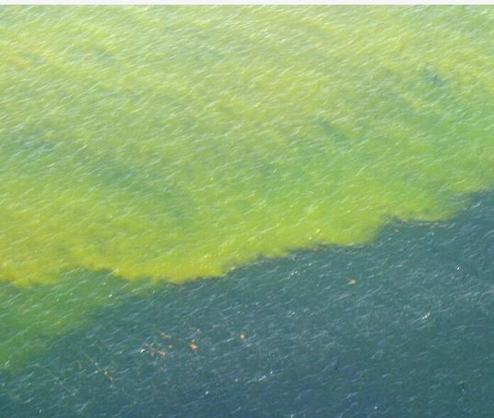
Example of alignment sheet for evaluating local events and planning.

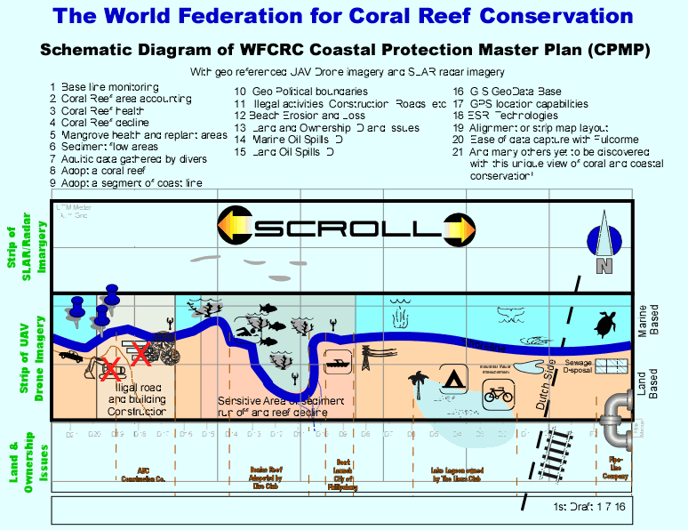
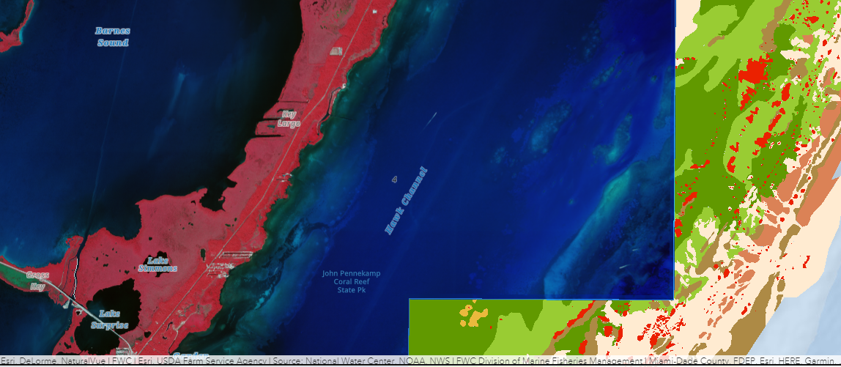
The Proposed Keys Drone Corridor and Center Line

