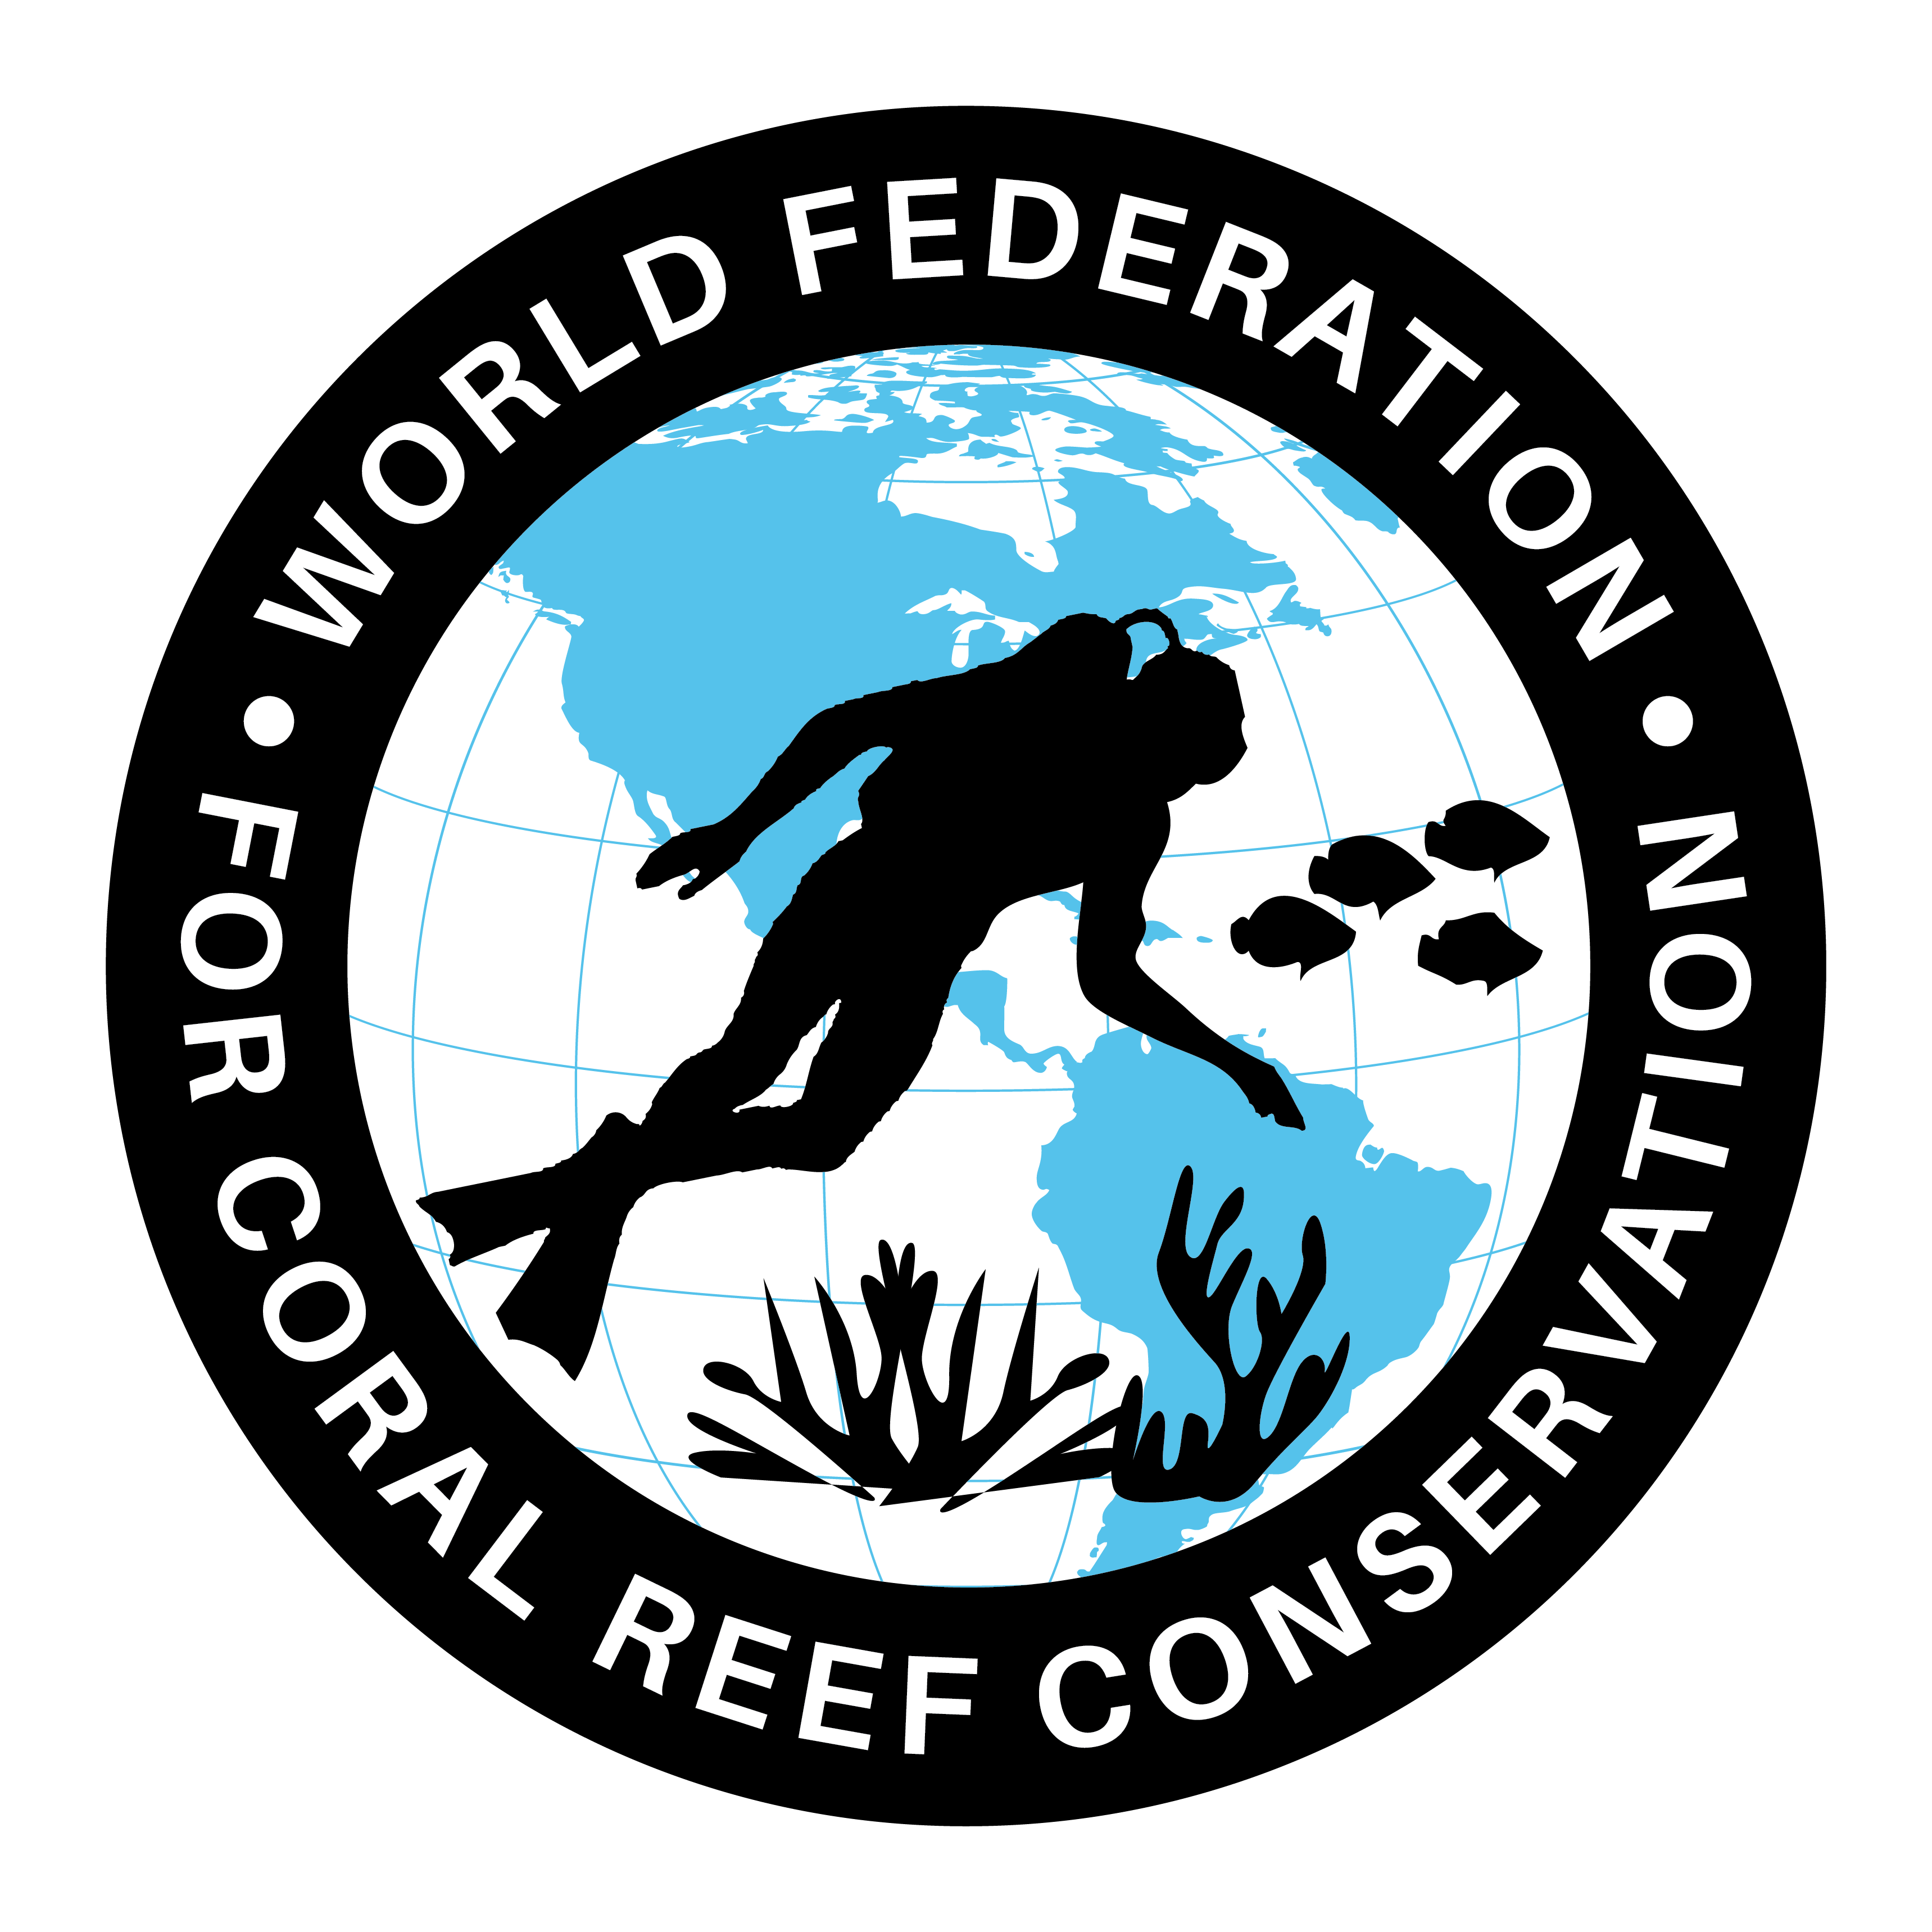
Coastal Protection Master Plan (CPMP)
Join WFCRC

The World Federation for Coral Reef Conservation 281.971.7703 P.O. Box 311117 Houston, TX 77231
Vic Ferguson Executive Director 512.986.1902 vic.ferguson@wfcrc.org info@wfcrc.org

5/12/17


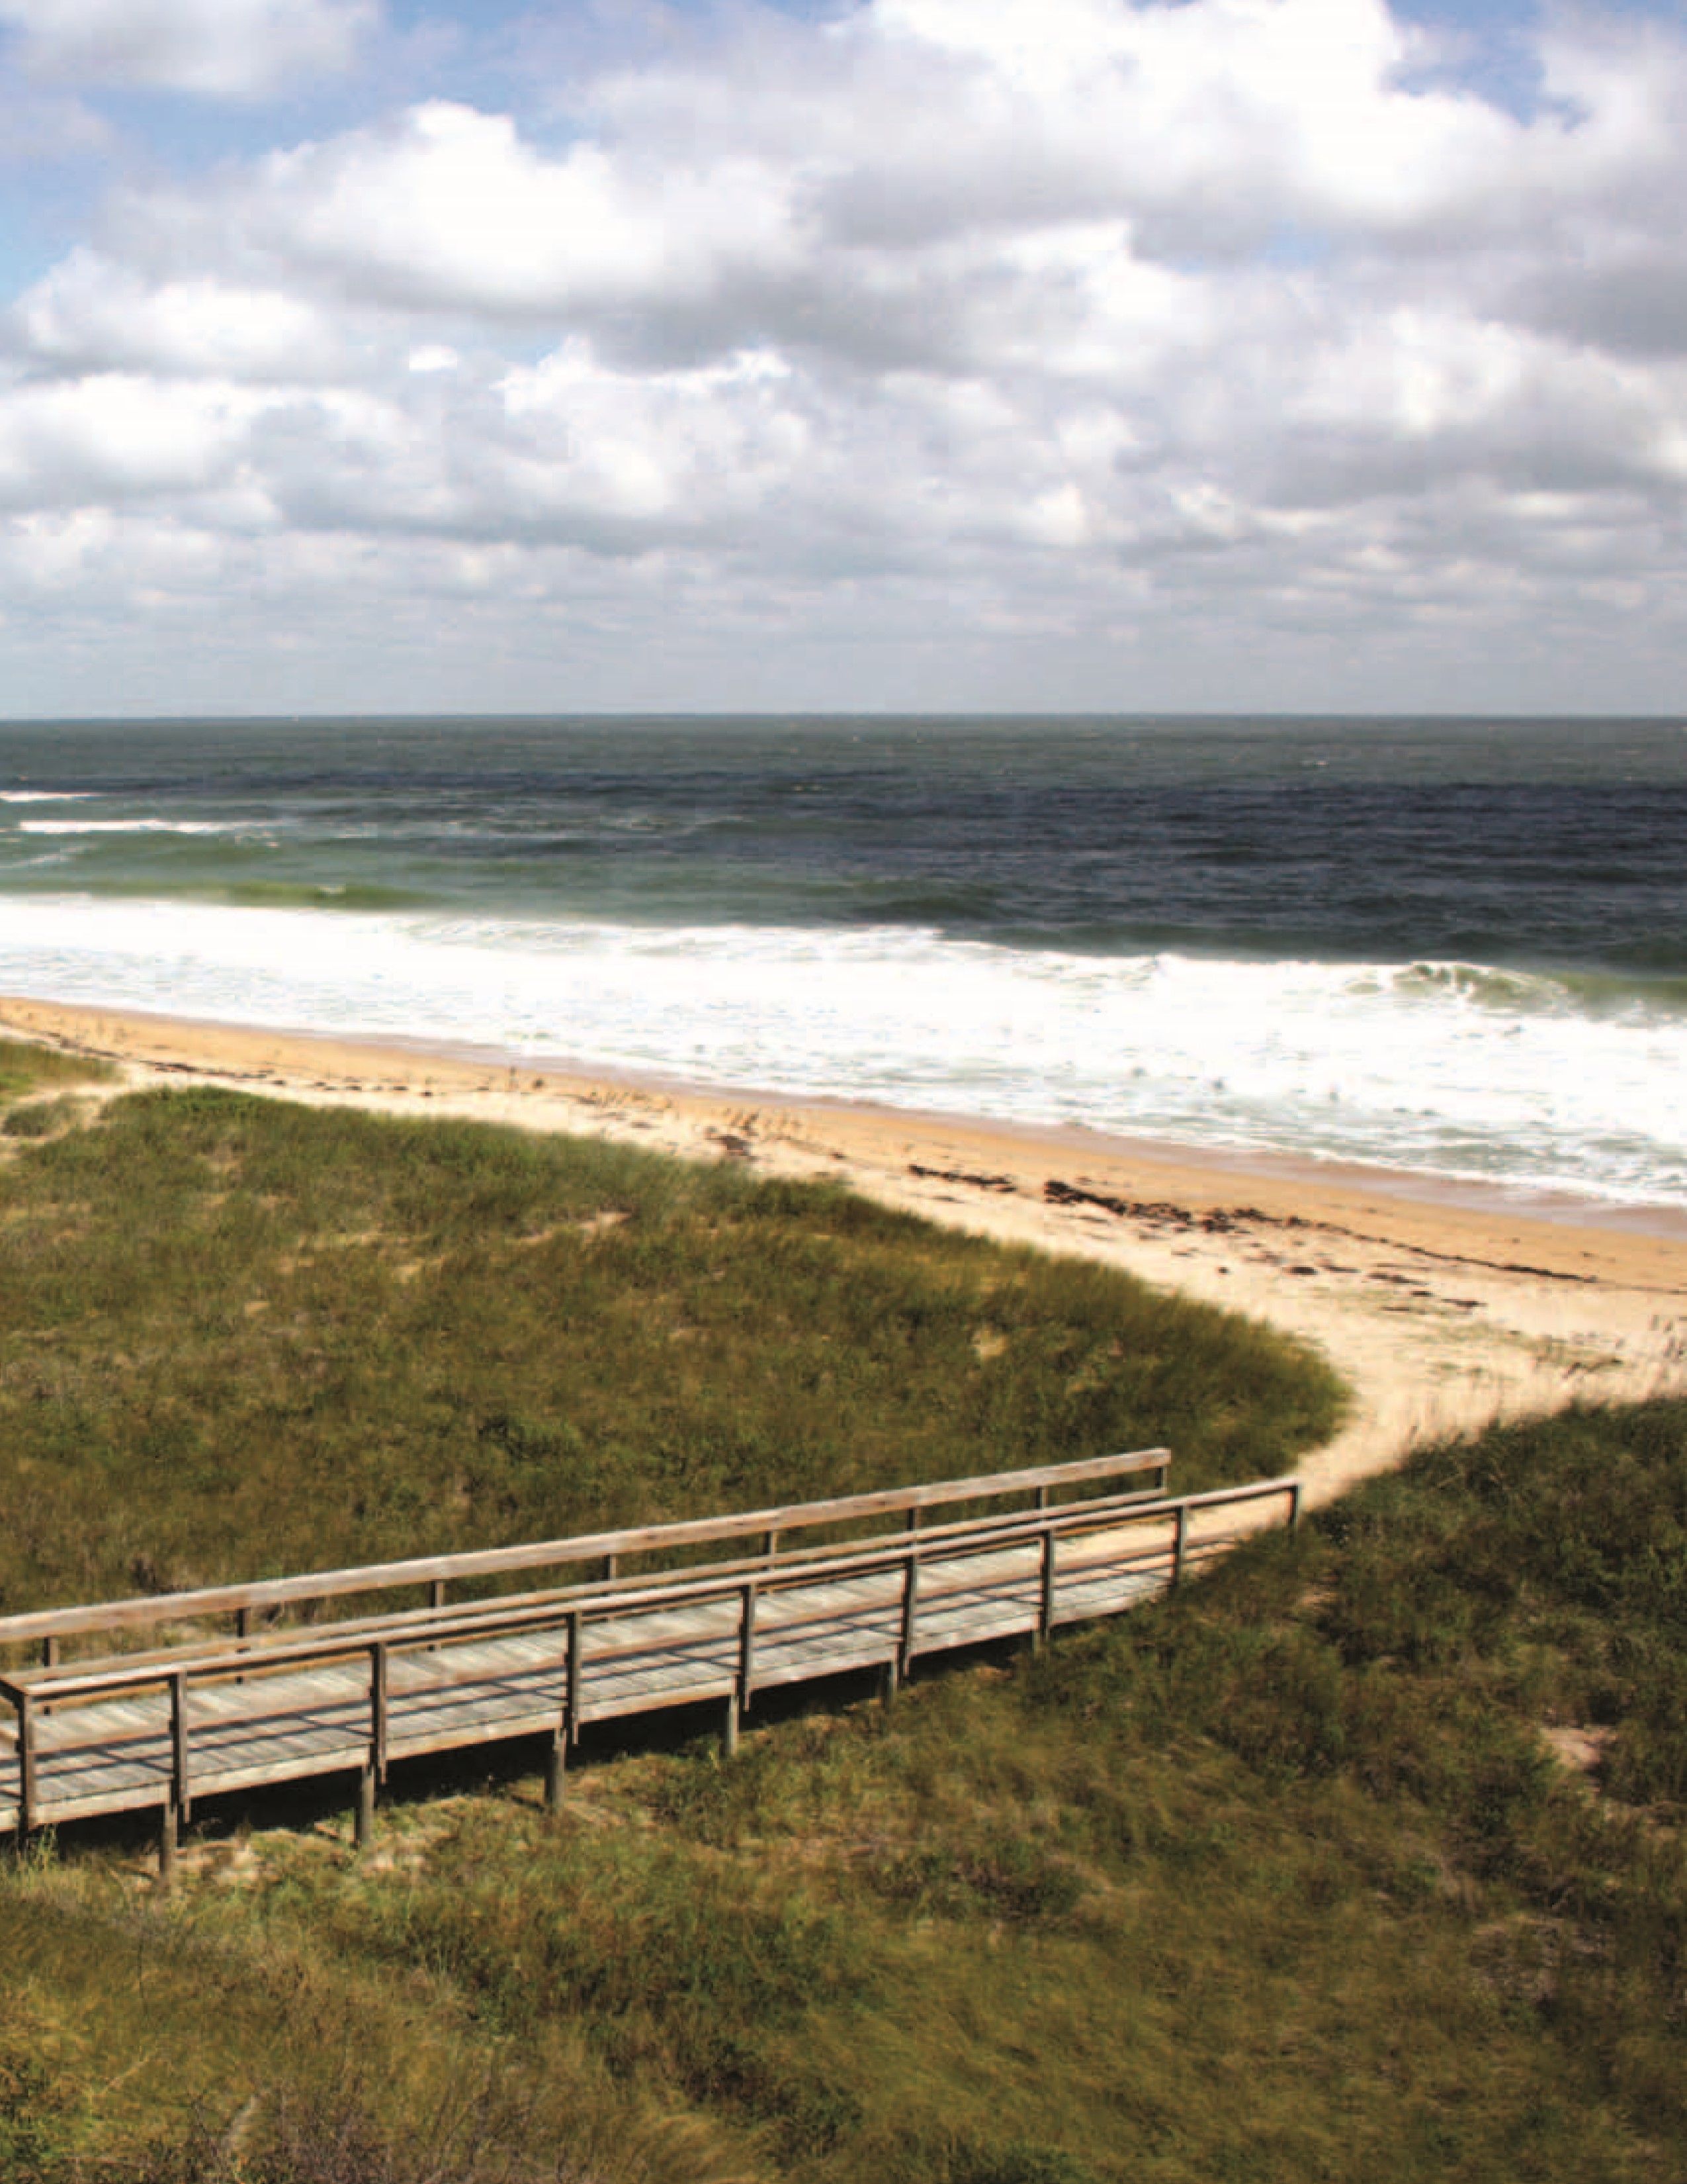
Coastal Protection Master Plan (CPMP)
KEY OBJECTIVE: Is to create the long term health and cooperation necessary for long term survivability of sensitive coastal and marine areas around the world.
The Goal: is to balance human social, economic and recreational needs with the coastal planning while creating long term protection of threatened and endangered species and the habitats that they rely upon.
Although the plants and animals that inhabit the coastline have adapted to a dynamic environment, they are nonetheless vulnerable to human disturbance, particularly disturbances impacting the quality and/or quantity of available habitat. Thus, as coastal populations and shoreline development continue to expand, there will be an increasing need to balance human requirements with natural resource protection. It is against this backdrop that the WFCRC has embarked on the development of the Coastal Protection Master Plan (CPMP).
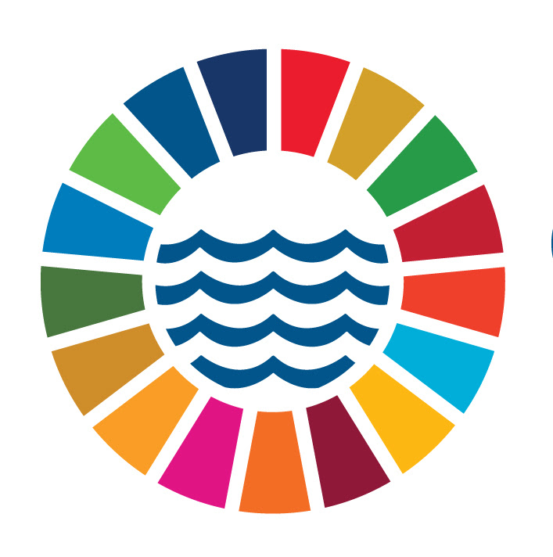

Highlights of benefits:
Benefits of having a Coastal Protection Master Pan (CPMP)
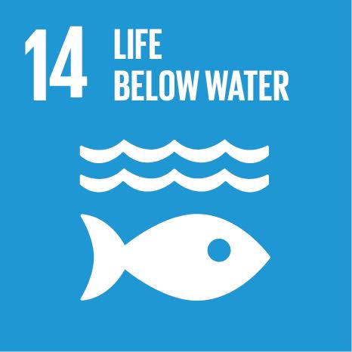
- Disaster and 1st response overall operational picture of coastal areas utilizing UAV and other remotely sensed imagery
- Long term base line monitoring of coral and beach decline.
- Coral reef area accounting in sq. hectares, health, and decline
- Coral adoption programs
- Identifying coral and mangrove health, decline and re plant areas.
- Beach erosion/maintenance, sediment and storm water runoff, beach raking and debris removal
- Sediment/turbidity threats to coral reef
- Adoption of a segment of coast line
- Geo Political boundaries
- Land and Ownership ID and Issues
- Land and Marine Oil spills
- GIS GeoData Base
- GPS location capabilities
- ESRI Technologies
- Alignment or strip map layout
- Ease of data capture with Fulcorme
- Frame work to develop local public awareness, hold town hall meeting and public workshops and to continue its on-going outreach programs.
- With certain criteria being met there is considerable latitude for flexibility and creativity. Consequently, stakeholder participation is not only desirable but essential to the success of any coral and/or coastal conservation plan.
- Updates on the effectiveness of this plan can be published on a regular basis as well as receiving feed back from stakeholders
- Broad support for the program is essential as the future of some of the world’s marine treasures are in the hands of the stakeholders affected by mam made threats.
- And many others yet to be discovered will yield a unique view of coral and coastal conservation.
- See the CPMP diagram below.

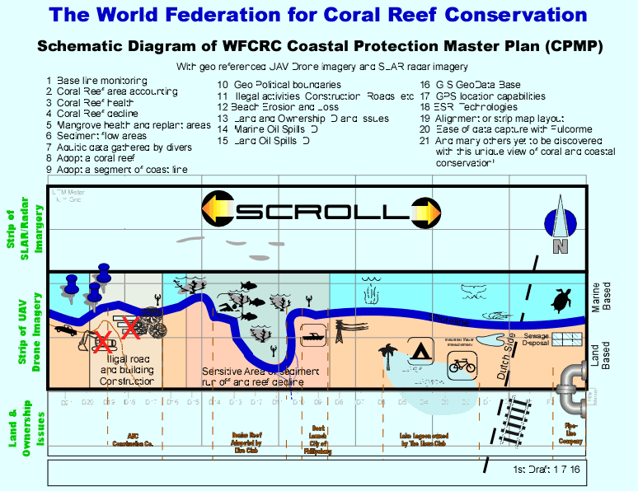
For additional reading see The WFCRC Document Gallery for articles about:
- Public Service Announcements (PSA)
- Coral Alert Network (CAN)
- Emergency Reporting Reports (ERR)
- Call to Action (CTA)
- Marine Protected Areas (MPA)
- Marine Life Alert (MLA)
- Seismic and Oil Production Threats
- Natural Science Reports (NSR)
- Oil Spill Alerts (OSA)
- And other miscellaneous documents

Vic Ferguson
The World Federation for Coral Reef Conservation
Executive Director
P.O. Box 311117
Houston, Texas 77231
vic.ferguson@wfcrc.org
www.wfcrc.org
281.886.7428 (office)
281.309.1201 (cell)
The only thing necessary for the triumph of evil is that good men do nothing”….Edmund Burke

