
Collaborative Coral Reef Registry
Join WFCRC

The World Federation for Coral Reef Conservation 512.986.1902 4010 Skipper Rd. Sebring, Florida 33870

Vic Ferguson Executive Director/Founder vferguson001@gmail.com vferguson@thewfcrc.info
8/16/21

During the middle to late Jurassic (1), coral reefs began to appear in the “rock record”. The rock record (below) is the Rosetta stone for the makeup of the earth’s geological epochs. Without the rock record we would not know anything about past environments, fauna and flora, cycles, events and so much more. The rock record has led to the discovery and the understanding of past events and what may be in store the future. Cycles are identified using the record, making predictably more reliable. Making the data gathered a real value to any registry, for any location.
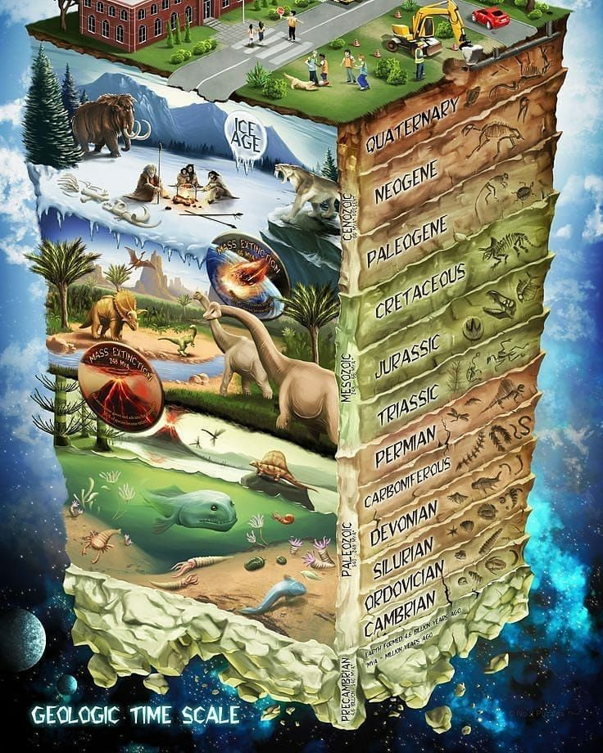
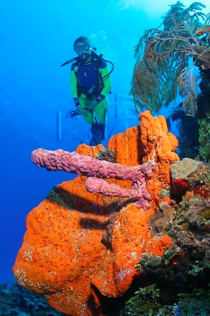

Jurassic

Figure 1 Geologic Rock Record
Figure 2
Collaborative Coral Reef Registry

Scientists can date and categorize fossils to determine when the organisms lived relative to each other over time. The resulting fossil record tells “the story of the past” and shows the evolution of the earth, over millions of years.
The rock record itself provides relevant and useful information about the environment in which the fossils were formed. Fossils can be used to recognize rocks of the same or different ages. In other words the rock record provides detailed information about the makeup of geologic epochs, the similarity to the Collaborative Coral Reef Registry is clearly identified within the ESRI platform as seen in our Keys Collector.
Currently dozens of organizations are rushing to develop, populate and execute GIS geo portals for various applications, our focus is on pushing data down into the hands of the local casual end user that is himself focused on coral and coastal health and monitoring.
The Collaborative Coral Reef Registry captures a more holistic view of coral reef and coastal environments all based on GIS platforms, for the very long term. The best results come from evaluating and monitoring ALL of the impacts on coral reefs, terrestrial, marine and human.
Many organizations have made great strides in capturing compartmentalized, Coral Reef data and deposited it in secure servers around the world. In most cases this data is not readily shared and in some cases even charged for.
Knowledge workers and end users would have to specially know where to look for these data scattered across the internet. A single source for coral and coastal data will provide a substantially better overall evaluation process, with user friendly, interactive, scalable GIS Portals, maps and meta data.

By studying fossils, evidence for evolution is revealed. Paleontologists are scientists who study fossils to learn about life in the past. Fossils allow these scientists to determine the features of extinct species. Paleontologists compare the features of species from different periods in history. With this information, they try to understand how species have evolved over millions of years. And the same can be said for The Collaborative Coral Reef Registry, which is its digital twin.
Rock Layers and the Age of Fossils
There are many layers of rock in the Earth's surface (figure 1). Newer layers form on top of the older layers; the deepest rock layers are the oldest. Therefore, you can tell how old a fossil is by observing in which layer of rock it was found. The fossils and the order in which fossils appear are called the fossil record. The fossil record provides evidence for when organisms lived on Earth, how species evolved, and how some species have gone extinct.
The Collaborative Coral Reef Registry allows for local events and participation by local constituents, threats and parameters over time to be studied in relation to many other parameters in a single location without having to use mutable sources and/or databases.
For example, with the ability of individual citizen scientist or the family on the beach, observations at a known location (lat, lng), will be able to make assumptions about how other observations may affect coral such as contaminated water, sediment runoff, or the movement of the red tide, research or what happen last year or earlier.

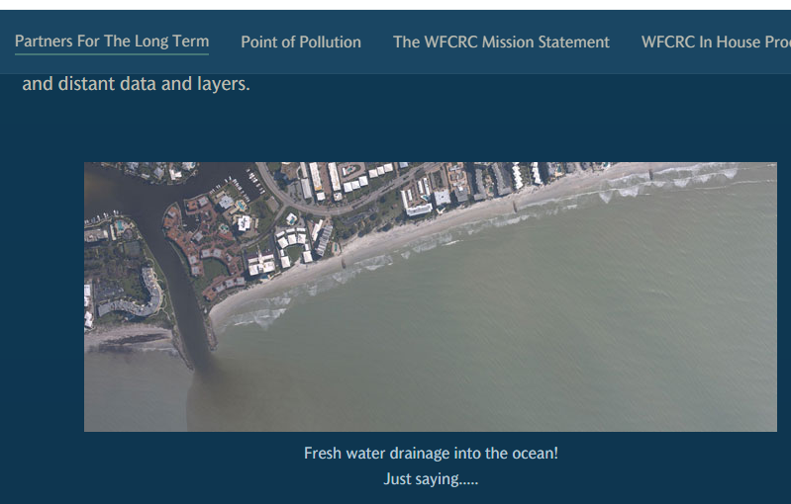
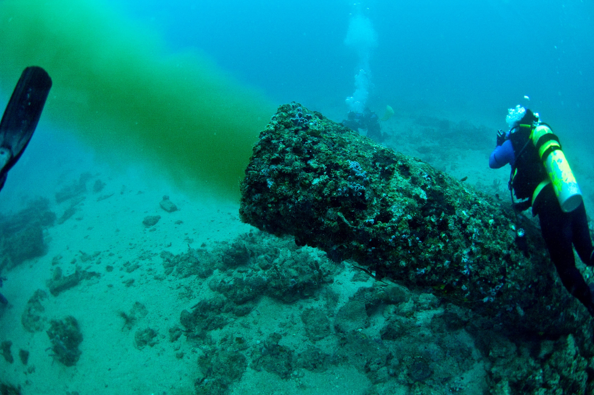
With digital stream tracing for location, along with alerts from gaging stations and other point sources of pollution and sediment release, downstream alerts are displayed on gis mobile maps giving local constituency a heads up on impending events. Beach goers would find this information helpful as they plan where to swim and/or gather seafood.
These are just a few of the relative impacts on local coastal areas, many more impacts will be revealed over time as this information is pushed down into the hands of the local end user.
Generations will be able to look back, in time at coral and coastal environments/data and make predictions based on past events.
Setting Data Free
“At the moment geoscience is really held back in many areas because we haven’t managed to set data free. It’s still in isolated databases, or even worse, in analogue form,” said Michael Stephenson, AAPG member and executive chief scientist at the British Geological Survey.
Data Types
WFCRC is working to consolidate specific data for any specific locations, into a searchable platform for a deep-dive into the Digital Earth, described by some as a “geological Google.” Or, digital twins. Our working group is a collaboration of earth/coral scientists, data managers, coastal conservationists, coral restoration/planting coral, and GIS Professionals, and is creating a data model to share and exchange coral, coastal conservation resource information for our end users.

One deeply rooted concern is the ability to allow existing data sources to “talk” to each other and combine with RSS feeds, IoT and other relative threads. The initiative was sanctioned by the International Union of Geological Sciences in 2018 and developed in cooperation with national geological surveys, professional associations, academic institutions and scientists around the world.

In a world where everything seems to be connected – information, technology, and viruses – it only makes sense that earth science and geological data should be connected in the same way.
The reality, however, is different. Marine and Geological data collected by individuals, companies and academic institutions across the world over hundreds of years is scattered across the globe and stored in different formats.
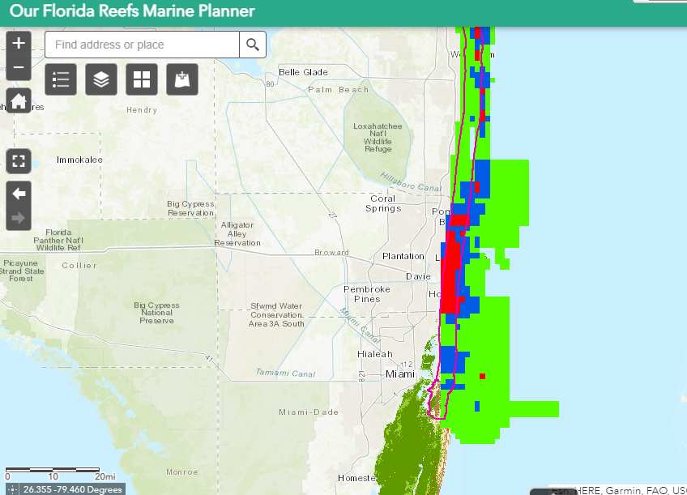
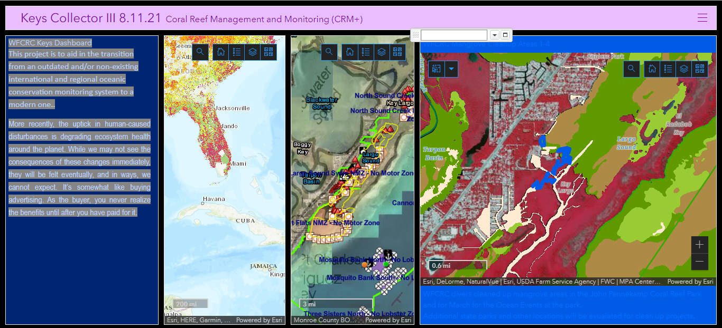
By mashing up mutable information layers, previously unknown events, trends and trouble spots become visible. This is a decision based on real time data. The best kind!

(1) Upper to late Jurassic coral reefs can be typified by their faunal composition, dominance, and frequency of coral species, their sedimentological characteristic, and their general shape and dimensions.

The Digital Revolution
The world today is witnessing a digital revolution that will change history. “The emergence of Big Data has brought brand new goals, visions, paths and technologies.” We are able to use data to demonstrate the four-billion-year evolution and history of the Earth visually and using other people-friendly approaches,” That will raise the level of human cognition of planetary processes to an unprecedented level. And hopefully raise the awareness of the decline of 70% of the earth’s surface, our oceans.
Share our digital vision of the beautiful underwater world!
There is a current and immediate need to better administer to our ocean's health, coral reefs, water quality, and coastal environments in a complex business frame work, and it’s imperative to keep objectives very simple. The goal is to make the objectives conversational so everyone – from the mechanic working on the motorboat to the chairman of the board of directors – can address them with ease. But when it’s difficult to see those initiatives as a big picture, the intended simplicity is lost.

For organizations that go through risk mapping or business planning exercises, tracking progress can be an issue. Spending so much time chasing updates, monitoring deadlines, and reporting on results, longer-term strategic projects can get left behind. We all share the obligation to find a better solution!
The Keys Collector oceanographic observation Dashboard along with The Collaborative Coral Reef Registry, impact assessment on long term catalogued data and how the end user will now have access to a new world of gis data with relevance to specific locations’ like The Florida Keys. With the new access that end users will have to this data, the ecosystem management and recommendations is aimed at evaluating how oceanographic observations and data, will best serve the Keys or any location.
“When the end-users have access to the app, they would be able to easily take a photo of the ocean and related, relevant current events, submit their data, see their point on the map, and click it to immediately see their image pop up. They have an interactive map on their mobile device that’s simplified. I think that helps encourages collaboration of people to go out there and be more involved. You’re not just collecting data, sending it off, and then not seeing anything. You’re seeing data come in from people around the world, which reinforces the fact that you’re part of this bigger cause.”
Future research questions that focus on issues like: “would you be more inclined to participate in a conservation effort if you could participate digitally” “It’s not only about building the technology. It’s about knowing what’s coming and what’s possible for the future of this application and initiative. This is about building an application for users to participate in an ongoing, long-term citizen science effort.
The World Federation for Coral Reef Conservation
Executive Director/Founder
Relief without Borders
March for the Ocean
4010 Skipper Rd.
Sebring, Florida 33875
vferguson001@gmail.com
vferguson@thewfcrc.info
512.986.-1902
The only thing necessary for the triumph of evil is that good men do nothing”….Edmund Bur

