Concepts and ideas, not material
Created to assist in planting and growth of coral in a sandy composition and to anchor mangroves in sandy composition or unstable material that is subject to wave actions.
(patent pending)
Coral Anchor Mangrove Anchor
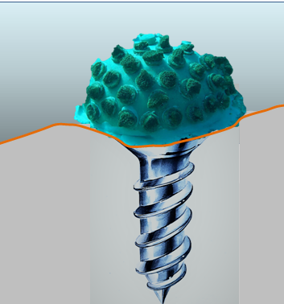
Mangrove Anchor

