5/25/16

Contact Us

FORWARD: Sodium Cyanide fishing for the aquarium business along with buying coral for aquariums is a practice that is common in many locations around the world and is the detriment of each and should stop. While the breath is narrow the depth is great when compared with other conservation issues it appears to be unnoticed. Farm raised aquarium fish and coral is best for the survival of all.
“We all should realize that there is a problem with our oceans and should be addressed globally, it’s our ocean to save……Executive Director WFCRC
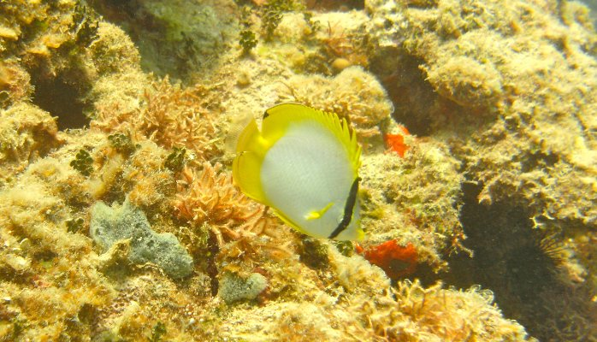

Gregor Hodgson

Finding Dory, Saving Nemo: Problems Facing Marine Aquarium Fish
Published on June 17, 2016

Gregor Hodgson

Executive Director at Reef Check Foundation
How many of your friends own a home aquarium with tropical fish? It is a popular home hobby and over 10 million Americans own an aquarium. When Dory, the sequel to the film Finding Nemo was released this week, many environmentalists worried that we would have a repeat of the Nemo disaster when thousands of kids tried to flush their clownfish down the toilet to “save” them by returning them to the sea.
But there is a more serious environmental concern regarding marine aquarium fish and that is fisheries management. For large food fish like tuna, national and international management organizations try their best to track both the size of tuna populations and the size of the fish. Using sophisticated models, scientists calculate what they think is a reasonable number of fish that can be caught each year and these are allocated to fishermen. Although our track record in fisheries management is terrible, generally the failures are due to politics not the scientific recommendations.
Like tuna, most tropical saltwater fish are captured alive, but unlike tuna they are kept alive and transported from countries like the Philippines and Indonesia to the US and Europe for eventual sale to consumers. Compared to the $30 billion world tuna trade, the entire marine aquarium trade is estimated to total less than $100 million. So it doesn't get as much attention, and the fact is that 90% of marine aquarium fish are caught from unregulated and unmanaged fisheries. In places like Hawai’I and Australia, the fisheries are regulated.
Although the entire marine aquarium trade is small compared to tuna, the prices of some rare species of marine aquarium fish are the highest of any fish in the world – exceeding $100,000 per pound. Even relatively common fish like the Blue Tang (Dory) could fetch $100 per pound!
In addition, sadly, almost all tropical marine aquarium fish are caught using sodium cyanide mixed in water as a “knock out” chemical to disable the fish but not kill it. In the Philippines, for example, a diving fisherman will use a bottle of cyanide solution to squirt the poison into a crevice on the coral reef where a small fish like a Blue Tang, is hiding. If done properly, the fish is stops swimming, and is easily scooped into a net, but the cyanide also kills the corals and other animals surrounding the crevice. On reefs where cyanide fishing is carried out every day, the reef can be damaged. Although cyanide fishing is illegal in most countries where they are fished, the laws have been difficult to enforce. So the damage continues, and without fisheries management plans, the populations of marine aquarium fish are often reduced below “safe” levels.
In addition to problems at the source, there can be problems when the live fish are transported long distances by airplane. A typical flight from Manila to Los Angeles takes15 hours. Buyers and sellers don't want any fish to die but accidents happen, and cold temperature and lack of oxygen can cause fish to die in transit.
There are also problems here in the importing countries including the US. Like learning to drive, learning to keep tropical marine fish alive in a home aquarium requires special knowledge and training. Unlike clownfish, which are fairly easy to keep in captivity for several years, the Blue Tang requires special handling and food. Some fish are almost impossible to keep alive. But unlike driving a car, no license is required to buy even the most difficult-to-care-for tropical marine fish. As a result, many fish die in home aquaria. In a small study carried out by one of my former UCLA students in Sydney, Australia about 50% of the fish bought by home aquarium owners died within two weeks of purchase. Even if a larger study were to show this is high, and it is only10%, this is a lot of dead reef fish when over 12 million fish are imported into the US every year.
Given that fisheries like the tuna are formally managed using science, given that Reef Check is a science-based conservation organization, over ten years ago we accepted an invitation from conservation partners to try to work out a better management system for marine aquarium fisheries. We worked on this problem until 2008, and had some successes and some failures.
On the success side we were able to develop a suite of survey methods, a fisheries model and strategies to properly manage marine aquarium fisheries. These were tested in several countries and worked well. We also found that we could engage aquarium fishermen in setting up Marine Protected Areas to help build up their fish stocks and this improved stocks of both aquarium and food fish. Our partners had success in training fishermen to catch fish using nets and without cyanide.
Now, many environmentalists believe that the marine aquarium trade should be shut down because these are beautiful wild-caught animals much like an Amazon parrot or a Burmese python. I understand this point of view, but most marine aquarium fish species are extremely abundant, so if we ban the marine aquarium trade, to be fair, we should ban all fishing?
Assuming that the trade will continue for in the near future, what are the major issues that need to be addressed now to make it “sustainable” in the sense that we are not jeopardizing healthy populations of any species.
- Reduce wild catch: Figure out how to aquaculture more marine aquarium fish. Only a few have been solved.
- Reduce cyanide use: Crack down on cyanide use by providing resources to the enforcement agencies specifically for this purpose.
- Reduce cyanide use: Provide net-catch training for 1000s of fishermen by using training of trainers
- Enforce the Lacy Act: It is illegal to import anything obtained illegally in violation of the exporting country. Cyanide fishing is illegal in these countries. On March 9, 2016 a consortium of marine conservation groups filed a legal petition to force the US government to enforce the Lacy Act.
- Improve fisheries management: Use the MACTRAQ methods developed by Reef Check to better track and manage marine aquarium fisheries in exporting countries.
- Reduce transport mortality: Regulate the transport of wild caught fish to maximize survival.
- Reduce post-purchase mortality: Retailers should use well-known rankings of difficulty to control purchase of each fish species by require labeling fish, and limiting purchases to buyers who have been trained and certified to keep each level of marine fish.
Each of these subjects will be discussed in a future post.
As a scientist, I’d like to believe that we can use science to successfully guide management of marine aquarium fisheries. As a former Peace Corps Volunteer with the Bureau of Fisheries and Aquatic Resources in Cebu, Philippines -- a center of cyanide fishing, I am familiar with enforcement issues and I know how poor the coastal fishermen are. I know that if they can’t make money from aquarium fishing they will put even more effort into food-fish fishing, further damaging the reefs. And at the same time, I wonder how many kids have been poisoned inadvertently by fishermen mixing cyanide solution in their homes? If the trade is going to continue, we all need to do a better job of solving the problems noted above.
- LikeFinding Dory, Saving Nemo: Problems Facing Marine Aquarium Fish
- Comment
- ShareShare Finding Dory, Saving Nemo: Problems Facing Marine Aquarium Fish
Report this

Tagged in:
- fisheries
- coral reefs
- aquariums


Gregor Hodgson

Executive Director at Reef Check Foundation
- 3 posts
0 comments

Vic Ferguson
The World Federation for Coral Reef Conservation
Executive Director
P.O. Box 311117
Houston, Texas 77231
vic.ferguson@wfcrc.org
www.wfcrc.org
281.886.7428 (office)
512.986.1902 (cell)
The only thing necessary for the triumph of evil is that good men do nothing”….Edmund Burke

