7/23/16

21 JULY 2016

The Sounds of Seismic
Posted by: Haley McKey | 1 comment
Oil Prospecting in the Atlantic Ocean Could Have Serious Consequences for Endangered Marine Wildlife
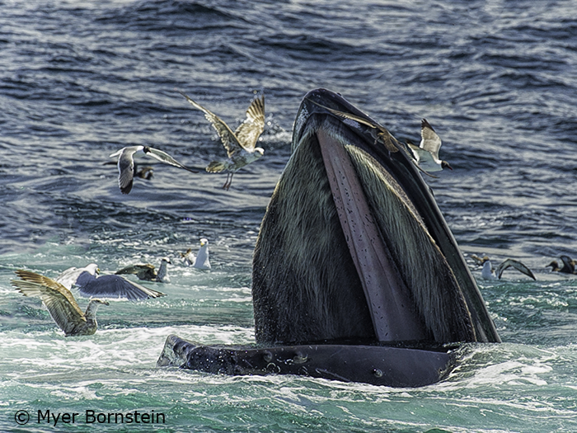
BOOM. BOOM. BOOM.

Ear-shattering explosions echo through the ocean. Dolphins, whales and sea turtles scatter, trying to get away from the source of the noise. What’s making this deafening sound? Seismic testing.
Seismic testing is a way for oil companies to find oil and gas reserves beneath the ocean floor and determine where to set up drill rigs. Boats tow air guns through the water behind them that blast compressed air with massive force. The sound is like a stick of dynamite dropped down a well, and testing can go on around the clock for weeks. Because the signature of the sound waves changes over oil, the blasts create an audio-image that reveal fossil fuel deposits beneath the ocean floor. But at what cost?
The deafening noise levels caused by seismic testing have harmful effects on ocean-dwelling wildlife, some of which experts are still working to understand. The deafening booms of the air guns are capable of causing temporary or even permanent hearing loss in nearby animals. Explosions can interfere with whales’ and dolphins’ ability to echo-locate, which may cause them to strand and die on beaches. Whales have been observed going miles out of their way to avoid seismic testing ships. The noise can also prevent whales and other marine mammals from communicating with one another.
Many species of whales rely on their “songs” to attract mates, tell their fellow whales about food, or warn them of nearby threats. If seismic testing drowns out these songs, it’s difficult to know whether whales can adapt. Testing can also frighten away prey species for whales, dolphins, sea turtles and other marine animals.

Last year, the federal government considered allowing the sale of oil and gas leases along the Atlantic Outer Continental Shelf, running from federal waters off Virginia through North and South Carolina to Georgia. But the plan faced strong opposition from a wide coalition of local communities, as well as local, regional, and national conservation organizations, including Defenders of Wildlife. While the Obama Administration has thankfully decided to take oil and gas drilling in the Atlantic off the table for the next five-year leasing plan, it is allowing seismic testing to move forward in the same area. It’s not clear when any companies will begin exploration; they must receive federal permits to do so first. But if they do, many species of marine wildlife will face new and serious challenges to their survival.
One whale in particular could be put in serious jeopardy by seismic testing. Only about 500 endangered North Atlantic right whales exist in the wild today, after extensive hunting in the nineteenth century nearly wiped them out. These whales already face plenty of threats, from ship strikes to entanglement in fishing gear. North Atlantic right whales generally stick close to the shoreline, migrating up to the Gulf of Maine in the summer, and spending the winter off the coast of Georgia to rest and calve in the warm, calm waters. The area where companies could begin seismic testing overlaps completely with right whale migration routes.


STOP SEISMIC TESTING!
Ask President Obama to protect our vulnerable marine wildlife and stop seismic testing in the Atlantic.

Sign the Petition »
Sea turtles are also at risk, with many of their nesting beaches located near testing areas. Newly-hatched sea turtles make a stressful, exhausting dash from their sandy nests to the water and, once there, continue their journey to the open ocean. These tiny creatures already overcome the threats of predators, cars and other obstacles just to reach the water. If they also have to swim through the seismic testing area before they can reach the open ocean, the sound could disorient them, causing them to waste vital energy avoiding the source of the noise instead of finding safe haven.
We don’t know how marine species will respond to the disruptive blasts or what long-term effects seismic testing could have on their survival and recovery. The Bureau of Ocean Energy Management (BOEM) drafted a report that concluded that seismic testing would only have “moderate” impacts on marine life when it first considered opening up the Atlantic coast to drilling. But based on scientific research and past evidence, the consequences are likely to be a serious concern. We must be vigilant and quick to respond if seismic testing is harming North Atlantic right whales and other imperiled species. Check back with us as this issue progresses — Defenders and our conservation allies are keeping a close eye on BOEM and oil companies alike.


Haley McKey, Communications Associate
Haley's beat areas include Defenders’ Florida and Alaska offices, climate change, right whales, sea turtles and government appropriations.
Categories: Marine Habitat, North Atlantic Right Whale, Sea Turtles, Wildlife

ONE RESPONSE TO “THE SOUND OF SEISMIC”
Please move towards green energy. Doing anything to make a dollar at the expense of animals, nature and humans is unconscionable. Conscious capitalism is what we need. Not people who will do anything to make a dollar at the cost of our planet Earth.

Vic Ferguson
The World Federation for Coral Reef Conservation
Executive Director
P.O. Box 311117
Houston, Texas 77231
vic.ferguson@wfcrc.org
www.wfcrc.org
281.971.7703 (office)
832.269.5589 (land line))
The only thing necessary for the triumph of evil is that good men do nothing”….Edmund Burke

