10/20/16


ENVIRONMENT

Researchers Encouraged by Local Lionfish Trap Tests
by Jeremy Morrison
Eighteen miles out into the Gulf of Mexico, lying in wait about a hundred feet deep, are a collection of contraptions that have Steve Gittings “pretty encouraged” and “really kinda jazzed.”
“I’m kinda pleasantly surprised about what we found in Pensacola,” said Gittings, science coordinator for the the National Oceanic and Atmospheric Administration National Marine Sanctuary.
Since July, Gittings and a his collaborators have been conducting tests on some prototypes of a lionfish trap he designed. In late August, the scientist wrote a report detailing what he considers to be the initial successes revealed during this summer’s testing.
Dr. Steve Gittings, with Alex Fogg and Allie Sifrit, examine a day’s catch in July.
“Lionfish love structure,” Gittings explained. “It just made sense that you’d leave a structure and when you brought up the structure they’d be in there.”

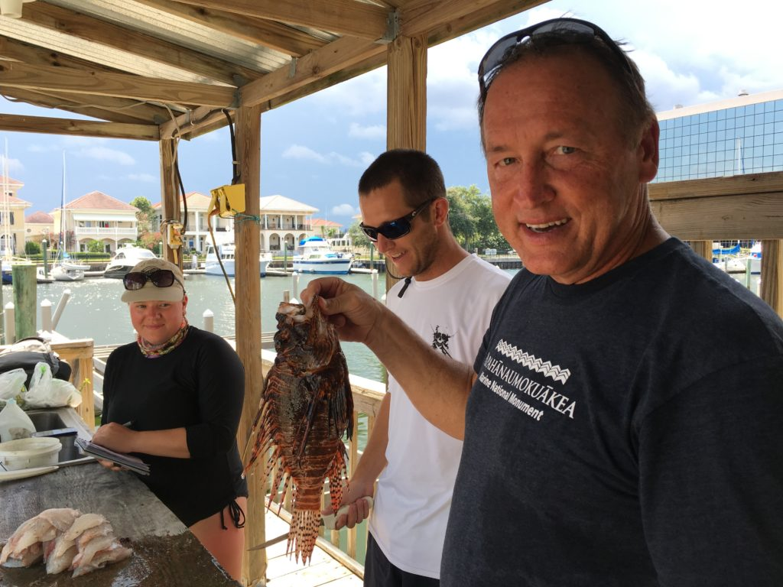
Gittings’ traps are based on a fairly simple design. The four-foot-squares consist of PVC frames, a bucket and a curtain that can be raised and lowered. The traps remain open — allowing fish to enter and exit — until the curtain is closed and the trap is raised to the surface.
Lionfish traps like this are currently being tested in the waters off of Pensacola. (photo/Dr. Steve Gittings)
The traps were designed to mimic a structure, such as an artificial reef of some kind, which lionfish are known to congregate around. This summer’s tests involved placing traps nearby existing artificial reefs — three chicken coops — in an attempt to lure away resident lionfish.
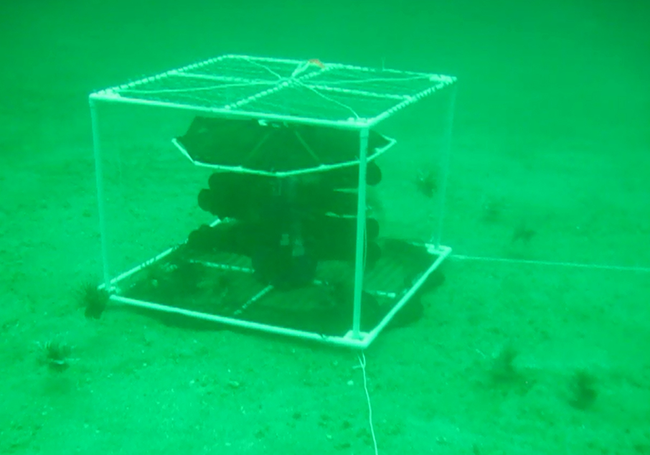
Earlier in the summer, Gittings and his team were seeing encouraging results when traps were left for shorter periods of time. After soaking for a day or two the traps capture about 35 percent of the lionfish they attract away from a structure, meaning that about 35 percent are still in the trap at the time it would be pulled.
But after a month on the bottom, the traps have performed much better. After soaking for that much time, about 87 percent of the fish attracted to the trap remain inside of it.

“At first pass it’s pretty exciting,” said Anna Clark, of Coast Watch Alliance.
Coast Watch, a local organization focused on fighting the invasion of lionfish, is keeping an eye on Gittings’ traps. The group dove down for a look in late August — “we didn’t shoot any lionfish, we just got video” — and liked what they saw.
“Some of them seemed to be really hunkered down,” Clark said.
Lionfish have thus far proved difficult to catch at anything resembling a commercial rate, with divers needing to spear each one of the invasive fish individually in an attempt to keep their numbers down and lessen the environmental impact the species has on the ecosystem
Clark hopes that the tests being tried out in the waters off Pensacola prove to be something of a game changer, allowing fishermen to haul up healthy loads of the fish, and from deeper waters than divers are able to access. She knows there has to be a better, more efficient way than the status quo if the lionfish is ever going to thrive on the seafood market, which is viewed as perhaps the best chance of controlling the species’ exploding population numbers.
“That’s going to be the sustainable solution here, and I thing the more viable solution,” Clark said.
But Gittings is still tinkering with his trap design. His next move will be to try out some changes — make it bigger to encompass more fish, make it collapsable to better fit on a boat — but eventually he’s hoping someone from the commercial side of the lionfish equation takes the design and improves on it.
“The fishermen are going to know pretty quickly what the strengths and weaknesses of these traps are once they buy into the concept,” Gittings said.
Another thing the NOAA scientist is hoping to try is positioning the traps away from any other structure. He’s wondering if sinking a trap in deeper waters, leaving it to rest on the sandy bottom would be beneficial.
“In deeper water where there’s no reefs, that doesn’t mean there’s no lionfish,” Gittings said, explaining that the species enjoys hunting near holes in the sand dug out by groupers. “You can find thousands of these grouper excavations on the Continental Shelf out there.”
For now, the scientist will keep an eye on the traps already in the Gulf, as he works to incorporate potential improvements into the design. But, after a summer of tests in Pensacola, there’s already some promising results surfacing and a basic premise that is worth getting excited about.

“The longer they stay in the water,” Gittings sums up his preliminary findings, “the more fish stay in the traps so you can catch’em.”

Vic Ferguson
The World Federation for Coral Reef Conservation
Executive Director
P.O. Box 311117
Houston, Texas 77231
vic.ferguson@wfcrc.org
www.wfcrc.org
281.886.7428 (office)
281.309.1201 (cell)
The only thing necessary for the triumph of evil is that good men do nothing”….Edmund Burke

