10/13/16

Red tide closes oyster beds east of Mississippi River
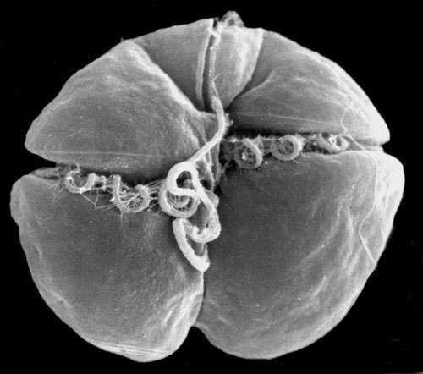
The single cell algae Karenia brevis, which is a dinoflagellate, turns water red or pink, which is why outbreaks are called Red Tide. The microscopic algae produces toxins that can kill fish, birds and marine mammals and cause illnesses in humans.
Mark Schleifstein, NOLA.com | The Times-Picayune
PrintEmail
By Mark Schleifstein,

LATEST LOUISIANA SEAFOOD STORIES
- UNO will improve shrimping nets, protect turtles with new grant
- BP oil spill cost fishing industry at least $94.7 million in 2010
- Every day is shrimp day in New Orleans
- Shucker for a day: Oysters, immigrants and an aching back
- How do blue crabs grow into big fat delicacies? Watch one molt
All Stories
Red tide, a harmful bloom of microscopic algae in seawater, has forced the closure of all oyster beds east of the Mississippi River in Louisiana waters, according to the state Department of Health and Hospitals. The agency said it was closing Oyster Beds 1 through 7, from Lake Borgne to the river's mouth, on Friday (Dec. 11) at sunset "as a precautionary measure due to the presence of Karenia brevis."
That's the scientific name of the microscopic algae that, in enough numbers, turns water a reddish or pinkish color, resulting in the name red tide. "These shellfish harvest areas will be reopened as soon as it is determined that environmental conditions are within the requirements specified by the National Shellfish Sanitation Program," the health department said in a statement.
Karenia brevis is a single-cell organism, or dinoflagellate, found frequently in Florida, Texas and Mexican waters, less often in Louisiana waters. The algae produce a variety of neurotoxins that can cause brain and stomach problems if eaten, and have been linked to major fish kills and deaths of marine mammals, sea turtles and seabirds. The toxins can also cause respiratory problems and eye irritations in human beings.
According to the National Oceanic and Atmospheric Administration's Harmful Algae Bloom (Red Tide) Watch program, Karenia brevis also is present along and off the shoreline of Harrison and Jackson counties in Mississippi, Mobile and Baldwin counties in Alabama and along the northwest Florida coast from Escambia to Franklin counties.

Vic Ferguson
The World Federation for Coral Reef Conservation
Executive Director
P.O. Box 311117
Houston, Texas 77231
vic.ferguson@wfcrc.org
www.wfcrc.org
281.971.7703 (office)
512.986.1902 (cell)
The only thing necessary for the triumph of evil is that good men do nothing”….Edmund Burk

