12/7/16

​Despite oil slick, 9,000 olive ridley eggs

picked up from Chennai coast
TNN | Feb 22, 2017, 09.57 AM IST
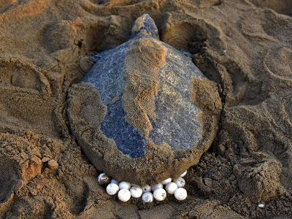
An Olive Ridley Turtle lays her eggs in the sand (AFP photo)
CHENNAI: Braving the oil slick that has stubbornly clung to the city shoreline since January 28, olive ridley turtles have laid more than 9,400 eggs along the coast. All of them have been shifted to hatcheries for incubation.
Chennai Wildlife Warden K Geethanjali told TOI that forest department staff, who regularly patrol the city beaches, had till Tuesday collected 9,418 eggs from 80 nests.
Geethanjali said eggs collected from nests on the stretch from Marina to Besant Nagar were incubating at the hatchery on Elliot's Beach, while those collected from nests further south were at the hatchery on the Vadanemmeli beach in Kancheepuram district.
Supraja Dharini, chairperson of the TREE Foundation which works for environment education, conservation and community development, said no turtles had died this season due to the oil slick. Two turtles found dead on the Ernavur coast recently with a coat of oil on their bodies had died after being entangled in fishing nets. The carcasses floated towards the place where the oil slick was and got stuck in it, she added.
This has been a good nesting season for the entire country. Sea turtle biologist and programme officer Dakshin Foundation Muralidharan Manoharakrishnan said the Rushikulya river mouth in Odisha was the site of Aribadda, the mass nesting of turtles. This year, the event lasted from February 13 to 20. Last year, there was no mass nesting in Rushikulya. This season, 3.5 lakh turtles came to the Rushikulya river mouth for nesting, Muralidharan said.

Gehirmatha, another site where mass nesting once took place, is now empty, he said.

Latest Comment

Hope they are safe Saranathan Lakshminarasimhan
The nesting season has been good in neighbouring Andhra Pradesh too, said Supraja Dharini, adding that turtles had come in good numbers to beaches in Nellore, Prakasam, Guntur, Krishna, Vizianagaram and Srikakulam district. Around 97,295 eggs were collected and shifted to the hatcheries, she said.

S S Davidson, managing trustee of Kanyakumari-based Tribal Foundation, said this year their teams had collected 10,300 olive ridley eggs from the shore and safely put them in hatcheries. Last year, only 5,200 eggs were collected from the 28 km stretch of beach in the district. In the current season, more than 1,000 hatchlings had been released into the sea, he said.

Marine cops roped into protecting Olive Ridley eggs

J Arockiaraj|

TNN | Updated: Feb 22, 2017, 01.32 PM IST

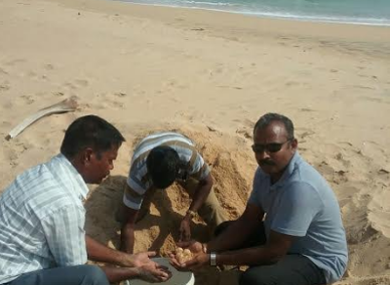
(TOI photo)

MADURAI:The forest department, which is responsible for monitoringWhile the initiative has been undertaken along the Tamil Nadu coast, the effort has yielded significant results along the Kanyakumari coast, where a whopping 10,000 turtle eggs have been collected this year

Every year, Olive Ridley turtles visit the Kanyakumari coast to lay their eggs, which fall prey to poachers and stray dogs despite constant vigil undertaken by the forest department. Once the turtle nesting season starts along the coast, the department sensitises residents of coastal hamlets about turtle conservation.

Fishermen are also deployed as turtle watchers. The role of turtle watcher is to keep a watch along the coast and alert the forest department in case of poaching. They also look out for turtle nests and eggs, handing them over to the hatchery established in the districts. The eggs are protected in the hatchery till they hatch and young turtles are released into the sea. Funds are sanctioned every year to deploy turtle watchers from the fishing community.

This year, Kanyakumari forest department downsized the number of turtle watchers from 12 to 6 due to funds crunch. As concerns were raised about conservation, marine police stepped in to lend a helping hand. "We carry out regular patrolling of beaches and keep a watch for turtle movements. Once the nest is spotted we alert forest officials and collect the eggs with their help, handing them over to the hatcheries", said Colachel marine police inspector, F Sahaya Jose.

With this additional task force, the forest department has collected 10,500 eggs so far this year. Last year, they collected 2400 turtle eggs of which 2200 hatched. "After conservation efforts started, this is the highest number of turtle eggs collected in a nesting season. Marine police personnel have been doing a great job, said Kanyakumari district forest officer, Vismiju Viswanathan. The department is probing if there could be any other reason for this surge in turtle eggs in addition to improved conservation efforts along with marine police.

Coastal Security Group ADGP C Sylendra Babu said that one of the tasks of coastal security group is protecting the marine environment. So protecting sea turtles - a threatened marine species - becomes their duty as per standard operating procedures. All marine police stations have been asked to carry out turtle conservation patrolling in Chennai, Thiruvallur, Nagapattinam and Kanyakumari districts. "We also work with environmental organisations in turtle conservation and train our staff too for the purpose," he said.

Stay updated on the go with Times of India News App. Click here to download it for your device.

RELATED

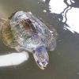Olive Ridley turtle gets new life with plastic prosthetic flipper
- 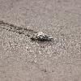In the steps of the Olive Ridley

